#B7D4EF

#DAE9F7
7.8"
THE ENFIELD COUNCILS & NEIGHBORHOOD WATCH TEAMS NAMES TABLE
Exhibit 1a+

- File Temp Link Location
- https://horrific-corruption-files.webhop.me/Groups-of-Involved-People-List/

Number | 1
Details | Enfield Civic Centre. Enfield Civic Centre. Silver Street, Enfield, London, EN1 3XA
Officers Name | - Ian.Davis@enfield.gov.uk.  - Ian Davis
Position | - Bosses  - Chief.Executive@enfield.gov.uk
Exhibit Number | [Exhibit A1]  Ian Davis
Laws & Regs / Info
12/09/2014 | The Asbo Dates Are to be included!  - The Asbo dates  PC Sophie Theodoulou  Police Officer Who Lied and said that she Served me the First Asbo Folder!  Page Numbers: 57,58  12/09/2014  --  Asbo Granted 04/08/2015  End of Asbo Court Order - 04/08/2020  The Forged Asbo conditions placed upon me finished but I could never go out ever again to a party in case I got set up again by the police and the Council!  End:
18/11/2016 | The Enfield Councils History FOI Indexed  Stage 4  Re: CCTV camera on inner communal/fire door  Page Number: 10  18/11/2016  10  Enfield Connected  Council  Simon Cordell  109 Burncroft Avenue  Enfield  Middlesex  EN37JQ  Dear Mr Cordell,  Re: CCTV camera on inner communal/fire door  Sarah Fletcher Neighbourhood Officer  The Edmonton Centre, 36-44 South Mall,  Edmonton London N9 OTN Sarah.Fletcher@enfield.gov.uk  0800 40 80 160  18lh November 2016  It has been brought to my attention that you have fitted a security camera onto the inner communal/fire door on the ground floor of our building.  This is in breach of tenancy conditions as it has been fitted without permission.  Please arrange for the camera to be removed by Friday 25th November 2016.  Failure to remove the camera by this date will result in the Council arranging for the removal of the camera and carrying out any necessary repairs to the structure of the building for which you will be charged, and we may take action against you for breach of your tenancy conditions.  Please contact me on or before 5.00pm on Friday 25th November 2016 to advise that the camera has been removed or we will proceed with the action as advised above.  Yours Sincerely,  Sarah Fletcher Enfield Council  Ian Davis Director Regeneration Environment Enfield Council  Civic Centre,  Phone: 020 8379 1000  Website: www.enfield.gov.uk  Reed this document in another language or format call Customer Services on 020 83791000, or email enfield.council@enfield.gov.uk
22/12/2016 | The Enfield Gov / Email’s Issue: 03  Geoffrey Mann Confidential  / Page Numbers: 2690,2691,2692,2693,  ENFIELD Connected  ENFIELD  Ian Davis  Ms Lorraine Cordell  Sent via Email  Dear Ms Cordell,  Council  Please reply to: Geoffrey Mann  E-Mail: geoffrey.mann@enfield.gov.uk  My Ref: COM 1885  Your Ref:  Date: 22nd December 2016  Re: Mr Simon Cordell - 1 0 9 Burncroft Avenue - COM 1885.  - I write with reference to your letters of complaint dated 24th November 2016 copies of which were received via email on 24th November 2016, 5th December 2016 and 8th December 2016. I will respond to the issues you raised as follows.  - Anti-Social Behaviour Order We are aware that the police applied for an Anti-Social Behaviour Order (ASBO) which was granted on 4th August 2015 against your son in relation to activities that happened at locations away from Burncroft Avenue. We are aware that your son is appealing against the ASBO, and we are therefore unable to comment further.  - CCTV We can confirm that a letter was sent to your son by Sarah Fletcher, Neighbourhood Officer on 18th November 2016 giving him until 25th November 2016 to remove the CCTV that he had installed on the internal communal door leading to flats 109 and 111 Burncroft Avenue and facing towards the main door of the block. We can also confirm that another letter was sent to him on 29th November 2016 by Lemmy Nwabuisi, Anti-Social Behaviour Officer in relation to complaints received from your son's neighbours concerning the CCTV. This matter  DIRECTOR - REGENERATION & ENVIRONMENT EQUALITY FRAMEWORK FOR LOCAL GOVERNMENT EXCELLENT ENFIELD COUNCIL CIVIC CENTRE, SILVER STREET ENFIELD EN1 XV WEBSITE: WWW.ENFIELD.GOV.UK  Page 2691,  - concerns a breach of tenancy conditions and will be addressed separately from this complaint.  - 3. Allegations of Anti-Social Behaviour You referred to alleged issues that your son was having with his neighbours; however, you· did not specify which neighbours and or provide a specific time frame when these complaints were made. We have checked our records since 4th August 2015 and found two records of telephone complaints received from your son. One on 20th August 2015 and again on 26th January 2016 which related to noise and the issues he was having with a neighbour. These concerns were dealt with at the time by relevant officers. We note your comment that your son has been a tenant for many years and that there have been no complaints about him until the publication of the ASBO against him on 4th August 2015. However, our records show that since your son's tenancy began on 14th August 2006, there has  - been at least one previous complaint against your son from another neighbour prior to the ASBO. We are aware of the alleged incident that happened on 4th October 2016 as this was reported to us and this will be addressed separately as part of ongoing Anti-Social Behaviour investigations. We note your comments regarding the police and must advise that you take up any issues with the Independent Police Complaints Commission. We also note your comment regarding an alleged incident on 14th August 2016. This was not reported to the Council and should be a matter for the police. We note your comment that your son is scared to go home due to the alleged issues with his neighbours. Regarding the allegations of ASB against your son and the issues regarding his dog, we note your comment that you do not think it is justified to attend the meeting with Lemmy Nwabuisi prior to your formal complaint being addressed. We note your comment that you have been advised by a solicitor to wait for the SAR. We also note your comments  Page 2692,  - in relation to the letter sent by Lemmy Nwabuisi on 29th November 2016 regarding reports of anti-social behaviour made against your son by his neighbours and that you will address these once the SAR is received.  - Please note that these allegations are serious breaches of tenancy conditions and will be addressed separately as part of an ongoing investigation.  - We have attempted to meet with your son to discuss the allegations made against him and give him the opportunity to respond.  - It is important that these issues are addressed, and another meeting will be arranged to facilitate this in due course.  - Subject Access Request (SAR) The SAR that you have submitted is being responded to separately in accordance with required timescales.  Communications  - We are aware that you left messages for Sarah Fletcher on three occasions between 16 and 21 November 2016 and she was not available at these times.  - We confirm that she spoke directly with Mr Simon Cordell by telephone on 22nd November 2016.  - Housing Options As a single resident living in a one-bedroom property, the Council considers that you􀯭 son is suitably housed.  - We do not have sufficient evidence in relation to your son's allegations of anti-social behaviour against his neighbours to be able to refer him for a transfer on the housing register.  - He can make an online application himself to be placed on the housing register by visiting the Council Housing pages of the Enfield Council website at www.enfield.gov.uk. His eligibility for transfer will then be assessed by the Housing Options team in accordance with Council policy and they will advise whether his application is accepted. Alternative options to move are available to him through the mutual exchange scheme, where tenants are able to swap their home with another tenant, and the fresh start scheme, where tenants can be supported in moving to a private rented home. Further information can be found online using the URLs below:  Page 2693,  - www.homeswapper.co.uk.  - https://www.enfield.gov.uk/forms/form/203/fresh start scheme.  - If you wish to discuss this matter please do not hesitate to contact me. Please note that I away from the office and will be returning on Tuesday 3rd January 2017.  Yours Sincerely_  Geoffrey Mann  Neighbourhood Manager  IMPORTANT - Enfield residents should register for an online Enfield Connected account. Enfield Connected puts many  Council services in one place, speeds up your payments and saves you time - to set up your account today go to  www.enfield.gov.uk/connected
29/12/2016 | The Enfield Gov / Email’s Issue: 04  Letter to Mr. Simon Cordell  / Page Numbers: 2700,2701,2702,  ENFIELD  Connected  Ian Davis  Director - Regeneration & Environment Enfield Council Civic Centre, Silver Street Enfield EN1 3XY  EQUALITY FRAMEWORK FOR LOCAL GOVERNMENT EXCELLENT  Website: www.enfield.gov.uk  © If you need this document in another language or format contact the service using the details above.  Mr Simon Cordell  Please reply to: Lemmy Nwabuisi  109 Burncroft Avenue  En3 7jq  Anti-Social Behaviour Team  Enfield Community Safety Unit  B Block North  Civic Centre  Enfield EN1 3XA  E-mail: lemmy.nwabuisi@enfield.gov.uk  My Ref:  Your Ref:  Date: 29 December 2016  Dear Mr Cordell,  Re: Reports of Anti-Social Behaviour, Harassment, Intimidation and Threatening Behaviour  I write with regards to reports of anti-social behaviour, intimidation, harassment and threatening behaviour made against you by your neighbours. The reports include using threatening, abusive and insulting words and language, aggressively demanding money, intimidation and making threats towards your neighbours. It is also alleged that on  04th October 2016  you banged on your ceiling, and you later started to bang and kick at your neighbour’s door. It is alleged that you were very aggressive and was shouting through your neighbour’s door and that you then proceeded to drag his motorbike from where it was parked and started to smash it up. It is also alleged that your dogs are left by themselves all day and night barking and causing noise disturbances to your neighbours. Your neighbours have also alleged that you have installed a CCTV in the communal area with the camera pointing towards the main entrance to the block thereby making them to feel very uncomfortable when entering and leaving the block. Your neighbours have alleged that this is an invasion of their privacy. If these allegations are true, they are in breach of the following terms and conditions of your Tenancy Agreement:  2701,  2.2.1 Anti-social behaviour, nuisance and noise disturbance.  We will consider all legal remedies available to us to deal with anti-social behaviour, domestic abuse, harassment, rate crime, nuisance, gang activity and other criminal activity where this is supported by sufficient evidence.  If we take legal action, we will ask the court to give us an order against you for the legal costs we have incurred.  Condition 10. You must not act in any way which causes, or is likely to cause, a nuisance or annoyance or is anti-social.  Condition 11. You must install any radio and/or video equipment or carry out any physical measures to respond to any nuisance or anti-social behaviour which you are suffering from without first consulting us.  2.2.3 Harassment and hate crime.  Condition 16. You must not harass or threaten to harass anyone because of their age, colour, culture, disability, ethnic origin, gender, gender reassignment, HIV status, nationality, race, religion, sexual orientation or for any reason.  2.2.6 Other unacceptable behaviour  Condition 21. You must not abuse, harass, make offensive comments and/or malicious allegations, use or threaten to use violence against any of our officers or agents, or against a councillor. This applies at any time and in any place. We may report the matter to the police.  2.15 Pet(s) and animal(s)  Condition 76. You have the right to keep one pet, or animal such as a cat, a dog, small bird, fish, non-poisonous insect, spider, small snake or lizard, rabbit, hamster, guinea pig, mouse, gerbil or domestic rat as long as they do not cause damage to the property, or nuisance or annoyance to anyone in your locality.  Condition 81. If your pet(s) or animal(s) is/are causing a nuisance, annoyance or disturbance to others, or is/are being treated inappropriately or cruelly, we  2702,  will take action and give written notice asking you to remove it/them from your home.  It is very important that we meet with you to discuss these very serious allegations and give you the opportunity to respond to them. I have therefore arranged for you to meet with me at the Civic Centre, Silver Street, Enfield,  EN1 3XY at 2pm on Tuesday, 6th December 2016 to discuss this matter.  Please ask to see Mr Lemmy Nwabuisi from the ASB Team, Community Safety Unit at the reception when you get to the Civic Centre.  Yours Sincerely  Lemmy Nwabuisi ASB Team  IMPORTANT - Enfield residents should register for an online Enfield Connected account. Enfield Connected puts many Council services in one place, speeds up your payments and saves you time - to set up your account today go to  www.enfield.gov.uk/connected
29/12/2016 | The 1st Injunction Order / Lemmy / pub Book Issue: 1!  Lemmy Harassment Letter  / Page Numbers: 31,32  Lemmy Nwabuisi Re Anti-Social Behaviour Allegations against Mr. Simon Cordell!  ENFIELD Connected  ENFIELD Council  Please reply to: Lemmy Nwabuisi Anti-Social  Behaviour Team Community Safety Unit B Block North Civic Centre Enfield EN1 3XA E-mail:  lemmy.nwabuisi@enfield.gov.uk  My Ref:  Your Ref:  Date: 2 February2017  Dear Mr. Cordell,  Re: Allegations of Anti-Social Behaviour, Harassment, Intimidation and Threatening Behaviour  - I write with regards to reports of anti-social behaviour, intimidation, harassment and threatening behaviour made against you by your neighbours.  - I wrote to you on 29th November 2016 regarding these reports you to meet with me at the Civic Centre on 5th December 2016 to discuss the allegations made against you, copy attached. I received a letter from your mother dated 24th November 2016 in which she stated that she does not believe that it is justified to hold the meeting before your formal complaint and subject access request is dealt with. I understand these have now been dealt with.  - The Enfield Council, Community Safety Unit, Anti-Social Behaviour Team have continued to receive various allegations from your neighbours against you concerning alleged nuisance and anti-social behaviour towards them. The allegations include using threatening, abusive and insulting words and language, aggressively demanding money, intimidation, making threats towards your neighbours and tampering with the electricity and water supply to their flat.  - These are very serious breach of tenancy conditions, and it is very important that we meet with you to discuss these allegations and give you the opportunity to respond to them. I have therefore arranged for you to meet with me at the Civic Centre, Silver Street, Enfield, EN1 3XY at 2pm on Thursday, 9th F e b r u a r y  - Mr. Simon Cordell 109 Burncroft Avenue Enfield EN3 7JQ  - Director- Ian Davis Environment Enfield Council Civic Centre, Silver Street Enfield EN1 3XY Website: www.enfield.gov.uk  EQUAUTY & FRAMEWORK REGENERATION FOR LOCAL GOVERNMENT EXCELLENT  Page 32  - 2017 to discuss this matter. You should contact me on 02083795354 to rearrange the meeting if this date is not convenient for you. Please ask to see Mr Lemmy Nwabuisi from the ASB Team, Community Safety Unit at the reception when you get to the Civic Centre.  Yours Sincerely  Lemmy Nwabuisi ASB Team  Lemmy Harassment Letter  IMPORTANT - Enfield residents should register for an online Enfield Connected account. Enfield Connected puts many Council services in one place, speeds up your payments and saves you time - to set up your account today go to  www.enfield.gov.uk/connected
19/07/2017 | The Enfield Gov / Email’s Issue:  NOSP - Simon Cordell Possession  / Page Numbers: 3267,3268,3269,3270,3271,3272,3273,3274,3275,3276,3277,3278,  ENFIELD  Council  If you need this document in another language or format, contact the service using the details above.  Ian Davis Chief Executive  Enfield Council  Civic Centre, Silver Street Enfield EN13XY  Website: www.enfield.gov.uk  EQUALITY FRAMEWORK FOR LOCAL GOVERNMENT EXCELLENT  Mr Simon Cordell Please reply to: Lemmy Nwabuisi  109 Burncroft Avenue Anti-Social Behaviour Team  Enfield Community Safety Unit  EN3 7Jq B Block North  Civic centre  Enfield EN1 3XA  E-mail: lemmy.nwabuisi@enfield.gov.uk  My Ref:  Your Ref:  Date: 19th July 2017  Dear Mr Cordell,  Notice of Seeking Possession - without prejudice  It has come to our attention that you have breached several terms and conditions of your tenancy by causing nuisance, harassment and anti-social behaviour to your neighbours and Enfield Council employees.  Enfield Council takes all acts of anti-social behaviour very seriously. Consequently, we have no alternative but to serve you with the enclosed Notice of Seeking Possession.  You have breached your tenancy agreement by committing an act of anti-social behaviour.  The Notice is the first step towards repossessing your home. It is valid for twelve months and Enfield Council will commence legal action to repossess your home any time within this period if further substantiated allegation of breach of your tenancy conditions is made against you.  You may wish to seek legal advice from a solicitor or your local Citizens Advice Bureau for free and confidential advice from an organisation that is completely independent from Enfield Council.  ENFIELD  Connected  3268,  Please contact me on that above telephone number if you wish to discuss this further.  Yours Sincerely  Lemmy Nwabuisi ASB Team  IMPORTANT - Enfield residents should register for an online Enfield Connected account. Enfield Connected puts many Council services in one place, speeds up your payments and saves you time - to set up your account today go to www.enfield.gov.uk/connected  3269,  LONDON BOROUGH OF ENFIELD  NOTICE OF SEEKING POSSESSION  HOUSING ACT 1985 - SECTION 83  THIS NOTICE IS THE FIRST STEP TOWARDS REQUIRING YOU TO GIVE UP  POSSESSION OF YOUR DWELLING. YOU SHOULD READ IT AND ALL THE  NOTES VERY CAREFULLY.  Housing Department F O. Box No. 60, Civic Centre, Enfield  1. To: Mr Simon Cordell  NOTES TO PARAGRAPH 1  11/01/2018  Simon Cordell’s MP3’S Indexed  Stage 1  1x Recording  01m. 7.1. Enfield council Fraud Line 11_01_2018  Page Number: Update Page Number 1,  --  Snippet Extract from Exhibit: -  Okay. What is it put out? I'm happy to wait for her.  Is it possible to speak somewhere else in the meantime then? Like James Rolfe, James Rolfe the director of resources or with Ian Davis is even better. The chief executive, I've been speaking to Heather Littler, I have recordings of her, and she is completely failed the whistle blowing policies. When I've informed her of what her employees below her are doing, I'm very concerned. She's putting me at fear of my life, and I would like her, or someone to investigate it all at the same time.  --  And more!
05/12/2018 | The Enfield Gov / Email’s Issue:  1098. Lorraine Cordell _Re_ Mr Simon Cordell of 109 Burncroft Ave, Enfield, EN3 7JQ  / Page Numbers: 4389,  From: Lorraine Cordell [lorraine32@blueyonder.co.uk]  Sent: 05 December 2018 14:09  To: Ian Davis  Sarah Cary  Jeremy Chambers  James Rolfe  Tony Theodoulou  Alev Cazimoglu  Subject: RE: Mr Simon Cordell of 109 Burncroft Ave, Enfield, EN3 7JQ  Attachments: On behalf of Mr Simon Cordell of 109 Burncroft Ave, Enfield, EN3 7JQ.pdf  To Whom It May Concern:  Please see attached letter regarding issues I have.
28/12/2018 | The Enfield Gov / Email’s Issue:  1125. Letter to Lorraine Cordell 28 12 18 (2)  / Page Numbers: 4439,4440,4441,  ENFIELD Connected  ENFIEL Council  Lorraine Cordell, Please reply to  E-mail: Andrea.Clemons@enfield.gov.uk  Date: 28th December 2018  Andrea Clemons  Community Safety Unit  B Block North  Civic Centre  Enfield  ENL 3XA  Dear Ms Cordell,  Re: Simon Cordell  - I am writing in response to your emails dated 17th and 20th December 18 where you have raised that you feel that some of the information provided in my letter to Joan Ryan MP dated 12th December 2018 is incorrect.  - I have therefore asked for legal clarification on the points raised.  - I accept that the order made by the Edmonton County Court on 9th August 2018 did not actually record that your son submits a housing transfer application on the condition that he engages with mental health team. However, you agreed that you would engage with the Enfield Mental Health Unit Team, so your son could receive assistance with his mental health conditions and housing.  - I understand that you.  - Agreed to submit a housing management transfer to be considered by the exceptions panel on 17/08/2018. However, following a discussion held with Ms lyavoo, one of the Council's lawyers on 16th August 2018 you were advised that the application being unsupported by medical evidence, if successful, would only result in a transfer of a property on a like for like basis.  - You explained to Ms lyavoo that your son needed support and would benefit from a larger property, so someone could come and live with him, and you were advised that this type of application must be supported by medical evidence.  - As your son was given an appointment to see the Enfield Mental Health Team on,31st August 2018, you asked that you son's application be deferred until the next panel meeting which was to take place on 29th September 2018.  - This was also confirmed in an email to Ms lyavoo on the same day.  - Unfortunately, you did not contact Ms lyavoo until 28th September 2018 at  --  IAN DAVIS CHIEF EXECUTIVE ENFIELD COUNCIL CIVIC CENTRE, SILVER STREET ENFIELD EN1 3XY  www.enfield.gov.uk  EQUITY FRAMEWORK FOR LOCAL GOVERNMENT EXCELLENT  If you need this document in another language or format, contact the service using the details above.  Page 4440,  - 4.20pm where you asked for an update regarding your son's management transfer application.  - You were aware that the panel meeting would take place on 29th September 2018 but only contacted Ms lyavoo less than 24 hours before the meeting.  - You also failed to provide Ms lyavoo with an update regarding the appointment I and whether you had managed to obtain the necessary medical evidence.  - Ms lyavoo contacted you on 12th October 2018 and advised you that the next panel meeting was to take place on 18th October 2018 and any applications would need to be submitted by 18th October 2018.  - She also asked that you clarify the basis of the application and whether you were able to provide medical evidence.  - Unfortunately, you did not respond to' her.  - ln relation to the allegations made in regard to the draft Order submitted to the Court. Ms lyavoo explains that she contacted Ms Trishna Kerai, of Stuart Miller Solicitors; the caseworker instructed on behalf of Simon Cordell on 10th August 2018 and emailed her a draft order.  - Ms lyavoo did not hear from Ms Kerai, so she emailed her again on 13th August 2018 and asked that she provides her agreement as soon as possible and if no response was made by 4pm on the same day she will have to email the draft to the Judge.  - Ms lyavoo states that she received a response from Ms Kerai on the same day stating that she was in agreement with the order, but she was waiting for your instructions.  - As no response was forthcoming,  - Ms lyavoo had to email the order to the Court on 15th August2018 and she also copied Simon's case worker to the email.  - Ms Kerai has never indicated that she was on annual leave during the time of the correspondence but confirmed that the delay was due to the receipt of your instructions.  - Ms lyavoo indicates that the order was following guidance provided by District Judge Dias.  - The Court order does not propose to be verbatim or to be a summary of all arguments exchanged in Court.  - I apologise for the delay in responding over the Christmas period and I will contact you shortly to advise you about where any future enquiries on this matter should be addressed.  4441,  Yours Sincerely  Andrea Clemons  Community Safety Unit  IMPORTANT - Enfield residents should register for an online Enfield Connected account. Enfield Connected puts many Council services in one place, speeds up your payments and saves you time - to set up your account today go to  www.enfield.gov.uk connected
25/01/2019 | The Enfield Gov / Email’s Issue:  1145. Lorraine Cordell RE  / Page Numbers: 4489,  From: Lorraine Cordell  lorraine32@blueyonder.co.uk  Sent: 25 January 2019 17:27  To: Andrea Clemons  Kaunchita Maudhub  Mr. Ian Davis  Subject: RE:  To Whom It May Concern:  - I am writing this email to get an update regarding my complaint dated the 05/12/2018 as I have not heard anything regarding it, and you are now out of the time limit for replying to a complaint and have not asked for more time.  - Could I please have the name of the person who is dealing with the complaint so that I can have contact with them?  - Also, I have not yet had a reply to my last letters written to you.  - Could you also please tell me if Lemmy Nwabuisi is still dealing with my son's case, if not what is the name of the person who has taken over please from the Anti-Social Behavior Team, could you please say if it is Kaunchita Maudhub as if it is I do not believe it is correct that she is dealing with my son's case as she was part of the reason my son was arrested on the 09/01/2018.  - Also, could you please state what stage level my complaints are at, is it stage 1,2 or 3.  - Also, could you please state under what jurisdiction within law, Enfield Council and Enfield Council legal services and the Anti-Social Behavior Team is using to share data to the mental health team and also other bodies without the consent of my son?  - Also, on what jurisdiction within law, Enfield Council and Enfield Council legal services and the Anti-Social Behavior Team is using to ask for information relating to my son from the mental health team and other bodies without 1st getting consent or even asking for consent from my son?  - Also, what security is being taken by Enfield Council and Enfield Council legal services and the Anti-Social Behavior Team when passing information over to other bodies within?  - Also, when Enfield Council has been told no data can be shared with the mental health and other bodies why it is still being shared?  - Could someone please get back to me regarding this issue within 3 working days?  Regards  Lorraine Cordell
03/03/2019 | From: Lorraine Cordell <lorraine32@blueyonder.co.uk>  Sent: 03 March 2019 15:29  To: Chief Executive <Chief.Executive@enfield.gov.uk>  Subject: RE: Complaint  To Whom It May Concern:  - I am writing this email as I feel it is the only option I have left, I have written emails and complaints and I just do not get a reply to them, I have had to CC you into some of them in order to try and get a reply some I do get a reply when I CC you into emails but most of the time I get nothing.  - I do not feel it is correct have to do this and as far as I know when you are CC into emails, I am sure you should over see it and make sure things are getting addressed but it seems like this is failing now and I would like to know the reason why it is failing so badly.  - I do know there is a pending court case for my son which Enfield Council has submitted to the court, but I do not feel that is a reason why emails / letters / complaints are not followed up, from my understanding when a complaint is submitted you are on a time limited in order to make a reply yet even complaints are failing to deal or address complaint in a timely manner, I do not just write emails and letters for the fun of things I write them in order to get answer to what I am asking.  - I am sorry for the way in which I have had to word this email, but this is not just one letter / complaint / email which has gone a none replied to this has been ongoing now for years.  - The way in which my son has been treated is a disgrace by Enfield Council, not once in all these years has anyone from Enfield Council come t see my son and as his side to anything or look at all the data my son has got which will prove he has not done all the things that is being said.  - It seems all Enfield Council wants to do is court case after court case and mislead the courts as that has been done many times regarding my son, and when the court orders something Enfield Council fails to do that as well.  Page 4542  - This is becoming more and more serious regarding the failing towards my son and I feel it has gone far enough and therefore I would like you to address these failing.  Regards  Lorraine Cordell
03/03/2019 | The Enfield Gov / Email’s Issue:  1166. Lorraine Cordell _Re_ Complaint_ (1)  / Page Numbers: 4540,  From: Lorraine Cordell [lorraine32@blueyonder.co.uk]  Sent: 03 March 2019 15:29  To: 'Ian Davis’s  Subject: RE: Complaint  To Whom It May Concern:  - I am writing this email as I feel it is the only option I have left, I have written emails and complaints and I just do not get a reply to them, I have had to CC you into some of them in order to try and get a reply some I do get a reply when I CC you into emails but most of the time I get nothing.  - I do not feel it is correct have to do this and as far as I know when you are CC into emails, I am sure you should over see it and make sure things are getting addressed but it seems like this is failing now and I would like to know the reason why it is failing so badly.  - I do know there is a pending court case for my son which Enfield Council has submitted to the court, but I do not feel that is a reason why emails / letters / complaints are not followed up, from my understanding when a complaint is submitted you are on a time limited in order to make a reply yet even complaints are failing to deal or address complaint in a timely manner, I do not just write emails and letters for the fun of things I write them in order to get answer to what I am asking.  - I am sorry for the way in which I have had to word this email, but this is not just one letter / complaint / email which has gone a nonreply to this has been ongoing now for years.  - The way in which my son has been treated is a disgrace by Enfield Council, not once in all these years has anyone from Enfield Council come t see my son and as his side to anything or look at all the data my son has got which will prove he has not done all the things that is being said.  - It seems all Enfield Council wants to do is court case after court case and mislead the courts as that has been done many times regarding my son, and when the court orders something Enfield Council fails to do that as well.  - This is becoming more and more serious regarding the failing towards my son, and I feel it has gone far enough and therefore I would like you to address these failing.  Regards  Lorraine Cordell
04/03/2019 | The Enfield Gov / Email’s Issue:  1167. Chief Executive _RE_ Complaint [SEC=OFFICIAL]  / Page Numbers: 4541,4542,  From: Chief Executive [Chief.Executive@enfield.gov.uk]  Sent: 04 March 2019 12:11  To: Lorraine Cordell  Cc: complaints and information; Andrea Clemons  Subject: RE: Complaint [SEC=OFFICIAL]  Classification: OFFICIAL  Dear Ms Cordell  - Thank you for your email addressed to the Chief Executive.  - I am writing in acknowledgement and to you that a copy of your correspondence has been passed to the Complaints and Access to Information Team. A response will be sent to you direct on the issues raised.  Regards  Heather Littler  Senior Admin Officer  Chief Executive's Unit  London Borough of Enfield  Civic Centre, Silver Street, Enfield, EN1 3XY  Tel: 020 8379 4037  Email: heather.littler@enfield.gov.uk  "Enfield Council is committed to serving the whole borough fairly, delivering excellent services and building strong communities"
04/03/2019 | Additional Email Attachments & Emails / Issue:  16. 1. 1  lorraine32@blueyonder.co.uk_03.04.2019_RE Complaint [SEC=OFFICIAL]  ALL NEW STUFF  04/03/2019  / Page Numbers: 333,334,335  333,  From: Lorraine Cordell <lorraine32@blueyonder.co.uk>  Sent: 04 March 2019 13:21  To: 'Chief Executive'  Subject: RE: Complaint [SEC=OFFICIAL]  Dear Heather, Littler  - Thank you for the below reply, but I fear just passing a copy of my correspondence will do very little, as I have been waiting for a reply just from one complaint since I believe the 05/12/2019, and there are multiple emails and letters going back to 2018 and the start of 2019 I have yet to have a reply from, also the SAR I put in on 25/11/2018 is still on going with really only data from 1997 included within a few documents I did get which I am writing emails for updates and getting no replies.  - So, you can see things are for some reason things are not being dealt with, Also I get no correspondence asking for more time, I write more emails to ask for an update but yet no replies so I think you can see that issues are not being dealt with in the correct way, and this has been like this for years not a few months, it is like I am wasting my time sitting and writing anything as it seem Enfield Council are not addressing anything I have asked.  - This is why I have asked the Chief Executive's Unit to get involved as I feel I am getting nowhere, and that should not be the case I should at least get a reply. There are multiple issues, and it seems where my son is involved Enfield Council just pushes it under the table.  - As it seems you have just pushed this to the same teams that are not doing their job and have not done their job for some time, is there anyone else in Enfield Council I can take this to that is higher as it seems no one wants to do anything within Enfield Council,  - I also do feel that departments within Enfield Council have deleted multiple of my correspondence from Enfield Council systems so it looks like I am doing nothing, when in fact I am. Multiple beaches in data can also be proven regarding the sharing of my son's data, and multiple other beaches. I have been told to ask under what jurisdiction within law; Enfield Council is using to share data, and what security is being taken by Enfield Council when passing information over to other bodies within, yet I have had no reply to this also along with multiple other questions I have asked.  - I would like to know if anyone at Enfield Council is going to take anything serious?  Regards  Lorraine Cordell
27/06/2019 | Additional Email Attachments & Emails / Issue:  36. 1. 1  Complaints and inform at Council contact [SEC=OFFICIAL] 3  27/06/2019  / Page Numbers: 375,376,377  --  375,  From: complaints and information <complaintsandmformation@enfield.gov.uk>  Sent: 27 June 2019 15:03  To: Lorraine32@blueyonder.co.uk  Subject: Letter regarding Council contact [SEC=OFFICIAL]  Attachments: Cordell letter 27.06.19.pdf  Classification: OFFICIAL  Dear Mr Cordell,  - Please find attached letter for your attention regarding communications with the Council.  Yours sincerely  Dionne Grant  Complaints and Information Service Manager  Enfield Council  Civic Centre  Silver Street, Enfield  EN13XA  Classification: OFFICIAL  Enfield Council is committed to serving the whole borough fairly, delivering excellent services and building strong communities.  Opinions expressed in this email are those of the individual and not necessarily those of the London Borough of Enfield. This email and any attachments or files transmitted with it are strictly confidential and intended solely for the named addressee. It may contain privileged and confidential information and if you are not the intended recipient and receive it in error you must not copy, distribute, or use the communication in any other way. All traffic handled by the Government Connect Secure Extranet may be subject to recording/and or monitoring in accordance with relevant legislation.  This email has been scanned for viruses, but we cannot guarantee that it will be free of viruses or malware. The recipient should perform their own virus checks.  Disclaimer  The information contained in this communication from the sender is confidential. It is intended solely for use by the recipient and others authorized to receive it. If you are not the recipient, you are hereby notified that any disclosure, copying, distribution or taking action in relation of the contents of this information is strictly prohibited and may be unlawful.  This email has been scanned for viruses and malware, and may have been automatically archived by Mimecast Ltd, an innovator in Software as a Service (SaaS) for business. Providing a safer and more useful place for your human generated data. Specializing in; Security, archiving and compliance.  376,  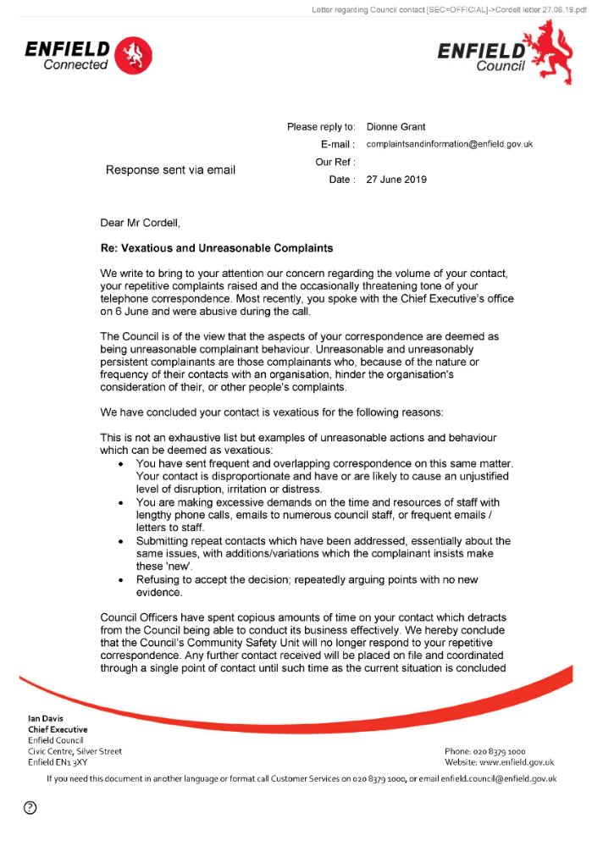  377,  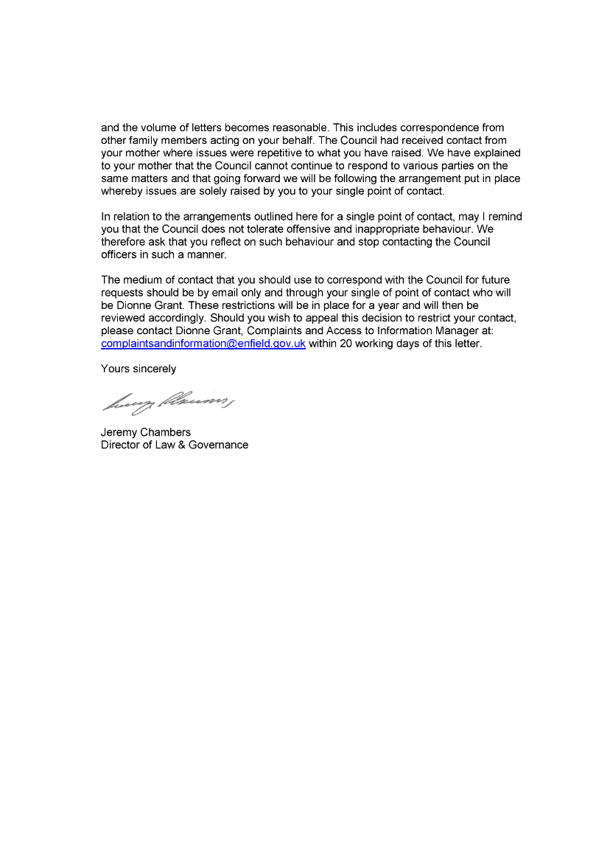  End of Picture!
24/06/2020 | Additional Email Attachments & Emails / Issue:  23. 2.  Letter regarding contact Enfield Council-24-06-2020 18-03  24/06/2020  / Page Numbers: 52,53  --  52,  From: Lorraine Cordell <lorraine32@blueyonder.co.uk>  Sent time: 24/06/2020 08:18:03 PM  To: Rewired <re_wired@ymail.com>  Subject: FW: Letter regarding contact with Enfield Council [SEC=OFFICIAL]  This is what I have asked her  --  From: Lorraine Cordell <lorraine32@blueyonder.co.uk>  Sent: 24 June 2020 20:09  To: ' complaints and information' <complamtsandmfonriation@enfield.gov.uk>  Subject: RE: Letter regarding contact with Enfield Council [SEC=OFFICIAL]  Dear Karen Hale  - I was wondering if you sent a copy of this to my son via his address. Or has it just been sent to me?  - If you could also, please send me a list of dates and times my son has called for the past year I would be grateful.  Regards  Lorraine  --  From: complaints and information <complaintsandinformation@enfield.gov.uk>  Sent: 24 June 2020 15:33  To: 'Lorraine32@blueyonder.co.uk' <Lorraine32@bluevonder.co.uk>  Subject: Letter regarding contact with Enfield Council [SEC=OFFICIAL]  Classification: OFFICIAL  Dear Mr Cordell,  - Please find attached letter for your attention regarding communications with the Council. Yours sincerely  Karen Hale  Complaints and Information Service Manager Complaints and Information Team Enfield Council  Classification: OFFICIAL  Be the first to receive the latest Council news straight to your inbox  SIGN UP ONLINE NOW  www.enfield.gov.uk/enewsletters  Enfield Council is committed to serving the whole borough fairly, delivering excellent services and building strong communities.  Opinions expressed in this email are those of the individual and not necessarily those of the London Borough of Enfield. This email and any attachments or files transmitted with it are strictly confidential and intended solely for the named addressee. It may contain privileged and confidential information and if you are not the intended recipient and receive it in error you must not copy, distribute, or use the communication in any other way. All traffic handled by the Government Connect Secure Extranet may be subject to recording/and or monitoring in accordance with relevant legislation.  This email has been scanned for viruses, but we cannot guarantee that it will be free of viruses or malware. The recipient  53,  should perform their own virus checks.  Disclaimer  The information contained in this communication from the sender is confidential. It is intended solely for use by the recipient and others authorized to receive it. If you are not the recipient, you are hereby notified that any disclosure, copying, distribution or taking action in relation of the contents of this information is strictly prohibited and may be unlawful.  This email has been scanned for viruses and malware, and may have been automatically archived by Mimecast Ltd, an innovator in Software as a Service (SaaS) for business. Providing a safer and more useful place for your human generated data. Specializing in; Security, archiving and compliance.
24/06/2020 | Additional Email Attachments & Emails / Issue:  24. 1. 1  Complaints and information act with Enfield Council [SEC  24/06/2020  / Page Numbers: 54,55,56,57,58  --  54,  From: complaints and information <complaintsandmformation@enfield.gov.uk>  Sent: 24 June 2020 15:33  To: Lorraine32@blueyonder.co.uk  Subject: Letter regarding contact with Enfield Council [SEC=OFFICIAL]  Attachments: Cordell letter 24.6.2020.pdf; Cordell letter 27.06.19.pdf  Classification: OFFICIAL  Dear Mr Cordell,  - Please find attached letter for your attention regarding communications with the Council. Yours sincerely  Karen Hale  Complaints and Information Service Manager Complaints and Information Team Enfield Council  Classification: OFFICIAL  Be the first to receive the latest Council news straight to your inbox  SIGN UP ONLINE NOW  www.enfieldgov.uk/enewsletters  Enfield Council is committed to serving the whole borough fairly, delivering excellent services and building strong communities.  Opinions expressed in this email are those of the individual and not necessarily those of the London Borough of Enfield. This email and any attachments or files transmitted with it are strictly confidential and intended solely for the named addressee. It may contain privileged and confidential information and if you are not the intended recipient and receive it in error you must not copy, distribute, or use the communication in any other way. All traffic handled by the Government Connect Secure Extranet may be subject to recording/and or monitoring in accordance with relevant legislation.  This email has been scanned for viruses, but we cannot guarantee that it will be free of viruses or malware. The recipient should perform their own virus checks.  Disclaimer  The information contained in this communication from the sender is confidential. It is intended solely for use by the recipient and others authorized to receive it. If you are not the recipient, you are hereby notified that any disclosure, copying, distribution or taking action in relation of the contents of this information is strictly prohibited and may be unlawful.  This email has been scanned for viruses and malware, and may have been automatically archived by Mimecast Ltd, an innovator in Software as a Service (SaaS) for business. Providing a safer and more useful place for your human generated data. Specializing in; Security, archiving and compliance.  55,  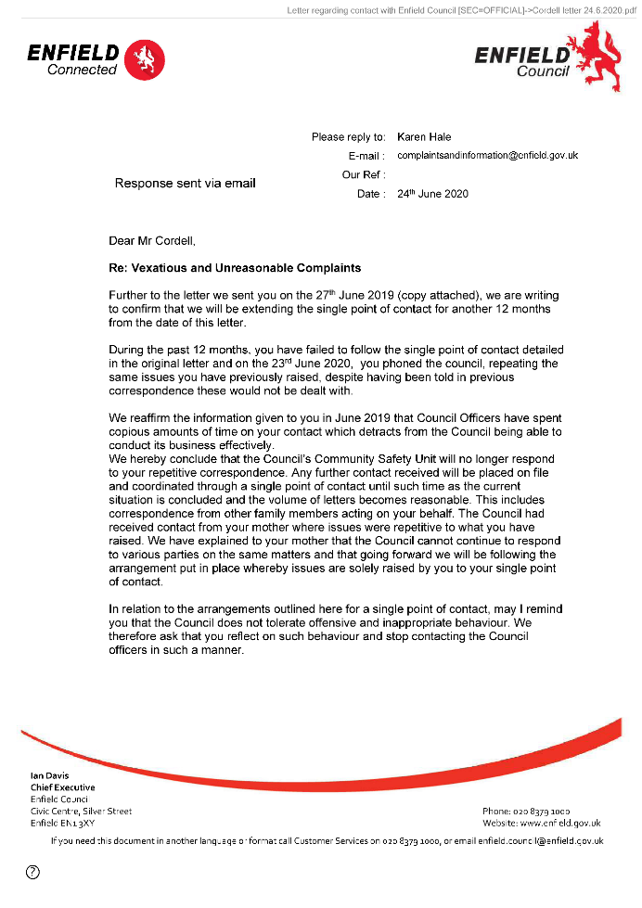  56,  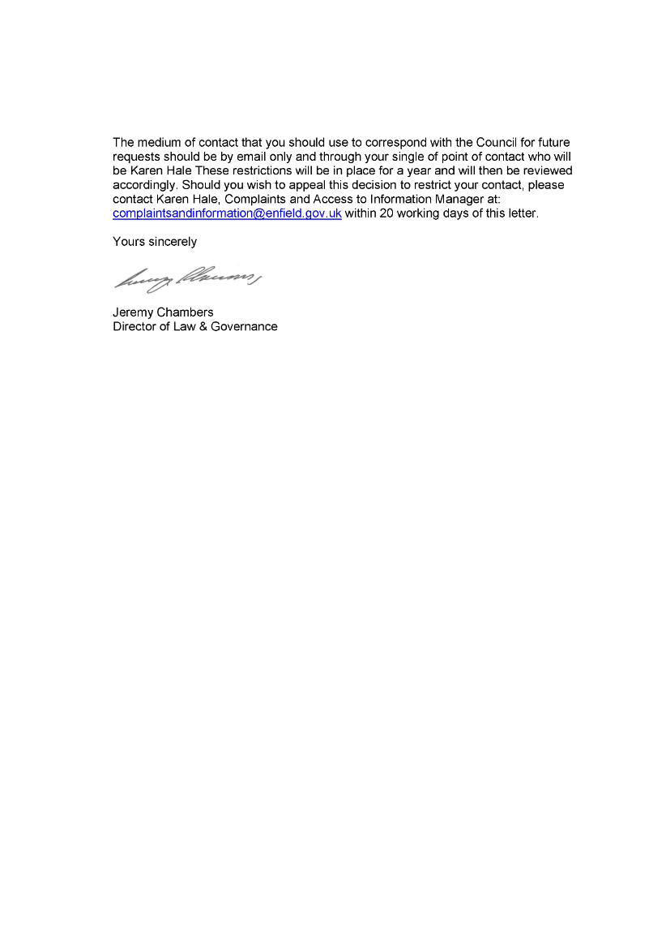  57,  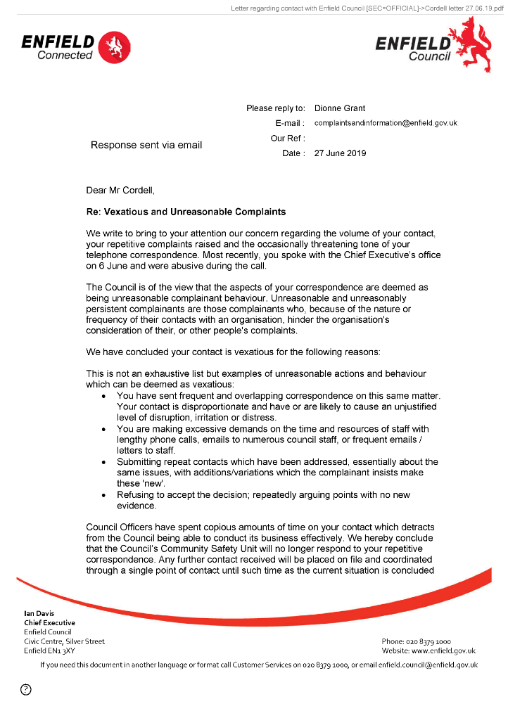  58,  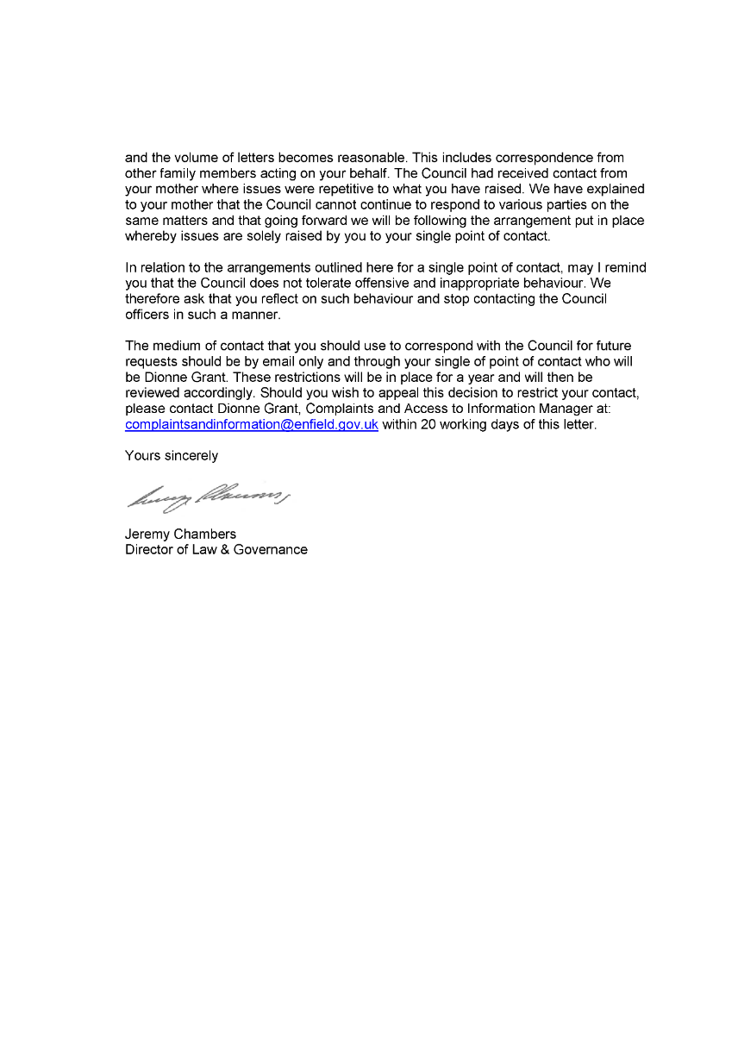  End of picture!
24/06/2020 | Additional Email Attachments & Emails / Issue:  25. 1. 1  lorraine32@blueyonderg contact with Enfield Council  24/06/2020  / Page Numbers: 59,60  --  59,  From: Lorraine Cordell <lorraine32@blueyonder.co.uk>  Sent: 24 June 2020 23:19  To: complaints and information  Subject: RE: Letter regarding contact with Enfield Council [SEC=OFFICIAL]  Importance: High  Dear Karen Hale  - I was wondering if you sent a copy of this to my son via his home address and if so on what date? Or has it just been sent to me?  - If you could also, please send me a list of all dates and times my son has called and for what reason he has called for the past year, highlighting dates where you state he has been Vexatious and Unreasonable I would be most grateful.  - Also, I am sorry for the updated email the reason is due to me reading the letter fully what you have written, can you also please supply me with dates in the last year I have contracted the council for my son regarding the issues listed in the letter dated the 23/06/2020, again highlighting all dates and times you state I have been Vexatious and Unreasonable.  - I believe I contracted the council named officer once after the letter dated 27/06/2020 which I had no reply to.  - The other contract I had was due to an ongoing court case, which most of the time my son’s solicitors was contracting the council towards the end of the case, I had to address the council directly as my son no longer had a solicitor acting for him.  - The only other time I had contract was when the MP was addressing issues regarding a court order which the court made which the council did not comply with.  - And the only other time I have had contact is due to repairs that needed doing to my sons flat.  - Could you therefore supply me with the above information as soon as possible so this can be addressed in a timely manner?  Regards  Lorraine
12/11/2021 | https://horrific-corruption-files.serveblog.net/Cant-Call-the-Council-4-Help/  https://horrific-corruption-files.webhop.me/Hide/ | - On the 12/11/2021  I got more like this it just got unblocked about 3 months ago 25/05/2024.  - On the 12/11/2022More to add! Chief Executive +
00/00/0000 | Extra Exhibits Taken from Newspapers!  - Set 1  - https://horrific-corruption-files.serveblog.net/Boris/  - Set 2  - https://horrific-corruption-files.serveblog.net/Boris/Boris%20Cannons/ | - On the 00/00/0000,  These files below have not been looked at for a while and need overviewing again, there will be more to add!
00/00/0000 | For Ian Davis Extracted from Newspapers!  - Ian Davis - Chief Executive - Enfield Council _ LinkedIn.html  - Ian Davis starts in 2007 - New London Architecture.html  - Ian Davis's email & phone _ Enfield Council's Chief Executive email.html  - Ian John Davis companies_house_document.pdf  - Record of meeting with Enfield Council with Rob Leak & Ian Davis together 2015 Aug.html  - Enfield Council top earners up 60% in a year _ Enfield Independent.html  - Top Enfield Council job advertised for whopping £185k per year as Rob Leak retires _ Enfield Independent.html  - APP A - Whistleblowing Policy March 12.pdf | - Between the dates of 25/05/2024 and 00/00/2024 it is said that Mr. Ian Davis Attempted to Murder the Now Claimant [✞⚰️] by
For Jeremy Chambers from Newspapers!
Some people are allowed in and some people aren’t!
- The Council “neither confirms nor Denies” the Allegations of sexual harassment misconduct leading to Settlement Agreements. – ShepwayVox Dissent is not a Crime.html

- Jeremy C. - Director of Law and Governance - Enfield Council _ LinkedIn.html

For Doctor Greenside
25/10/2018
https://horrific-corruption-files.webhop.me/Temp/(4)%20Doctors%20Files/Doctors%20Folder%20pics/

