Title: Decline of Community and Tenancy Integrity in a Council Estate
Who’s the girl illegally attacking me in 115 and should she legally be in the flat also her Motive “MO” behind what she does?

Girl Known as: Rebbeca O`Hare
The Illegal Subletting of Council Stock Homes!
The illegal subletting of flats by council secure tenants constitutes towards a breach of their tenancy agreements. In my block, there are six flats arranged over three levels, with two flats on each level. Each front door faces the next, and the bottom-floor flats have back gardens. I have lived in one of these bottom-floor flats since 2006.
This estate is designated for individuals over 40 years old; however, I've noticed an increasing trend of younger individuals moving in alongside the adult tenants. While their presence has contributed to some changes, my negative experiences in the community primarily stem from the actions of the original adults I once considered friends. Unfortunately, I have faced racial hatred, unfounded rumours, and a toxic atmosphere fuelled by individuals seeking to emulate violent behaviour. These actions have severely damaged our community spirit without justification and my life.
Between 2006 and 2014, Burncroft Avenue thrived with a strong sense of community, and I cherished my time here. Sadly, that sense of belonging has faded, and my overall experience has significantly declined. Despite this, I continue to keep an eye on the activities around me, taking notes of who lives where as I have also been forced to maintain a diary of the wrongs I have endured due to the original adults and now some youngers that have copycatted their illegal actions, taken against my person and as requested by the council and police, as to when they asked me to document incidents involving members of the estate in my block and they as the Enfield Council and My landlord sent me a diary form to fulfil.
The two ground-floor flats are council-owned, while the second-floor flats are numbered 113 and 115, with 113 being directly above my flat and both flats belonging to the Enfield Council and their sub company The Enfield Homes. When I first moved in, 115 was occupied by a young couple, both white British and with whom I had no issues. Since 2014, I have experienced sustained harassment from residents of flats 111, 113, 115, and 117 Burncroft Avenue. The tenancy at 115 initially changed to a Turkish woman, who appeared to be renting temporarily. This later changed, and Rebbeca O’Hare is now occupying flat 115 — a council-owned property — without a secure tenancy agreement.
This claim is substantiated by video footage submitted by Rebbeca O’Hare herself (Exhibit 11: ROH_01_mp4), which captures the installation of a new front door identical to those issued exclusively to Enfield Council housing stock. The footage confirms that the door replacement was carried out by Gerda Security Products Limited, a contractor officially appointed by Enfield Council.
“Enfield Council has contracted Gerda Security Products Limited to install the new fire doors. Gerda Security Products Limited is a leading provider of fire safety solutions, known for their high specification fire door sets and emergency access systems.”
The installation timeline further confirms council involvement:
- 8:00 AM on 04/02/2025: New front door fitted at 111 Burncroft Avenue
- 8:00 AM on 04/02/2025 and 05/02/2025: New front doors fitted at 113 and 115 Burncroft Avenue
These installations were part of a coordinated rollout across council-owned flats, and the identical door type — visible in the footage — matches those issued exclusively to Enfield Council tenants. This directly contradicts any claim of private tenancy and confirms that Rebbeca O’Hare is occupying the property without secure tenancy rights.
To ensure transparency and accountability, I formally request disclosure of:
- The tenancy status of flat 115
- The installation records from Gerda Security Products Limited!
- The Enfield Council housing officer responsible for overseeing these installations to confirm the truth about 115 being illegal sublet and with their acknowledgement due to the submitted as well as ownership of the front door!

Also, I have provided you with the following contact details:
• The Contact Details (telephone, email, and postal address) for:
a. Gerda Security Products Limited:
- Telephone: 01638 711028
- Email: enquiries@gerdasecurity.co.uk
- Postal Address: Gerda House, 54 Chiswick Avenue, Mildenhall, Suffolk, IP28 7AY
b. The Enfield Council housing officer responsible:
- Telephone: 020 8379 1000
- Email: housing@enfield.gov.uk
- Postal Address: Housing Department, Enfield Council, Civic Centre, Silver Street, Enfield, EN1 3XA
- CASE_SUMMARY_PDF.PDF:
📂 Extracted Title Structure from Case Summary
- Application for Order(s) on Conviction:
- She clearly admits that she is not a secure tenant so why is she living in a secure tent’s council flat, or she and the police would say so!?
- “I am the above-named individual and reside at location known to police.”

This evidence is critical in exposing tenancy misrepresentation and validating the timeline of coordinated harassment. It also reinforces the need for council scrutiny and legal accountability.
And lastly the flat titled as Flat 117 is the last address of concern and is the flat directly above 113. The situation escalated, as the council and police sided with them, due to initiating the problems of cause and this wrongful behaviour further exacerbating the problem.
With that being explained, I can now get closer to the point — namely, the legal occupation and inhabitancy of 115 Burncroft Avenue, and the unlawful actions taken against me by the current occupant and her collaborators. These actions were achieved through coordinated setups, false allegations, and procedural manipulation, all of which are documented and exhibited through the following evidence:

2006, 2007, 2008, 2009, 2010, 2011

 | - Accused as liable  - Doctors!  - Enfield Council!  - Met Police Force!  - The listed occupants apart from 119  - The reason that we have adduced this exhibit into these proceedings is as listed below! |  | Evidence: Exhibit BB1 /  - We contain Evidence in the Now Claimants Diary!  Weblink:  Evidence: Exhibit BB52 /  - This is a picture of the front layout of Burncroft Avenue  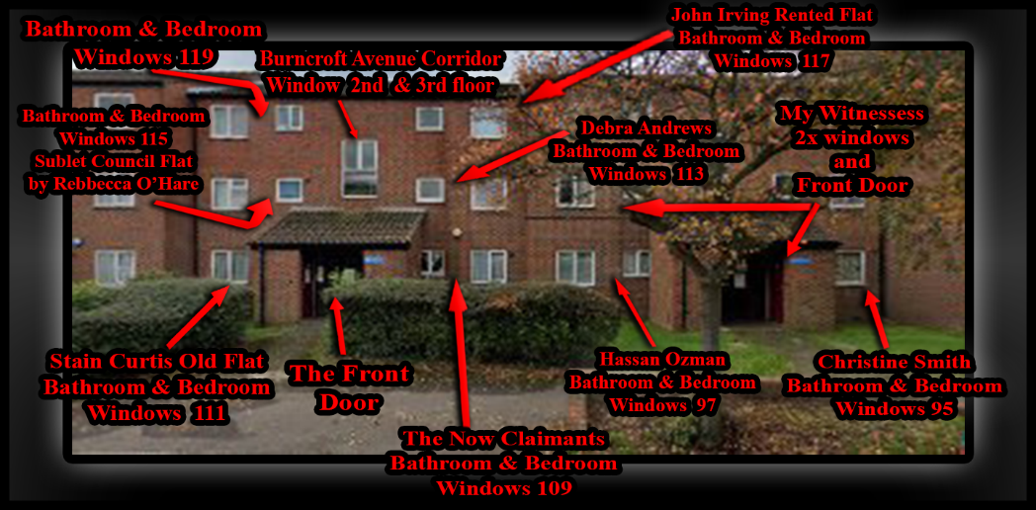

🧭 Purpose of the Image:
- This diagram supports my case by:
- Documenting who lives where in relation to Flat 115 (Rebecca O’Hare’s flat).
- Clarifying visibility and access points, especially relevant to her claims about seeing or being seen.
- Establishing physical layout for forensic contradiction of her timeline.

🏢 Breakdown of Labels and Their Significance:
Annotation | Description | Relevance
BATHROOM & BEDROOM WINDOWS 115 | Rebecca O’Hare’s flat | - Rebecca O’Hare (Flat 115) illegally sublets the council flat, breaching tenancy agreements. Her flat’s windows (bathroom & bedroom) are central to her false claims about visibility and movement. This map disproves her disapprove ability to see or interact safely as stated, while, exposing her harassment and intimidation against me. The image supports the pattern of her illegal occupation and targeted victimization, towards me, undermining her credibility and demonstrating systemic failure to address her misconduct.
BURNCROFT AVENUE CORRIDOR WINDOW 2ND FLOOR STAIRS | Communal stairwell window | - This is in between the second and third floor but easily accessible for assessing whether she could have seen me or vice versa.
JOHN IRVING RENTED FLAT BATHROOM & BEDROOM WINDOWS 117 | Another resident’s flat | - Statement: Flat 117 Burncroft Avenue – Council-Enabled Harassment, Fabricated Legal Process, and Evidentiary Breakdown  Flat 117 Burncroft Avenue, originally rented by John Irving, has been sublet to Enfield Council through a private intermediary, Ashdale Services Limited, a residential accommodation management company. Ashdale, in collaboration with the council, places temporary occupants in this flat under statutory frameworks such as the Housing Act. These placements have consistently involved individuals who have participated in sustained harassment, intimidation, and coordinated attacks against me.  The flat itself has been deliberately neglected and weaponized. Its creaking floors and structural damage are not incidental, they are used by occupants to create psychological disruption. Despite repeated reports, the council has failed to intervene, allowing the flat to operate as a torture room, with its occupants acting as tools to destabilize my life and dismiss my right to live peacefully.  This abuse is not isolated. ASIDA Services Limited, another property enforcement company, issued notices permitting random inspections and threatening eviction for damages but yet they have ignored the deliberate misuse of the property by council-placed individuals, as I reported them or as they should have been inspected. This dual failure by both Ashdale and Enfield Council has enabled a system of abuse, surveillance, and environmental harm that violates my rights and safety.  In one particularly egregious incident, John Irving attempted to break into my home, falsely claiming to be a plumber. I immediately reported this to a council officer named Lemmy and recorded the interaction. Instead of investigating or protecting me, Lemmy met with John Irving and together they produced a fabricated statement designed to cover up the break-in attempt. This false statement was later used in a possession order against me.  However, due to the strength of my evidence, including recordings, surveillance logs, and witness accounts they could not bring the cases to trial and the Housing possession order cases, and two injunction order cases were all lost. Yet the authorities continued to trap me in an illegal and abusive legal process, imposing conditions based on fraudulent and fabricated claims. These actions were designed to set me up, to keep me confined within a system that ignored due process and enabled ongoing harm.  The council’s failure to act on tenancy violations, their complicity in enabling harassment, and their reliance on falsified documentation all point to a coordinated effort to undermine my existence. The misuse of Flat 117 and surrounding properties has had a direct and measurable impact on my health, safety, and legal standing.  Weblink: https://server2.pointto.us/PNC-Claim/1.%20PNC-Tool-Kit/04.%20New-Diary-11-12-23/04.%20New-Diary-11-12-23/New-Diary-11-12-23/Some%20Parts%204%20Diary%20New%20style%2028-05-22/This%20just%20come%20out%20of%20117%203rd%20set%20of%20tennants%20in%202%20years%20or%20more/
DEBRA ANDREWS BATHROOM & BEDROOM WINDOWS 113 | Flat directly above yours | 🔹 Timeline of Occupants and Actions from Flat 113 Burncroft Avenue  1. Debra Andrews – Initial Disruption Phase:  - Role: First known hostile occupant of Flat 113.  - Actions:  - She initiated noise-based harassment, deliberately targeting my rest and work hours to disrupt my daily life.  She colluded with other residents to create a hostile and intimidating living environment.  Her behavior set the foundation for a continuing pattern of provocation and harassment originating from this flat.  Furthermore, government officials exploited her vulnerabilities, including her cholesterol and mental health history, the loss of custody of her three children, and her struggle with alcoholism—to fabricate false records against me. They used this to produce misleading reports and misrepresentations of my conduct to themselves, the authorities as part of an illegal campaign to attack me and discredit me.  - Initiated noise-based harassment, particularly targeting my rest and work hours.  - She colluded with other residents to create a hostile living environment.  - Her behaviour laid the groundwork for what would become a pattern of provocation from this flat.  - She was involved and used by Government Officials illegally to attack me they used her cholesterol mental health history and prior 3 children taken away from her as well as alcoholism dependency in creating false history against me were they developed a fake record of false reporting and misrepresentation of my conduct to authorities.  2. George Quinton – Escalation and Surveillance:  - Role: Successor to Debra Andrews.  - Actions:  - Introduced surveillance-like behaviour, including monitoring your movements and interactions while mentally and physically attacking me.  - He deliberately victimised me and copycatted the prior occupant.  - George Quinton – Escalation and Deliberate Neglect: While Debra Andrews was still residing in the flat, my mother and I repeatedly wrote to the council about the poor and unsafe condition of the floors. When Debra moved out, the council placed builders into the flat and then assigned George Quinton as the new occupant. The council claimed that all repair work had been completed, but this was false—they had only been pretending to replace the floor. When George allowed my mother and me into the flat, we discovered that the floor had been cut into numerous uneven pieces, resembling the piano keys in the movie Big that Tom Hanks famously jumps on. The nails were improperly fixed, especially at the corners, creating multiple trip hazards on each section of the floor. This dangerous flooring was deliberately left in this hazardous state, seemingly to enable George to continue copying Debra’s pattern of harassment and victimisation. The council’s failure to properly repair the flat not only ignored safety standards but actively facilitated ongoing abuse against me.  - His tenure marked a shift from passive disruption to active targeting.  3. Ambrose – Tactical Provocation:  - Role: Occupant following George Quinton.  - Actions:  🔹 Pattern of Council-Enabled Harassment: Debra Andrews, George Quinton, and Ambrose Atoro  🔸 Debra Andrews – Foundation of Provocation:  - Debra Andrews was the initial occupant whose behavior laid the groundwork for sustained harassment.  - She initiated noise-based attacks, deliberately targeting my rest and work hours.  - She colluded with other residents to create a hostile living environment.  - Her conduct established a template of provocation that subsequent occupants replicated.  - Critically, Debra was used illegally by government officials to attack me. They exploited her vulnerabilities—including her mental health history, cholesterol issues, alcoholism, and the loss of custody of her three children—to fabricate a false narrative against me.  - This manipulation led to false reporting and misrepresentation of my conduct, forming the basis of a fraudulent record used to justify further legal action.  🔹 George Quinton – Escalation, Surveillance, and Council Negligence  - George Quinton succeeded Debra and escalated the harassment.  - George Quinton was placed in the flat following Debra Andrews, continuing and escalating the pattern of harassment against me. His behavior included:  - Surveillance-like monitoring, tracking my movements and interactions.  - Mental and physical intimidation, including deliberate noise-based disruption during legal preparation.  - False reporting and misrepresentation of my conduct, submitted to authorities to reinforce a hostile narrative.  - Exploitation of unsafe housing conditions, including a deliberately fragmented floor left unrepaired by the council. When my mother and I were later allowed into the flat, we documented the flooring—cut into uneven sections with improperly fixed nails, creating trip hazards and psychological stress.  - George’s conduct was not isolated, it was shaped by a vulnerable personal history. He suffers from mental health issues, stemming in part from the loss of his mother at a young age, which left him emotionally destabilized. This trauma contributed to his susceptibility to manipulation and erratic behavior. There are also serious allegations concerning sexuality exploitation during his youth, which may have further impacted his psychological state.  - Despite his known vulnerabilities, Enfield Council placed George in a flat already associated with harassment and provocation, without safeguards or supervision. Rather than offering support, the council enabled a situation where George’s instability was weaponized allowing him to replicate and escalate the tactics used by Debra Andrews.  - This placement must be viewed as part of a broader pattern of council-enabled provocation, where vulnerable individuals with known histories were strategically positioned to destabilize me and obstruct my legal defence.  🔸 Ambrose Atoro – Strategic Placement Despite Violent History:  - Ambrose was placed in the flat after George, despite a documented history of extreme violence.  - At age 20, Ambrose committed a brutal armed robbery at Brick Lane Post Office, assaulting the postmaster with a fake handgun and causing grievous bodily harm.  - He had escaped from Chase Farm Hospital the day before, where he was being held for schizophrenia.  - He was sentenced and transferred under Section 47 of the Mental Health Act 1983, with a Section 49 restriction—meaning he could not be released without approval from the Secretary of State.  - According to housing transfer records dated 12 August 2021, Ambrose was explicitly barred from returning to the area of his previous victim.  - Despite this, Enfield Council and police placed him at Burncroft Avenue, near my residence, already destabilized by Debra and George.  - Ambrose was reportedly offered early release on the condition of accepting psychiatric treatment, and his placement appears to have been strategically designed to provoke further escalation.  - Since arrival, he has engaged in floor banging, verbal baiting, and timed disturbances, especially during legal preparation, mirroring the tactics of his predecessors.  ⚠️ Legal Implications  - The council’s decision to place three successive occupants—each with escalating patterns of harassment and known vulnerabilities—constitutes gross negligence and institutional abuse.  - They ignored safeguarding protocols.  - They enabled coordinated harassment.  - They manipulated vulnerable individuals to provoke and destabilize me.  - This pattern must be formally addressed in court as part of a broader abuse of process and denial of my right to live safely and prepare my legal defence without obstruction.  - Weblink: https://server2.pointto.us/R-2014-and-Onwards/05.%20Old%202014OnwardsExhibitsV1/2014%20and-Onwards-Exhibits/Housing%20Transfer%20File/Transfer/Transfer/Neighbours%20Only/People%20-%20Neighbours%20Ambrose%20Newspaper%20File%20Master%2012-08-21/  4. Richard Edward Skinner – Current and Most Aggressive Phase:  - Role: Present occupant of Flat 113.  - Actions:  - Engages in persistent and direct provocation, including loud stomping and heavy footsteps directly above my front room during critical times when I am working or preparing legal documentation.  - His actions are deliberately timed and coordinated with council activities to disrupt and interfere with my ability to compile legal evidence, demonstrating a calculated psychological harassment campaign.  - The intensity and nature of his conduct pose a serious threat to my physical and mental well-being, amounting to a life-endangering pattern of harassment through an ongoing spree of illegal actions targeted against.  ⚖️ Evidentiary Pattern:  - Each occupant has built upon the tactics of the previous, escalating from noise and passive disruption to active setups, false allegations, and coordinated interference.  - The flat itself has become a central node of harassment, with each resident contributing to a sustained campaign against you.  - Your documentation, including spatial maps, video evidence, and contradiction tracking—clearly shows that Flat 113 has been used as a strategic platform for destabilization.
CHRISTINE SMITH BATHROOM & BEDROOM WINDOWS 95 | Ground-floor flat | 🔹 Exhibit: Christine Smith – Foundational Role in Coordinated Legal Targeting:  - Subject: Christine Smith – Secure Council Tenant of Burncroft Avenue  - Status: Still the Current Occupier as of 06/10/2025  - Reference: “Secure Council Tenants” registry and Now Claimant’s evidence archive  📍 Summary:  - Christine Smith has remained a secure council tenant at Burncroft Avenue, with confirmed occupancy as of 2006. Over the years, the Now Claimant has amassed a large magnitude of evidence showing that Christine Smith played a central and initiating role in the illegal activities and administrative targeting that followed.  - Her involvement is not incidental, it is foundational. Without her actions and coordination, none of the court order applications or government system entries but mostly any Mental Health History that allows illegal targeting of the Now Claimant would even exist. She positioned herself as the root cause and enabler, working alongside co-defendants and unnamed collaborators to embed false narratives and procedural traps.  🔎 Key Points of Involvement:  - Christine Smith’s name appears across multiple government systems, linked to applications and entries that triggered legal actions against the Now Claimant.  - Her status as a secure tenant gave her institutional access and credibility, which she used to seed false claims and support fabricated allegations.  - She operated in tandem with at least two named individual and others,  - Stain Curtis,  - Carron Dunno,  - forming a network of complicity that spans housing, legal, and administrative channels.  - Her actions laid the groundwork for subsequent setups, including those involving:  - Flat 113 (Debra Andrews, George Quinton, Ambrose, Richard Edward Skinner) and Flat 115 (Rebecca O’Hare).  ⚖️ Evidentiary Importance:  - Christine Smith’s role is not reactive, it is generative. She is the origin point for the systemic targeting.  - Her continued occupancy as a secure tenant suggests institutional protection or oversight failure, despite the volume of evidence against her.  - This exhibit supports the claim that the harassment and legal targeting were not isolated incidents, but part of a coordinated campaign rooted in tenancy privilege and administrative manipulation.
HASSAN OZMAN BATHROOM & BEDROOM WINDOWS 97 | Adjacent flat | 🔹 Exhibit: Hassan Ozman (“Ozzie”) – Criminal Activity and Council Negligence:  - Subject: Hassan Ozman – Secure Council Tenant  - Address: 97 Burncroft Avenue (Next Block of Flats)  - Status: Occupant from 2004 to at least 06/10/2025  - Alias: “Ozzie” – One person + sub-renters  📍 Summary:  - Hassan Ozman, known locally as “Ozzie,” has been a secure council tenant at 97 Burncroft Avenue since approximately 2004, with confirmed occupancy up to 06/10/2025. His flat is located in the next block, but his front room and bedroom walls are directly side-by-side with the Now Claimant’s, allowing for physical and auditory interference.  - Ozzie has routinely rented his council flat out to loggers, and this also includes the bedroom alone of whom such illegal loggers have remained a persistent and disruptive problem. These sub-renters have contributed to a pattern of illegal activity and environmental destabilization, leading to a complete loss of usage of my bedroom.  🚨 Criminal Conduct and Documentation:  - Hassan Ozman has committed multiple crimes against the Now Claimant, including acts of aggression and disruption.  - These incidents have been documented in the Now Claimant’s diary, and supported by audio recordings, video footage, and witness testimony from third parties.  - One such event is described as an illegal frenzied escapade, in which Ozzie was caught in the act.  - Despite the volume and clarity of evidence, both Enfield Council and the police have refused to fairly investigate or act on the documented crimes.  🔎 Spatial Impact:  - Ozzie’s flat shares wall-to-wall proximity with the Now Claimant’s front room and bedroom.  - This positioning allows him to create noise, vibration, and psychological pressure, even from a separate block.  - His use of sub-renters further amplifies the disruption, creating a rotating cast of hostile occupants with no accountability.  ⚖️ Evidentiary Importance:  - Establishes Hassan Ozman as a long-term, institutionally protected tenant, despite repeated criminal behaviour.  - Highlights the failure of Enfield Council and police to act on clear evidence, recordings, and witness accounts.  - Demonstrates how spatial adjacency and sub-letting practices have been weaponized to destabilize the Now Claimant’s living environment.  - Supports the broader claim that harassment and criminal setups are not isolated, but part of a multi-flat, multi-tenant campaign rooted in council negligence.
THE NOW CLAIMANTS BATHROOM & BEDROOM WINDOWS 109 | Your flat | Crucial for establishing my location and line-of-sight during the incidents.
STAIN CURTIS OLD FLAT BATHROOM & BEDROOM WINDOWS 111 | Historical resident | 🔹 Flat 111 Burncroft Avenue — Tenancy History, Timeline, and Impact on Me  - Tenants Documented:  - Stain Curtis and his wife: Secure tenants until wife’s passing in 2010 and Stain until 2020.  - Janice Burton: Transitional occupant after Stain’s death.  - New Secure Tenant: Assigned 30/09/2022.  - Timeline and Actions:  - Before 03/09/2010:  Stain Curtis and his wife lived together in Flat 111 as secure tenants. During this time, their presence was stable, and no significant issues were noted affecting me directly.  - 03/09/2010:  Stain’s wife passed away, marking the start of a negative change in the flat’s environment.  - 2010 to ~2013:  After his wife’s death, Stain Curtis began living alone and started drinking heavily and once the tenancy was officially transferred in just Stains name, he soon allowed Debra Andrews to become his drinking partner and lover as they became an intimate relationship. The Enfield Council transferred the flat of 111 into Stain Curtis’ name in late 2013 and this is when the harassment escalated.  - 2013 to 14/02/2020:  During this period, I experienced increasing harassment from noises, aggressive behavior, and intimidation originating from Flat 111. Stain’s drinking contributed to a volatile atmosphere and several incidents where he was verbally and physically aggressive towards me, while using his flat as a weapon to hurt and torcher me while no person would protect my life from harm by them. I thought they was going to kill me, and I would become a murder investigation that the police and councils would cover up.  Stain, sometimes together with other occupants or alone, would engaged in targeted actions designed to disturb my peace and wellbeing. This included:  - Loud noises and floor banging directly to my kitchen wall and Rebecca O’Hare would copy the him and the last tenants of 115.  - Aggressive confrontations and threats, some of which I recorded.  - Ongoing intimidation that affected my ability to live and work peacefully or defend myself fairly in the courts of law.  - The environment created by Stain and others volatile and contributed heavily to my distress during these years.  - February 2020 – October 2021: The Shiftwork of Harassment  Stain Curtis’s death in mid-February 2020 didn’t mark the end of the campaign—it marked its evolution. Flat 111 may have gone quiet for a moment, but the silence was tactical. The surrounding flats—113, 115, 117—activated like a relay team. The harassment didn’t pause. It rotated.  They worked in shifts. Rebbeca O’Hare, Richard Edward Skinner, the occupants of 117, Ozzie, and the loggers—each took turns. Whether it was stomping, baiting, or timed disruptions, the tactics were coordinated. The goal was clear: destabilize me, obstruct my legal work, and provoke reactions that could be weaponized.  Stain’s absence didn’t deter them, it emboldened them. His legacy wasn’t buried; it was inherited. They weren’t just neighbours. They were successors to a blueprint of psychological warfare. Each one tried to outdo the last, chasing notoriety like it was currency. They weren’t just copycats. They were auditioning to be the next headline—the next “hot” killer in a campaign that the council refused to dismantle.  And through it all, I documented every shift, every sound, every betrayal. Because truth doesn’t sleep, even when they work in shifts.  - Between 2021 and 2022:  Janice Burton briefly occupied the flat as a transitional tenant. Her time in Flat 111 was short-lived, as she gave up her tenancy after incidents that involved her indirectly contributing to the hostile atmosphere and me recording them.  - 30/09/2022:  A new secure tenant was assigned to Flat 111. Since then, the flat’s impact on my situation has shifted just slightly but the history of disruption from this address remains a significant part of the wider pattern of harassment I have endured.  - Summary:  - Flat 111, particularly during Stain Curtis’s tenancy after his wife’s passing, was a major source of harassment, intimidation, and distress for me. The aggressive behavior, noise disturbances, and threatening actions from this flat formed a core part of the hostile environment I experienced at Burncroft Avenue. The transitional occupancy by Janice Burton briefly extended this disruption, and while the new tenant’s impact is currently limited, the legacy of Flat 111’s role in my challenges remains clear, and that being that the police and council officers are the ones that allowed these crimes to flourish.
BATHROOM & BEDROOM WINDOWS 119 | Upper-level flat | Did not get involved in attacking me!

🔍 Strategic Use in Mr S. P. Cordell’s Defence Case:
- This annotated image helps you:
- Disprove Rebecca’s claim: of seeing me in the corridor or being threatened from a specific vantage point.
- Establish your own visibility: e.g., if I were outside or inside during key moments.
- Support witness statements: e.g., neighbours who could or couldn’t have seen the interaction.
- Challenge tenancy legitimacy: e.g., if Rebecca’s flat was sublet or occupied unlawfully.

 | - Accused as liable  - Doctors!  - Enfield Council!  - Met Police Force!  - The listed occupants apart from 119  - The reason that we have adduced this exhibit into these proceedings is as listed below! |  | Evidence: Exhibit BB3 /  - This is a picture of the front layout of Burncroft Avenue  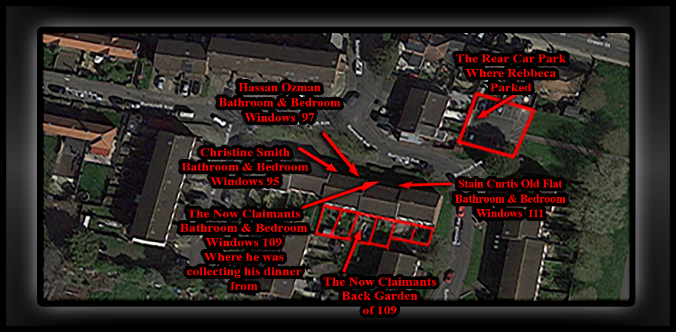

🔹 Exhibit: Christine Smith (Flat 95) – Strategic Surveillance, False Allegations, and Coordinated Access
- Christine Smith, occupant of Flat 95, has played a deliberate and sustained role in the harassment campaign against me.
- Her flat’s bathroom and bedroom windows directly overlook the front entrance of my property, giving her a clear and uninterrupted line-of-sight into my daily movements. While such visibility is not inherently illegal, it was exploited as a tactical vantage point—used to monitor, provoke, and ultimately fabricate criminal allegations against me.
- In addition to this visual access, Christine’s back garden and front room provide indirect physical access to my garden, separated only by Ozzie’s garden, which served as a narrow buffer. This layout was strategically manipulated. Christine, in coordination with Stain Curtis and Carron Duno, allowed Carron to use two light-skinned children placed under her welfare—children who were not biologically hers, but had been left in her care following the death of their mother, who had been in a relationship with Carron’s male associate.
- Christine Smith then falsely alleged that I had entered my garden and threatened the children, despite the fact that I had not stepped into the garden at all. The police arrived, refused to disclose the identities of the alleged victims, and proceeded to section me under false pretenses. I was later released on bail and able to prove the truth, leading to the charges being dropped in court.
- This incident was not a misunderstanding, it was a coordinated setup, designed to:
- Weaponize Christine’s line-of-sight and garden access.
- Fabricate a criminal narrative to justify police intervention.
- Shield Stain Curtis from exposure for his illegal tapping and harassment, particularly the kitchen wall tapping now replicated by Rebbeca O’Hare and others.
- Reinforce a council-backed campaign of obstruction and psychological destabilization.
- Christine Smith’s involvement must be formally addressed in court as part of the systemic abuse of process, the normalization of surveillance-based harassment, and the denial of my right to a safe and fair living environment.

🔹 Exhibit Hassan Ozman: (Flat 97)
- Hassan Ozman has been involved in coordinated harassment alongside other neighbours. His bedroom and bathroom windows face key communal areas and my flat, enabling him to observe and falsely report my movements or the tenants he sublets the bedroom to. His actions have supported the council’s fabricated narrative and helped sustain the campaign of abuse against me and all while he and his tenants use drill and other objects to bang on my bedroom and front room walls or just simply tap with there fingers.

🔹 Exhibit the Now Claimants: (Flat 109)
- This is my residence. The image marks my bathroom and bedroom windows, as well as the back garden. It also shows where I was collecting my dinner during the incident. This location is central to disproving Rebecca O’Hare’s timeline and supports my documented movements and innocence.

🔹 Exhibit Stain Curtis: (Flat 111, Old Occupant)
- Previously occupied by Stain Curtis, this flat has historical relevance to the decline in community safety, as well as my wellbeing and expectancy of life. It was part of the block where harassment escalated, and its occupants contributed to the toxic environment that the council failed to address.

🔹 Exhibit Rear Car Park: (Where Rebecca O’Hare Parked)
- This is the exact location where Rebecca O’Hare parked on 02/08/2025. The image disproves her claim of entry and interaction, with myself, while showing were she states she remained in the car park while I was outside resolving a delivery issue. Her timeline is physically impossible based on this layout as demonstrated even more so, below!

🔹 Exhibit BB5 – 3: (Front Layout of Burncroft Avenue)
- This image shows the front layout of Burncroft Avenue. It establishes the physical structure of the block, entrance points, and flat positions. It is essential for understanding movement patterns and disproving claims made by neighbours and council officers.

🔹 Exhibit John Irving’s Flat: (117)
- Flat 117 is sublet by John Irving to Enfield Council and Co, who have placed individuals there that have attacked and harassed me. The flat was deliberately left in poor condition, with damaged floors used to provoke and monitor me as I have Exhibited as Mp4 and Jpgs as well as in written statements. Despite reports, the council enabled this abuse, making it part of their coordinated campaign.

 | - Accused as liable  - Doctors!  - Enfield Council!  - Met Police Force!  - The listed occupants apart from 119  - The reason that we have adduced this exhibit into these proceedings is as listed below! |  | Evidence: Exhibit BB4 /  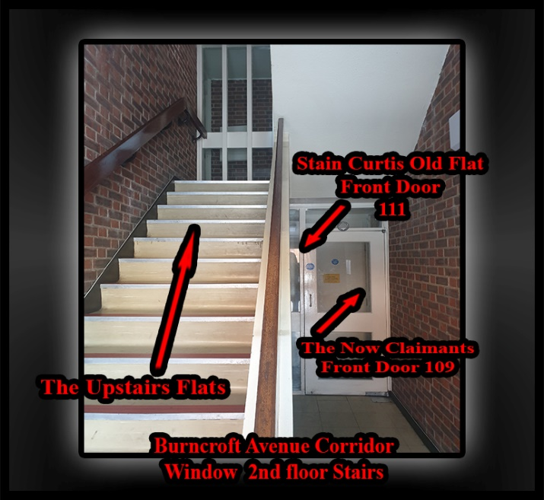

🔹 Exhibit Burncroft Avenue Corridor – 2nd Floor Stairs:
- This image shows the internal corridor layout of Burncroft Avenue, specifically the second-floor stairs. It marks the front doors of Flat 109 (my residence) and Flat 111 (formerly occupied by Stain Curtis), as well as the communal staircase leading to the upper flats. This layout is critical for disproving claims made by neighbours and council officers about my movements and visibility. It shows the physical separation between flats and the sightlines available, directly undermining fabricated allegations about corridor encounters and disturbances.

 | - Accused as liable  - Doctors!  - Enfield Council!  - Met Police Force!  - The listed occupants apart from 119  - The reason that we have adduced this exhibit into these proceedings is as listed below! |  | Evidence: Exhibit BB5/  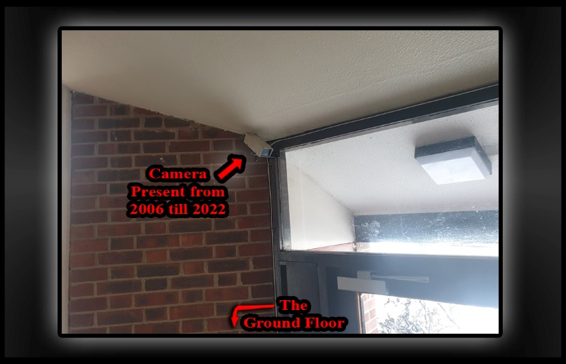

🔹 Exhibit Surveillance Camera Above Communal Entrance

- Location: Ground Floor Entrance, Burncroft Avenue
- Label: “Camera Present from 2006 till 2025”
- Subject: Long-Term Presence of Resident-Installed Surveillance and Selective Enforcement.

📍 Summary:
- This exhibit shows a surveillance camera mounted above the communal entrance of Burncroft Avenue, labelled as present continuously from 2006 through 2025. The camera was installed by a resident, not the council, and has remained in place throughout this period.
- In contrast, my prior personal safety camera, installed outside my flat’s front door for protection and to document harassment, was forcibly disabled by police on 14 August 2016. Later that year, Council Officer Sarah Fletcher issued a formal notice demanding its removal by 25 November 2016, with threats of financial penalty, despite no damage being caused or regulation or laws being broken.

🚨 Key Context and Implications:
- The resident-installed communal camera remained untouched, while my safety camera was singled out and removed.
- This selective suppression stripped me of the critical ability to gather real-time evidence, which would have undermined the false council and mental health records being constructed against me.
- Those false records never diagnosed as genuine or leading to a conviction were illegally used to justify unlawful orders and legal harassment, manipulated and deliberately fabricated by police and council alongside with true offenders.
- Had my safety camera not been taken down, Rebecca O’Hare would have lacked the means to orchestrate her setup against me with such impunity.
- The council and associated officials’ failure to protect my right to record enabled a coordinated campaign of harassment and defamation.

⚖️ Legal and Evidentiary Importance:
- Demonstrates deliberate suppression of tenant safety and evidence-gathering tools while allowing other surveillance to remain.
- Establishes a direct link between the removal of my camera and the fabrication of false legal and medical histories.
- Supports claims of discriminatory enforcement and collusion between council, police, and certain neighbours.
- Highlights how these actions facilitated Rebecca O’Hare’s ongoing ability to harass and set me up without accountability.

🧾 Outcome:
- My camera was disabled and removed starting 14th August–November 2016, leaving me vulnerable and unable to prove my innocence.
- The resident-installed communal camera remained operational through 2025, underscoring the unequal application of surveillance policies.
- This exhibit is central to exposing the systematic denial of my rights and the unlawful campaign against me.

 | - Accused as liable  - Doctors!  - Enfield Council!  - Met Police Force!  - The listed occupants apart from 119  - The reason that we have adduced this exhibit into these proceedings is as listed below! |  | Evidence: Exhibit BB6 /  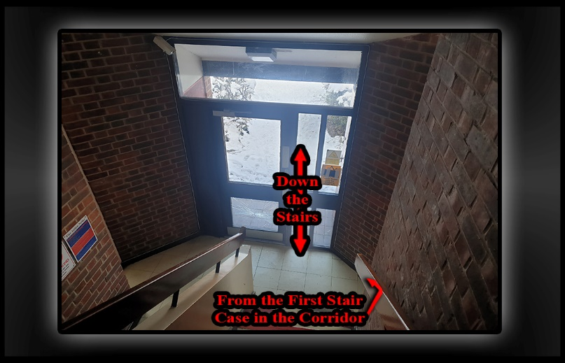

🔹 Forensic Breakdown, Why Rebecca O’Hare’s Stairwell Account Is Implausible

- Rebecca claims she went back downstairs to retrieve a nappy bag, implying a hurried return to the ground floor. However, given the close proximity of the stairwell to the front door, logic dictates that she would have simply exited directly and not paused or lingered in the corridor unless she had a reason to stop.
- If my back was turned at the time, I would not have seen her descending. But as she exited her flat, she would have immediately realised I was already in the corridor and at the front door, based on the timing of my movements. The layout makes this unavoidable.
- Had I heard her footsteps or movement on the stairs, I would have naturally turned around and spotted her. The stairwell is open, with clear sightlines over the banister. Any person descending would be visible, and any person already in the corridor would instinctively look up or toward the sound.
- For her version to be true, she must have deliberately stopped at the bottom of the stairs, rather than making a direct exit. Her statement does not acknowledge this pause or explain why she would linger, especially if she felt threatened or was in a hurry. This omission is critical.
- Moreover:
- She could have seen me from halfway down the stairs or spoken to me over the banister.
- Her failure to mention this natural visibility suggests intentional narrative shaping, not a spontaneous or truthful account.
- Her timeline requires me to be both unaware and present yet not engaged, a contradiction given the confined space and human instinct to respond to nearby movement.

⚖️ Conclusion:
- Rebecca’s account is logically and physically implausible. It relies on a compressed and contradictory timeline, ignores natural human behaviour, and fails to account for the spatial realities of the stairwell. Her version of events is constructed to support a false allegation, not to reflect what actually occurred.

 | - Accused as liable  - Doctors!  - Enfield Council!  - Met Police Force!  - The listed occupants apart from 119  - The reason that we have adduced this exhibit into these proceedings is as listed below! |  | Evidence: Exhibit BB5 – 2 /  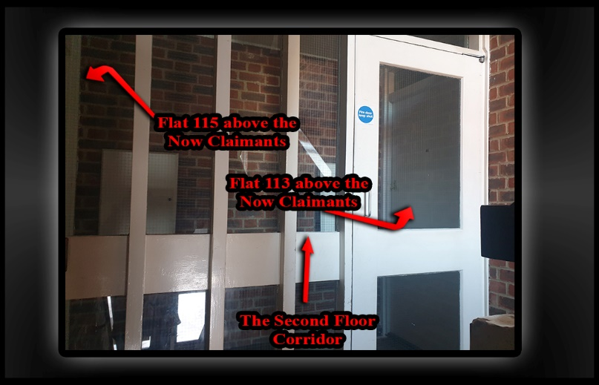

🔹 Forensic Rebuttal: Corridor Layout and False Allegation by Rebecca O’Hare

- Location: Second Floor Corridor, Burncroft Avenue
- Flats Involved: 113 (Richard Edward Skinner), 115 (Rebecca O’Hare)
- Date of Statement: 02 August 2025
- Subject: Misrepresentation of Door Interaction, Builder Engagement, and Threat Claims

📍 Spatial Reality:
- The second-floor corridor is extremely narrow, with only a few feet between each door.
- Richard’s door (Flat 113) is closest to the stairwell entrance and is the first door you reach.
- Rebecca’s door (Flat 115) is directly behind where I stood. Simply turning around places me face-to-face with her door, if it were present!
- Therefore, any interaction that occurred was incidental and proximity-based, not targeted or intentional.

🚨 Logical Breakdown:
- Rebecca admits I knocked at Richard’s door, not hers. That confirms my intent and direction.
- For her to engage with me, she had to come to her flat door voluntarily—I did not knock or call for her.
- The builder present at her door spoke to me first. Rebecca had no authority to decide whether he should speak to me.
- Her claim that I approached her is disproven by her own admission and the corridor’s layout.
- The interaction only occurred because she inserted herself into the situation, not because I sought her out.
- In contrast, Rebecca O’Hare resides in Flat 115, which is positioned above my hallway but to the side of my hallway and kitchen. Our bedrooms have an open gap between them consisting of the hallway and stairs, meaning that her bedroom is adjacent but not directly above mine and to the side of mine.
- Rebecca has used this positioning to cause targeted disruption in the following ways:
- From her hallway, she squawks and creaks the floorboards, using these sounds to make me unwell by monitoring movement and creating tension through her presence, while deliberately attacking me with pre-meditated intent.
- From her kitchen, she has repeatedly banged on floors and walls, sending vibrations directly into my kitchen and front room, and into my body and ears and this effects where I cook, work, and rest.

⚖️ Evidentiary Significance:
- Her statement contains another clear contradiction: acknowledging I knocked at Richard’s door, then claiming I was “banging on her door,” which was removed by the contractor, as she herself states.
- The tight layout of the corridor makes it impossible to be near one door without being near the other, but my proximity was not intended.
- Her version of events is structurally and spatially implausible and designed to support another false allegation.
- The video she submitted does not contain the threats she claims to have and disprove her serious accusations.

🧾 Conclusion:
- Rebecca’s claim that I approached her or threatened her is factually incorrect and contradicted by her own words, the corridor layout, and her video evidence. I knocked at Richard’s door in response to harassment. She chose to engage, and the builder-initiated contact. The layout of the corridor means any interaction was incidental. Her narrative is not supported by the physical environment, the timeline, of her events or in collaboration with the factual evidence and must be treated as a fabricated account designed to criminalize proximity and silence my self-defence.

 | - Accused as liable  - Doctors!  - Enfield Council!  - Met Police Force!  - The listed occupants apart from 119  - The reason that we have adduced this exhibit into these proceedings is as listed below! |  | Evidence: Exhibit BB5 – 2 /  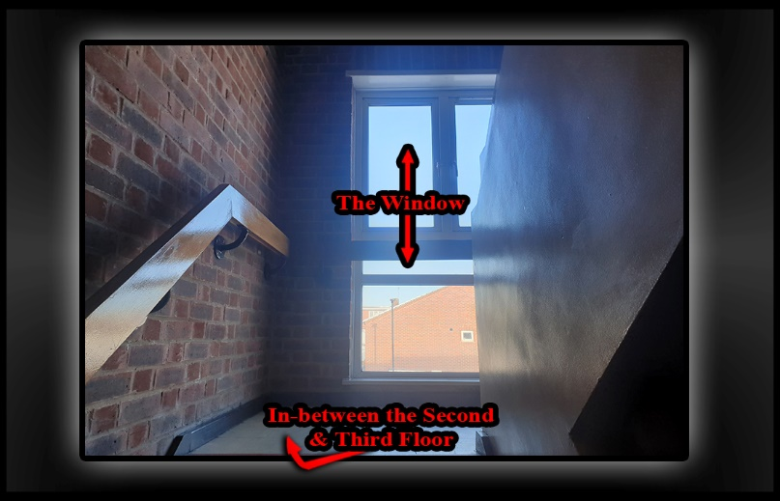

🔹 Stairwell Access and Observation Point

- The stairwell between the second and third floors provides easy and direct access to the last two flats in the block. Its location and design make it a convenient route for residents moving between floors without having to use the main corridor extensively.
- Additionally, this stairwell area serves as a natural observation point, which Rebecca could use to monitor activity at the building’s front entrance, much like how her bathroom and bedroom windows offer views to keep an eye on the surroundings.
- This positioning allows for discreet observation and could contribute to her awareness of who is coming and going, reinforcing her ability to watch the communal spaces without needing to be at the front door constantly.

 | - Accused as liable  - Doctors!  - Enfield Council!  - Met Police Force!  - The listed occupants apart from 119  - The reason that we have adduced this exhibit into these proceedings is as listed below! |  | Evidence: Exhibit BB5 – 2 /  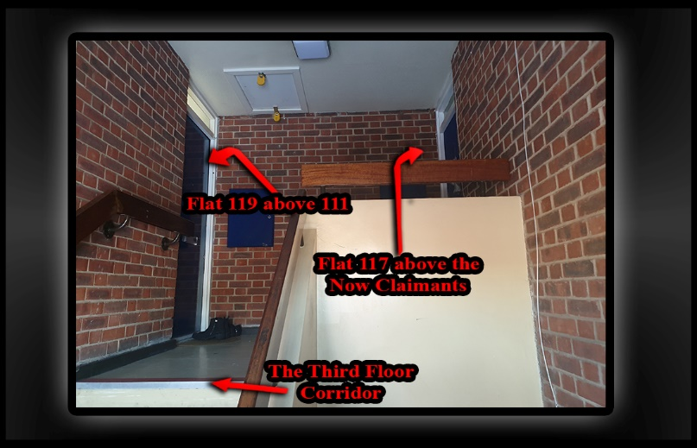

🔹 Statement: Comparative Impact of Flats 117 and 119 on My Home

- Location: Burncroft Avenue.
- Flats Involved:
- Flat 117 (Mathiylagans) – Full-room impact.
- Flat 119 – No involvement

- The harassment I’ve faced began with the occupants of Flat 117, the Mathiylagans family, as documented in my “2014 and Onwards” file starting at Section 2014. Due to the structural layout of the building, Flat 117 sits directly above my flat but with 115 in between allowing them to affect every room in my home and bedroom, kitchen, hallway, bathroom, and front room and all through deliberate noise, floor banging, and coordinated disruptions. This was a 24-hour 7 days a week attack against me a human being and British citizen.

⚖️ Evidentiary Importance:
- Establishes the full-spectrum harassment from Flat 117, beginning years prior and affecting all rooms.
- Clarifies that Rebecca’s influence is spatially limited but strategically disruptive, focused on the most sensitive areas of my home.
- Supports the claim that the flat of 117 occupants flat has contributed to a sustained campaign of psychological pressure, exploiting their spatial advantage with other neighbours such as Rebbeca O’Hare!

INFO | Statement Exhibit BB0 – 1 /
 | - Accused as liable  - Doctors!  - Enfield Council!  - Met Police Force!  - The listed occupants apart from 119  - The reason that we have adduced this exhibit into these proceedings is as listed below! |  | Evidence: Exhibit BB5 – 1 /  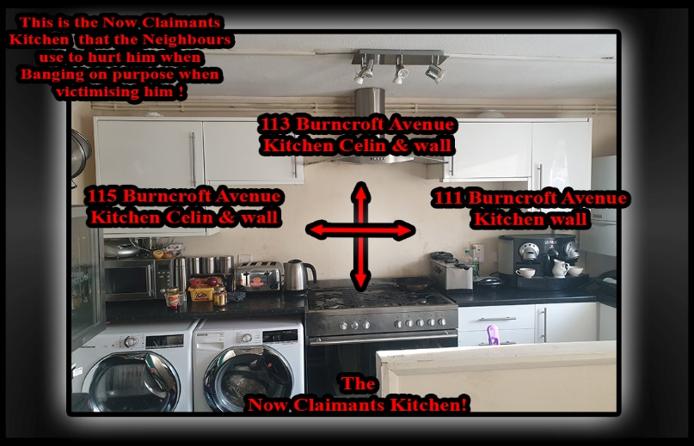

Picture-111-115-117-Attack-Point – Coordinated Harassment via Kitchen Adjacency and Weaponized Flooring
This image shows the reality of my living conditions and the coordinated harassment I continue to endure. My kitchen—labelled as “The Now Claimant’s Kitchen”—is surrounded by Flats 111, 113, 115, and 117. These aren’t just neighboring units. They are tactical positions used to target me.
Flat 111, previously occupied by Stain Curtis, was the origin point of the harassment. He lived on the ground floor, on the same block, next side to me. He initiated the wall tapping—especially through the kitchen wall—timed to provoke and destabilize me. His tactics were deliberate, rhythmic, and psychologically invasive.
Directly above him in Flat 115, Rebbeca O’Hare moved in and continued the harassment seamlessly. She didn’t just replicate Stain’s tactics—she escalated them. Her flat gives her access to both the vertical floors and shared walls, which she uses to mirror the tapping, stomping, and baiting techniques. She lives in the same block next side to me, and her actions are rehearsed and deliberate. She operates as if inheriting a role, using the same timings, same pressure points, and same psychological triggers.
Flat 119, which sits above both 111 and 115, has not been involved.
On my side of the block, the harassment is just as coordinated. Flat 113, currently occupied by Richard Edward Skinner, continues to use the floors to attack me. His flat was previously occupied by Ambrose Atoro, and after Ambrose moved out, the council attempted a superficial fix to the flooring. I was present when the work was carried out. They sprayed foam under the main beams on one side of the room—not a proper structural repair, but a cosmetic patch job.
Richard has deliberately re-damaged the temporary fix. He replicates the tactics of previous occupants, using the same beam-based mechanics to generate impact. By standing on one end of the long beam near his front door, he lifts the entire floor section—then drops it with force, creating targeted bangs directly above my kitchen. He does this in every room, not just the kitchen. The attacks extend above my bedroom and toilet, areas I’ve been unable to safely access since 2014 and even before. If I enter those rooms, I am visibly attacked—the harassment intensifies, and the banging becomes violent and targeted.
Above 113 is Flat 117, originally occupied by Mathiylagans and Co. “Co” refers to a cousin named Kanthren, who was hiding inside the front room. He pretended to live in Flat 119 but was actually operating from 117, where he initiated the early tapping attacks. Mathiylagans allowed and supported him, giving him cover and access. When the tapping began above my head while I was working, I went directly to Mathiylagans to ask who was responsible. They blamed Debra Andrews—a deflection I didn’t understand at the time, because I didn’t yet know about Kanthren’s presence.
I then knocked at Debra’s flat to ask her directly. She blamed Mathiylagans in return. No one took responsibility. No one stopped. The harassment escalated. At that time, Stain Curtis was in a relationship with Debra, and together they joined the pattern—using their positions to contribute to the noise setups and psychological pressure.
This isn’t incidental. It’s structured. Each flat plays a role. The floors have been altered, the walls exploited, and the council continues to allow it. My kitchen, my workspace, my home—turned into a battleground by design.
The harassment is rotational, coordinated, and council enabled. And I continue to document every moment of it.

Outside Exhibit of road coming in and car park Rebecca O’Hare drove into on the 06-10-2025

This video was created by a friend as a favour for everyone as I cannot go to my housing estate and make it myself due to wrongly imposed GPS Tag bail conditions! | 06-10-2025: server2.pointto.us/Durants/VID-20251004-WA0000.mp4

COPY OF REBECCA STATEMENT:

WITNESS STATEMENT
Criminal Procedure Rules, r 27. 2; Criminal Justice Act 1967, s. 9; Magistrates' Courts Act 1980, s.5B
URN
Statement of: Rebecca O' hare
Age if under 18: Over (if over 18 inserts ‘over 18) Occupation:
This statement (consisting of page(s) each signed by me) is true to the best of my knowledge and belief and I make it knowing that, if it is tendered in evidence, I shall be liable to prosecution if I have wilfully stated in it anything which I know to be false, or do not believe to be true.
Witness Signature: Date: 02/08/2025

This statement relates to my neighbour at 109 Burncroft avenue, EN3 7JQ I am the above named individual and reside at location known to police.
The incident I am about to describe occurred on Burncroft avenue, the address is a block of flats and there are 6 flats within the block and 2 flats per floor.
In January my neighbour Simon (109) was banging on my door shouting that I was making noise, I'll punch you up, I'll slap you up and your daughter. He also said he would do the same thing to my children's dad. I took a video of this and sent this to the police.
In January I was getting a new door fitted, I've taken my daughter to school. I've come home; the door was taken off the hinges by the contractor. Simon has come upstairs and i was in the living room and I could hear him, Simon was asking the contractor if the guy that lives opposite from me (113) was home. I've gone to the door, and he has started to accuse me of banging on the floor and keeping him awake at night. I've explained that I don't live above him then he has then shouting saying that he would hit me, hit my eldest daughter and drag my unborn baby out my stomach. I kept telling him to move from the door, he then went to say he's got videos of me on a website about being corrupt. As I've called the police on that occasion, he has said call the fucking police I don't care.
On Saturday 2nd August 2025 I was driving into the estate where my block of flats is, as I'm driving in,
I have seen my neighbour who I only know as Simon, he resides at 109 Burncroft avenue. Whenever I come into the estate the first place, I look is the bottom of my block, to see if he is outside. If he is I know that he would try and intimidate me, shout at me or something is going to happen.
As I have driven in and drove around the bend, I could see him from the side staring at my car. I've driven into the small car park on the left and parked my car. I've got out my car to see if he was still there or not, once I've seen he is not there I've walked my two kids upstairs. I've had to go back downstairs to grab my children's nappy bag I told my eldest daughter if the baby wakes up to call my phone. I've locked the door and taken the key with me as I'm walking down the stairs I hear another door, Simon has got to the bottom of the stairs before me, he was saying stuff but facing away from

Witness Signature:
Signature Witnessed by Signature:
Page 1 of 2
Page 1 of 2

Continuation of Statement of:
me. So, I wasn't paying any attention, and he has turned around and been like 'you hear me', not in response to him I was like what? And then he has said 'I will blow up your car; I will blow it to the other side of the street.' Then he was like if you come and ask me, I will tell you I didn't do it.
I've closed the communal door to put space between us, I've walked towards my car to get the nappy bag he has opened the door and was shouting stuff at me as I'm walking towards my car, I wasn't paying attention to what he was shouting at me I was trying to get to my car as quick as possible. I've got to my car and got what I needed and looked if he was still by the door, he wasn't by the door, so I've started walking back home, once I got into my flat. I called the police.
Because of his behaviour I am worried to leave the house with my children. I have been getting other people to drop things off for me. I try my best to stay as far away from him as possible but every time I see him, I know that something would happen, there has been incidents when I am at the shop, he would stare at me but would not say anything, trying to intimidate me. I feel unsafe in my own home and fear for me and my children because of his threats, every time I make a complaint a feel that it is put down to his mental health. I am concerned that only if he touches me or my children that something would be done.
Witness Signature:
Signature Witnessed by Signature:
Page 2 of 2

🧠 FORENSIC BREAKDOWN: WHY REBECCA’S TIMELINE IS IMPOSSIBLE
🕰️
MY SEQUENCE OF EVENTS
(STEP-BY-STEP)

Initial Exit for Delivery
  - You exited your home to meet the delivery driver.
  - You handed him a number (e.g., 45 or 20) and began walking back toward your front door.
Realization and Immediate Return
  - Before reaching your front door, you realized your bag was short.
  - You hurried back to the driver before he drove away.
Driver’s Delay
  - The driver got out of his vehicle again.
  - He attempted to phone his boss but couldn’t get through.
  - This added several minutes to the interaction, I would say about 10 minutes.
Witnesses Present
  - During this time, your next-door neighbours was outside and witnessed the exchange.
  - You were visible and engaged in conversation, your location and activity were public and legal.
Rebecca’s Claimed Entry
  - She claims she drove into the rear car park and brought her children upstairs.
  - I see her drive past me and into the car park while I was still outside, I remember this because I have never seen her driving a car before.
  - Therefore, she had not yet entered the block or brought the children up at this point of time.
I Continued My Presence in an Orderly Manner Outside!
  - As I remained outside for approximately 10 minutes resolving the delivery issue.
  - Rebecca must have remained hidden in the car park during this time; there’s no evidence she entered the building.
Second Delivery Agreement
  - I and the driver agreed he would return with the rest of the food, as the “Just Eat Exhibits Prove Below!”
  - I then returned inside to eat the partial delivery (chicken korma).
  - I only left the flat once again to collect the second half of the delivered food as the Exhibited telephone log demonstrates at
🔍 Logical Contradiction in Rebecca’s Statement

- She claims she brought the children upstairs and “Later Came Down to Retrieve Nappies.”
- She also claims she saw my “Back” in the corridor as she descended.
- But based upon my true & logical timeline:
- I was outside during her arrival.
- I only returned inside after the delivery issue was resolved and not at any time when she would not have had the children with her like she states in her official MG11 statemen or I would have seen her.
- It is obvious that I had no reason to re-enter the corridor once I was back inside my home because I had no one else to meet, and I don’t walk backwards. I was waiting for the second part of my delivery, and during that time, I was logically eating the first portion, the one I had already waited for and paid for. Had I not done so, it would have gone cold and spoiled. There was no justification for me to leave my home again, and any suggestion otherwise ignores both common sense and the documented sequence of events.
- For her to have been able to see me in the corridor, she would’ve had to descend at a time when I was no longer there.
- Unless she waited upstairs for 30–45 minutes before realising the nappies were missing “Which She Does Not Claim,” her version is “Impossible,” as it is not Chronological.

⚖️ Conclusion: Her Account Is Logically and Physically Implausible
Rebecca’s statement relies on a compressed and contradictory timeline. My actions were visible, witnessed, and consistent, by other persons versions of events and this is why the police refused to take their statements at the alleged scene and all of whom all contend against her illogical version of events and are attending court to give oral evidence.

Her version requires:
- Me to be in two places at once.
- For her too have entered the block while I was still outside (she admits didn’t) happen.
- A spontaneous corridor encounter that “Couldn’t” have occurred based on my actual movements, now explained as I was not fairly interviewed for this nor arrested for the charge brought before the court: Threats to Cause Criminal Damage 1971 and neither did I commit such crimes.
These factual observations undermine the credibility of her account and supports my assertion that her version of events is not just flawed, it’s structurally impossible.

🔍
GENERAL OBSERVATIONS

- Unsigned Statement: Rebbeca O’Hare.
- The MG11C form explicitly states “Witness Signature: ---” with no signature present. This renders the statement inadmissible unless verified in court.
- You are entitled to ask: “Who signed this statement, and when?”
- If unsigned, it fails the basic threshold under the Criminal Justice Act 1967 and Magistrates’ Courts Act 1980.

📂 January Incident and August: Alleged Threats and Video Evidence

- No video disclosed of alleged offences: Despite claiming to have sent video evidence to police, no footage has been disclosed under CPIA. →that challenges the charge of Threats to cause criminal damage on the 02/08/2025 that allows me and me legal defence team to Challenge:
- “Where is the video for this charge as its wrongly dated January and has nothing to do with threats to blow up a car, that are disputed.
- Has it been reviewed, timestamped, and verified by an officer?”
- Why has this wrong exhibit been disclosed and where is the real exhibit?
- Language used: Highly emotive and inflammatory but lacks corroboration to alleged victims statements.
- Also, there is no BWV, no third-party witness.

Door Fitting and Accusation
- Timeline ambiguity: She claims the door was off its hinges and she was inside, yet approached Simon un scared when she knew he was knocking on here next-door neighbours front door, why does she pretend in her statement that she acts otherwise?

- Simon and the contractor both spoke to each other, but she did not hear this!
- No contractor statement: The contractor is a key witness yet not cited or referenced, as he will prove Mr. Simon Cordell’s True Version of events.

- And then to her other → Contradictions:

Location Contradiction
- She states: “I don’t live above him.”

Website and Police Call
- Website reference: She claims you said she’s on a corruption website. That’s verifiable.
- Police call: No CAD number or officer response cited. Again, no disclosure.

📂 August 2nd Incident
Rebbeca O’Hare, Driving into the estate
- Pre-emptive fear: She admits she always checks if Mr Simon Paul Cordell is outside, but this really just shows bias and expectation and not an actual threat.
- Staring at car: Not illegal. No verbal exchange yet she unfairly claims intimidation.

Parking and Entry
- No interaction: She confirms I Wasn’t present when she parked and walked upstairs. No threat occurred.

Alleged Threat to Blow Up Car
- Is Something that never really happened, to Rebbeca O’Hare as it’s a cover up for what she has really done to Mr. Simon P. Cordell.
- No witnesses: She claims I made a serious threat while facing away from her. → Challenge: “How did she hear and interpret the words if she wasn’t paying attention?”
- No forensic follow-up: No CAD, no forensic sweep, no corroboration.

Shouting from communal door
- She admits: “I wasn’t paying attention to what he was shouting.” → Contradiction: If she didn’t hear the words, how can she claim threat or intent?

Fear and Mental Health Allegation
- Subjective fear: Her fear is real to her, but legally it must be based on an objective threat.
- Mental health claim: She alleges her complaints are dismissed due to mental health. That’s discriminatory and irrelevant unless medically substantiated and it cannot be.

⚖️ Legal Leverage Points
- Unsigned statement: Procedurally invalid unless signed and verified.
- No disclosed evidence: No video, BWV, No Video Exhibited of Rebbeca O;Hare demonstrating any of her claim’s, no contractor statement, No CAD logs, or any third-party corroboration, backing her alleged allegations.
- Contradictions: Timeline, location, and attention inconsistencies.
- Bias and expectation: Her own words show she anticipates conflict, not that it occurs.
- Discriminatory framing: Mental health references are prejudicial and unsupported.

📍EXHIBIT: TIME LOG – Arresting Police Officer

Subject: Officer’s Arrest Timeline & Evident Procedural Inaccuracies!
- This exhibit documents the arresting officer’s timeline and highlights clear contradictions, timestamp anomalies, and procedural breaches. It forms part of the master chronology and supports the rebuttal against fabricated or misrepresented arrest details.

🔹 Quoted Statement:
1. Statement of: PC George WILSON-WALLIS
2. Date: 02/08/2025
3. Context: Witnessing officer statement regarding the arrest performed by Police officer 1543NA
4. Narrative:
“Mobile patrol NA22L called for a van to facilitate the transport of an individual I would later find out to be called “Samual” to “Custody For The Offence Of Harassment.”
5. Timestamped Action:
“Whilst this was going on at “21:16 PC 1543NA began arresting Samual” for the offence of harassment through the door!”

❌ Forensic Corrections to PC Wilson-Wallis Statement:
- Misidentification:
The individual arrested was “Simon Cordell,” not “Samual.” This error undermines identification procedures and evidentiary integrity. PACE Code D refers to the Police and Criminal Evidence Act 1984 – “Code of Practice D, governs” how police officers in England and Wales conduct identification procedures. It’s all about ensuring that suspects are identified fairly, accurately, and lawfully, especially when eyewitnesses are involved and this PACE Code D is in breach, as .Mr. Simon Paul Cordell is not Samual.

- Statutory Breach:
- PACE Code D: Governs identification procedures. Misnaming violates fair identification standards.
- Data Protection Act 2018: Contains incorrect personal data handling breaches lawful processing obligations.

- Procedural Failure:
- Invalidates the MG11 as a reliable witness statement.
- Undermines chain of custody and suspect tracking.

- Consequences:
- Grounds for exclusion of the statement under Section 78 of PACE.
- Potential for case dismissal due to evidentiary contamination.

- False Attribution:
PC Wilson-Wallis claims the arrest was performed by PC 1543NA (Obsiye), but he was “Not Present” during the victim’s statement upstairs and did “Not Witness” the full engagement sequence.

- Arrival Timing:
He arrived “After” PC Chan and PC Obsiye had already engaged with the alleged victim and after they had both gone downstairs. His statement omits this and falsely implies full-scene awareness.

- Limited Scope:
His account references “Only Harassment,” omitting the broader allegations of: “Threats To Cause Criminal Damage 1971 Which Mandate Arrest And Charge, That Has Never Happened.”

- PC George WILSON-WALLIS states on the 02nd of August 2025 myself and PC WILLIAMS and not on the 01st of August 2025 as the arresting officer and statement taker of Rebbeca O’Hare, states.

- Pc George Wilson Wallis: states the time of him witnessing the arrest outside of the door was at: 21 :16Pm

- Pc George Wilson Wallis: Also, states that they managed to open the door at: 21 :17.

📍

ADDITIONAL OFFICER STATEMENTS

TIMELINE & CONTRADICTIONS

🔹 PC “Obsiye 1543NA” — Statement Date: 01/08/2025

Extract from statement:
- We asked to enter, and we spoke with her in the living room.
- She stated that she has been having issues with her neighbour, and it’s been ongoing for a while. She quickly grabbed her children and ran into the address. She remembered she left her nappy bag so went to go get it. That’s when the suspect caught her near the door and began saying something she did not know what he was saying at first so made a comment to herself that’s when the suspect said,
- She also stated there was another incident earlier in the year, when she did not have a front door and was getting it replaced.
- I explained to PC Chan 1405NA that the suspect who lived downstairs 109 would be arrested for harassment.
- I explained that he was arrested for harassment as today he went up to the victim and threatened to blow up her car and that no one would know it was him, also previously you had turned up to her house and threatened to slap her. You have been causing her distress.
- My BWV was on at the time and is exhibited as HAO/01

❌ Impossible Date:
- The incident occurred on 02/08/2025, yet Obsiye’s statement is dated 01/08/2025, a full day earlier.
- He repeats the “Incorrect Date Twice,” including the weekday (“Friday”), indicating “Deliberate Backdating,” not clerical error.

❌ Impossible Time:
- Statement claims duty between 0700 and 1600, yet the arrest occurred at 21:16.
- This discrepancy invalidates the statement’s temporal integrity.

Key Contradictions:
- Obsiye claims to have received the full victim statement, yet “PC Chan confirms” Obsiye was the only one speaking to her, while this was taken and the arrest of harassment was decided, alone.

- On Friday 1st August 2025 between the hours of 0700 and 1600 I was on duty in full uniform carrying full PPE kit and BWV. This day is incorrect, and nobody worn footage has been disclosed as watchable.

- Evidence Gap: No BWV footage has been disclosed showing this interaction in the living room.

- Discredited Motive: Her statements have been reused from prior NFA cases, which were already dismissed as displayed in the CPS files.

🔹 PC Chan — Statement Date: 02/08/2025 at 1300 hours

📍EXHIBIT: PC_CHAN_PDF.PDF — Statement Analysis and Evidentiary Breakdown
- Statement of: Calvin Chan

🔹 Quoted Statement:
- On Saturday 2nd August 2025 I was on duty in uniform
- On arrival PC Obsiye spoke with Rebecca O’Hare,
- I was trying to distract the daughter from listening to Rebecca explaining the allegation to PC Obsiye.
- she described him as wearing a blue checkered pyjama.
- We went downstairs to knock on the door
- I exhibit my BWV as CKC/01, “Exhibit Does not work as cant view video footage as intended.”

❌ Impossible Time:
- Arrest occurred at 21:16, yet Chan’s statement is timestamped 1300 hours, 8 hours earlier.
- He was present during the arrest but did not receive the victim’s statement as he states that he was distracting Rebbeca O’Hare’s child while Obsiye spoke with her.

Key Contradictions:
- Chan references the suspect’s name as “Simon,” contradicting Wilson-Wallis’s “Samual.”
- He confirms that “Obsiye Performed The Arrest,” not himself.
- His BWV (CKC/01) must be reviewed for timestamp accuracy and officer presence.

🔍 Contradiction Analysis Table:
Element | Quoted Statement | Implication
Date/Time | “Time: 1300 hours” | ❌ Impossible — Arrest occurred at 21:16, per PC George Wilson-Wallis. Chan’s timeline is chronologically incoherent.
Uniformed Duty | “I was on duty in uniform” | Confirms presence but does not reconcile with the arrest timeline.
Allegation Discussion | “She was explaining the allegation to PC Obsiye” | Chan was not the recipient of the allegation. His account is second-hand.
Suspect Description | “She described him as wearing a blue checkered pyjama” | Description was relayed to Obsiye, not Chan. Chan’s reference is indirect.
Door Knock | “We went downstairs to knock on the door” | Implies first contact but timestamp makes this impossible unless arrest occurred earlier.
BWV Exhibit | “I exhibit my BWV as CKC/01” | Must be scrutinized for timestamp accuracy. If it shows events near 21:00, Chan’s statement is misdated and is not viewable as we request it to be disclosed to us.

🧠 Forensic Narrative: Initial Police Attendance and Arrest Chronology
Date: 02/08/2025
Location: 109 Burncroft Avenue, Enfield
Timeframe: Leading to arrest at 21:16

🚨 Scene Attendance: Only Two Officers Present
- Officers’ Present:
  - PC Calvin Chan
  - PC Obsiye
These were the only two officers on scene. No van. No backup. No prior units.
- Arrival Context:
  - Both officers arrived together and proceeded downstairs to knock on the door.
  - This was the first point of contact.

🗣️ Victim Interaction: Exclusivity of Dialogue
- The alleged victim spoke only to PC Obsiye.
  - Chan was not actively involved.
  - He did not receive or record any direct allegation.
  - Any claim of independent verification by Chan is unsupported.

👕 Suspect Description: Source and Validity
- Description of blue checkered pyjamas was given verbally to PC Obsiye.
  - Chan’s reference is second-hand, and only independently observed as to this statement.

🎥 BWV Footage: CKC/01
- Chan exhibits CKC/01 as his BWV.
  - Must be reviewed for:
    - Timestamp integrity
    - Presence of other officers (none)
    - Sequence of engagement and arrest

🔒 Arrest Execution
- Arresting Officer: PC Obsiye
  - Sole officer who engaged the alleged victim.
  - Arrest performed through the door at 21:16, corroborated by PC George Wilson-Wallis.
  - Chan did not perform the arrest.

❌ Contradictions and Implications
- Chan’s timestamp of 1300 hours is factually impossible.
- His claim to have received the allegation or participated in the arrest is invalid.
- CKC/01 must be disclosed in full to expose:
  - Timestamp anomalies
  - Officer’s presence
  - Engagement sequence

📍EXHIBIT: TIME LOG OF POLICE OFFICER ABOUT ANOTHER POLICE OFFICER’S ARREST TIME
- Statement of: PC George WILSON-WALLIS
- Date: 02/08/2025
- Context: Witnessing officer statement regarding the arrest performed by officer 1543NA

Narrative:
- “Mobile patrol NA22L called for a van to facilitate the transport of an individual I would later find out to be called Samual to custody for the offence of harassment.”

Timestamped Action:
“Whilst this was going on at 21:16 PC 1543NA began arresting Samual for the offence of harassment through the door!”

🕰️ Evidentiary Implications of the Time Log:
- Exact Arrest Initiation Time:
Arrest began at 21:16, witnessed and recorded by PC George Wilson-Wallis.

- Third-Party Corroboration:
Independent verification of arrest time and method.

- Sequence of Events:
Van request occurred before arrest—suggesting premeditated logistics.

- Location and Method of Arrest:
“Through the door” implies no direct contact, “Raising Serious Questions About Lawful Entry And Suspect Awareness.”

- Potential Contradictions:
Any custody logs or statements suggesting a different arrest time (e.g., 21:30) are to be challenged using this timestamp.

⚠️ Misidentification Alert
- The individual referred to as “Samual” in Wilson-Wallis’s statement is not Simon.
  - This misnaming introduces a critical identity error.
  - If this name appears in custody logs, BWV audio, or witness statements, it may invalidate identification procedures and expose procedural negligence.

Master Rebuttal: PC Williams — Statement Date: 30/08/2022

❌ Impossible Year & Document Integrity:
- PC Williams’ statement is dated 30/08/2022, yet the incident occurred on 02/08/2025, a three-year discrepancy.

- This is not a clerical error, it reflects template reuse or misfiling, undermining the document’s admissibility and casting doubt on its authenticity.

🚨 Procedural Breaches & Contradictions:
- Caution Through Closed Door:
Williams confirms that PC Obsiye delivered the caution through the closed door prior to entry. This violates PACE Code C, which requires:
  - Lawful access
  - Visual identification
  - Clear comprehension and acknowledgment of the caution.

- Without direct contact, the Police Caution is “Legally Invalid.” This undermines the arrest’s enforceability and must be scrutinized in court.

- Chan’s Role Misrepresented:
Williams describes PC Chan (2464NA) as receiving the enforcer and breaching the door. However:
  - Wilson-Wallis attributes enforcer use to 2464NA, not Chan!

- Wilson-Wallis’s statement: “Once arriving at the scene, I brought PC 2464NA the enforcer to help break the door in whilst this was going on at 21 :16 PC.”
  - Chan’s own MG11 omits his badge number out!
  - Obsiye’s statement confirms Chan is 1405NA, not 2464NA, as Pc Wilson-Wallis attributes.

- This creates badge number ambiguity, and the obstructs from the prosecuting teams to disclose working copies of all attending police officers BWV Footage, raises serious questions about Police officer identity and accountability, as it seems to be hiding the truth about Official frauded documentation by the police officers involved.

🧠 Officer Index Confusion:
Officer Name | Badge Number | Role Claimed
PC George Wilson-Wallis | 1456NA | NA30L Operator
PC Reece Williams | 1675NA | NA30L Driver
PC Obsiye | 1543NA | Arresting Officer, Leg Restraint
PC Chan | 1405NA/2464NA | Enforcer, Taser, Entry
Unknown Officer | 2464NA | Enforcer User (if not Chan)
Unknown Officer | 2546NA | Leg Restraint (second set)
This table reveals two unnamed officers and badge number inconsistencies, suggesting either:
- “FABRICATED POLICE OFFICERS’ IDENTITIES” and / or.
- “DELIBERATE IDENTIFICATION OBFUSCATIONS.”

📟 Call Sign Confusion:
- NA22L: Chan and Obsiye’s unit
- NA30L: Williams and Wilson-Wallis’ van
- NA22N: Mentioned as the unit left with Simon but not listed in Police or CPS Disclosed files, such as CAD logs.
This mislabeling is being wrongly used to:
- Distance PC Calvin Chan from his Gross Misconduct and negligent act that led to Mr. Simon Paul Cordell medical injuries.
- Create confusion in the chain of custody, to wrongly waver legal responsibility away from NA22L: Chan and Obsiye’s police mobile unit and so that they can avoid accountability for post-arrest due care responsibilities.

⚖️ Legal Precedent: O’Hara v Chief Constable of the RUC (1997)
- The House of Lords ruled that an arrest is only lawful if the officer had reasonable grounds to suspect the specific offence at the time, “Not One Substituted Later.”

In this Case:
- Arrest was for harassment, as confirmed in multiple statements!
- Charge later reframed to Threats to Cause Criminal Damage!
- No new arrest, caution, or interview occurred!
- This violates PACE Code C and supports a challenge to the charge’s admissibility.

🔒 The Police and CPS, Trap for Defendants:
- In most cases, defendants cannot prove the arrest was for a different offence unless:
- The police admit it in their statements (As They Have Here).
- There’s clear documentation showing the original arrest basis (e.g., CAD logs, BWV footage, custody records).
- The defence team challenges the procedural timeline and demands disclosure.
- Without that admission, courts often assume the charge and arrest were aligned—even if they weren’t.

🗣️ Eyewitness & Medical Neglect:
- Upon exiting the building, I was told no ambulance would be dispatched, despite visible distress. It was only thanks to my neighbours, especially Saheed, who personally called emergency services, that an ambulance arrived. This occurred as I collapsed again outside, confirming the severity of my injuries.

🎥 BWV Reliability:
- Williams admits he did not review his BWV (RAW/01) prior to writing the statement. This weakens its reliability and opens it to challenge under evidentiary standards.

⚖️ Legal Significance of our findings!
These contradictions affect: All police officers’ statements in regards towards!
- Credibility of officer testimony.
- Chain of responsibility for use of force.
- Procedural accuracy in the arrest narrative.
- Misrepresentation of roles in official documentation.

- In the statement titled 05. PC Chan pdf, PC Chan is identified as Calvin Chan, but his badge number is not explicitly listed in the document.
Here’s what we can confirm:
- The statement header includes:
  - Name: Calvin Chan
  - Call sign: NA22L (shared with PC Obsiye)
  - Date of statement: 02/08/2025
  - Exhibit reference: CKC/01 (Chan’s BWV)
- However, unlike other officers (e.g., PC Williams 1675NA), Chan’s collar number or warrant ID is not included in the MG11 form or continuation pages.

- PC Chan’s badge number is 1405NA, as confirmed in both:
- Obsiye’s statement: “I was working alongside PC Chan 1405NA as NA22L”
- Chan’s own statement: While his MG11 doesn’t list the badge number directly, Obsiye’s cross-reference confirms it.
- This aligns Chan with the call sign NA22L, and his BWV is exhibited as CKC/01.

- In the statement titled 07. PC Williams pdf, PC Chan is explicitly identified with the badge number 2464NA.
- Here’s the relevant line from Williams’ account:
- “At approx. 2100hrs NA22L PC CHAN 2464NA and PC OBSIYE 1543NA called for a van…”
- This confirms Chan’s collar number as 2464NA, aligning him with call sign NA22L and the enforcer entry described in multiple statements.
- Would you like me to update your officer index or embed this into your contradiction map for BWV cross-referencing? It’s a key identifier for exhibit tagging.

- In the statement by PC George Wilson-Wallis, PC Chan is identified with the badge number 2464NA.
- This is confirmed in the line:
- “In this statement I will be referring to myself, PC WILLIAMS 1675NA, 1543NA and 2464NA…”
- Since PC Obsiye is 1543NA and Williams is 1675NA, the remaining identifier, 2464NA, belongs to PC Chan.
- This aligns with other statements and confirms Chan’s active role in the arrest and use of the enforcer. Let me know if you’d like this embedded into your officer index or used to tag BWV CKC/01 for cross-reference.

👮‍♂️ Police Officers Involved

Attache to call sign: NA30L.
NA30L was called out, by

PC CHAN 2464NA = NA22L

PC OBSIYE 1543NA = NA22L
and the operator was PC George Wilson-Wallis 1456NA.
The case is: CAD 6844/02AUG25.
And this is the CAD log: NA22L on 02/08/2025.

- “As Simon did not like us and was being more aggressive towards us and NA22L we have left Simon with NA22N and gone outside. Simon has eventually been taken in an ambulance to NMH. I have not watched my BWV prior to writing this statement and it is true to the best of my knowledge. I exhibit my BWV as RAW/01.”

Mr. Simon Paul Cordells Additional Statement 5

Statement Regarding Arrest and Use of Force at 109 Burncroft Avenue – 02/08/2025
The first officers who arrived at my door were met with a calm and reasonable request: that I be allowed to attend the police station voluntarily at a later date, in line with my medical note and scheduled operation. I explained my situation clearly, yet they showed no regard for my health condition, nor did they acknowledge that I had no prior warnings, no criminal history, and had committed no offence.
There was no immediate risk—I had been inside for over 30 minutes, alone, still in my pyjamas, and entirely non-threatening.
Despite this, PC Chan exited the building and returned moments later with a battering ram (enforcer). At that time, I was attempting to slide my medical note under the door for PC Obsiye to read. She refused to engage with it and appeared determined to escalate the situation unnecessarily.
Chan then forced the door open, immediately threw the enforcer to the floor, and I instinctively stepped back, holding the medical note above my head—a moment clearly captured on body-worn video (BWV). As confirmed in my MG11 statement submitted to Tuckers Solicitors, Chan aimed the enforcer at my head and threatened to shoot me in the face if I didn’t drop the note. His behaviour was aggressive, reckless, and entirely disproportionate. If the BWV footage has not been tampered with or concealed, it will demonstrate this clearly.
I was not resisting. Nonetheless, Chan struck me over the head with his stun gun, causing me to collapse backwards onto my sofa, screaming in pain and confusion. At that moment, no other officers were present.
PC Obsiye then targeted my legs, despite my repeated warnings about the location of my hernia, which I had explained to her multiple times. This too is documented on BWV. I was eventually dragged to the floor, with Chan on top of me while Obsiye continued to apply pressure and communicate via radio.
As I cried out for help, I repeatedly shouted to Chan, “Get me an ambulance!”—to which he responded, “I’m not getting you one.” This exchange is also captured on BWV and must be disclosed in full.
When additional officers arrived, they appeared shocked by the conduct of Chan and Obsiye. They instructed both to leave the flat immediately, which they did. The new officers removed my leg restraints, helped me stand slowly, and allowed me to gather my belongings and secure what remained of my home.
Upon exiting the building, I was informed that no ambulance would be dispatched, despite my repeated pleas and visible distress. It was only thanks to my neighbours—whose witness statements, including that of Saheed, confirm the truth—that emergency services were contacted. Saheed personally called for medical assistance, and the ambulance crew agreed to attend immediately. This occurred just as I stepped outside and collapsed again in pain, further confirming the severity of the injuries I had sustained and the urgent need for medical intervention.
Their actions were not only compassionate, but they were also lifesaving. Without their intervention, I would have been left without care, despite the presence of multiple officers and my clear medical distress.

🔍 Structural Breakdown:

“At approx. 2100hrs “NA 22L” PC CHAN 2464NA and PC OBSIYE 1543NA called for a van not on the hurry up”
- “NA 22L”: This is a call sign for a mobile patrol unit. But the spacing—“NA 22L” instead of the standard “NA22L”— implies a separation of responsibility or a deliberate attempt to distance the unit from the officers named after.
- PC CHAN 2464NA
- PC OBSIYE 1543NA

🧠

Forensic Timeline Integrity Table

Officer | Statement Date | Claimed Time | Role | Contradiction
PC Wilson-Wallis | 02/08/2025 | 21:16 | Witness to arrest | ❌ Misidentifies suspect; not present upstairs, BWV not reviewed!
PC Obsiye | 01/08/2025 | 0700–1600 | Arresting officer | ❌ Date/time impossible; backdated statement, BWV not reviewed!
PC Chan | 02/08/2025 | 1300 | Passive witness | ❌ Time mismatch; did not receive allegation, BWV not reviewed!
PC Williams | 30/08/2022: | 2100 | Late arrival | ❌ Wrong year; BWV not reviewed!

🛡️ Defence Statement: Absence of Intent and Recklessness as well as Procedural Breach
Despite never being lawfully arrested or interviewed under caution for the offence of Threats to Cause Criminal Damage (Criminal Damage Act 1971, s.2), I am still being prosecuted for it. This alone constitutes a procedural irregularity. But more critically, the prosecution must prove intent—and that element is entirely unsupported by the evidence.

⚖️ Legal Standard: Intent Must Be Proven
Under the Criminal Damage Act 1971, a conviction for threats to cause criminal damage requires the prosecution to establish:
- That the alleged threat was made
- That the accused intended the recipient to believe the - threat would be carried out
- That the accused intended or was reckless as to whether damage would occur
This is not a matter of assumption or hearsay. Intent must be proven through facts, not inference.

🚫 No Evidence of Intent Found Upon Detention
When I was detained, no physical, digital, or circumstantial evidence was found that could support intent to carry out any criminal damage. Specifically:
- No explosives of any kind—wired or wireless—were found
- No detonation mechanism, accelerant, or triggering device was recovered
- I was still in blue chequered pyjamas, as described by Rebecca O’Hare—no coat, no shoes, no change of clothes, which would suggest intent to leave the property
- No petrol container, nor any indication I was heading to a petrol station
- No lighter or ignition source was found in my possession
- My mobile phone was seized and examined, yet:
  - No text messages suggesting coordination or planning
  - No call logs indicating communication with any third party
  - No internet searches or notes that could imply preparation or motive

🧠 Contextual Reality vs Allegation
- The allegation—“I’ll blow up your car, no one will know it was me”—originates solely from Rebecca O’Hare’s statement, not from any police officer or corroborating witness. Crucially, she describes me as wearing blue checkered pajamas with my back turned, meaning I was retreating into my own flat, not advancing toward her or making any physical threat.
- The alleged threat was:
- Not witnessed by anyone else
- Not captured on BWV or CCTV
- Not supported by any physical or digital evidence

⚖️ Breakdown of Legal Requirements and Evidentiary Failure
To secure a conviction under Threats to Cause Criminal Damage, the prosecution must prove:
Legal Element | Required Proof | Evidentiary Reality
1. A threat was made | Verbal or written threat | Solely alleged by O’Hare, no witness, no recording
2. Intended recipient to believe it would be carried out | Fear or reaction from victim | Exhibits show no follow-up, no immediate action, no corroboration
3. Intended or was reckless as to whether damage would occur | Preparatory actions or materials | None found—no tools, no plan, no movement toward execution

📜 Precedent: O’Hara v Chief Constable of the RUC (1997)
- This case established that:
- “Suspicion by itself will not justify an arrest. There must be a factual basis for it… and the arresting officer must be able to articulate what offence they believed was being committed.”

In my case:
- I was arrested for harassment, not criminal damage.
- No officer articulated criminal damage as the arresting offence.
- The charge was retrospectively substituted, violating the principle of lawful arrest.

🧱 Conclusion: No Intent, No Grounds
- The prosecution cannot prove intent because:
- There was no physical evidence.
- There was no behavioral evidence.
- There was no digital evidence.
- There was no lawful arrest for the charge being tried.
- This trial proceeds on a retrospective substitution of charges, unsupported by facts and in breach of legal standards. The absence of intent is not just a gap—it is a fatal flaw in the prosecution’s case.

❌ Recklessness: Legally Invalid
- To claim recklessness, the prosecution must show that damage occurred or was likely to occur. In this case:
- No damage occurred.
- No attempt was made.
- No materials or actions were present that could have caused damage!
- Therefore, the recklessness element collapses, and the charge becomes factually and legally unsustainable.

Key-Screenshot– Just-Eat-Timining-and-115-Rebbeca -Statement!
INFO

 | - Accused as liable  - Doctors!  - Enfield Council!  - Met Police Force!  - The listed occupants apart from 119  - The reason that we have adduced this exhibit into these proceedings is as listed below! |  | Evidence: Exhibit A1 /  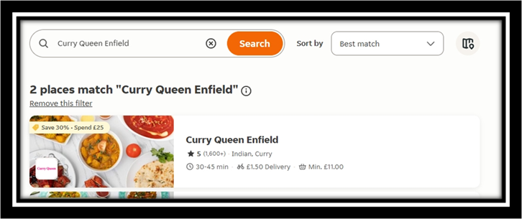  - 30 to 45 mins wait time for delivery.  Evidence: Exhibit A2 /  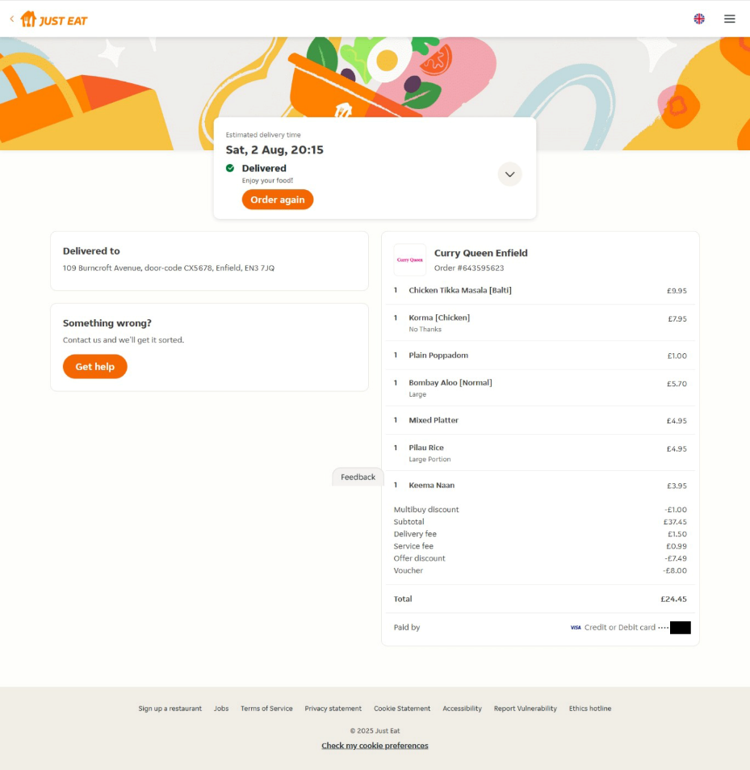  - Delivered Say 02 Aug 2025 20:15Pm  Evidence: Exhibit A3 /  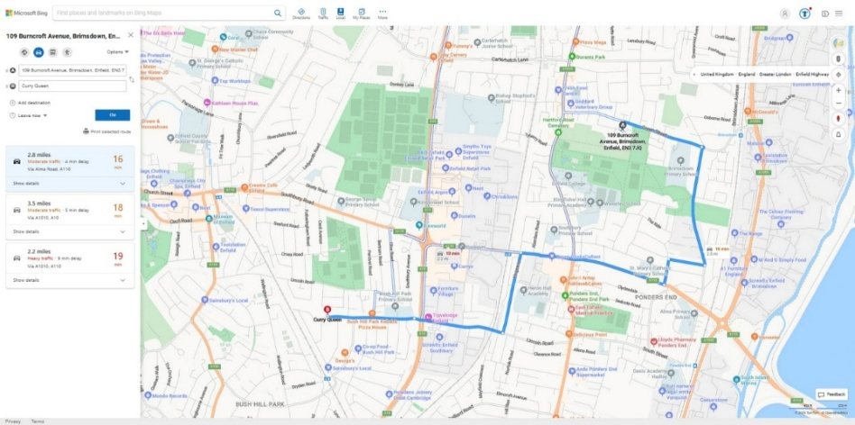  - 2.8 miles there and 2.8 miles back approximately 16 mins  Evidence: Exhibit A4 /  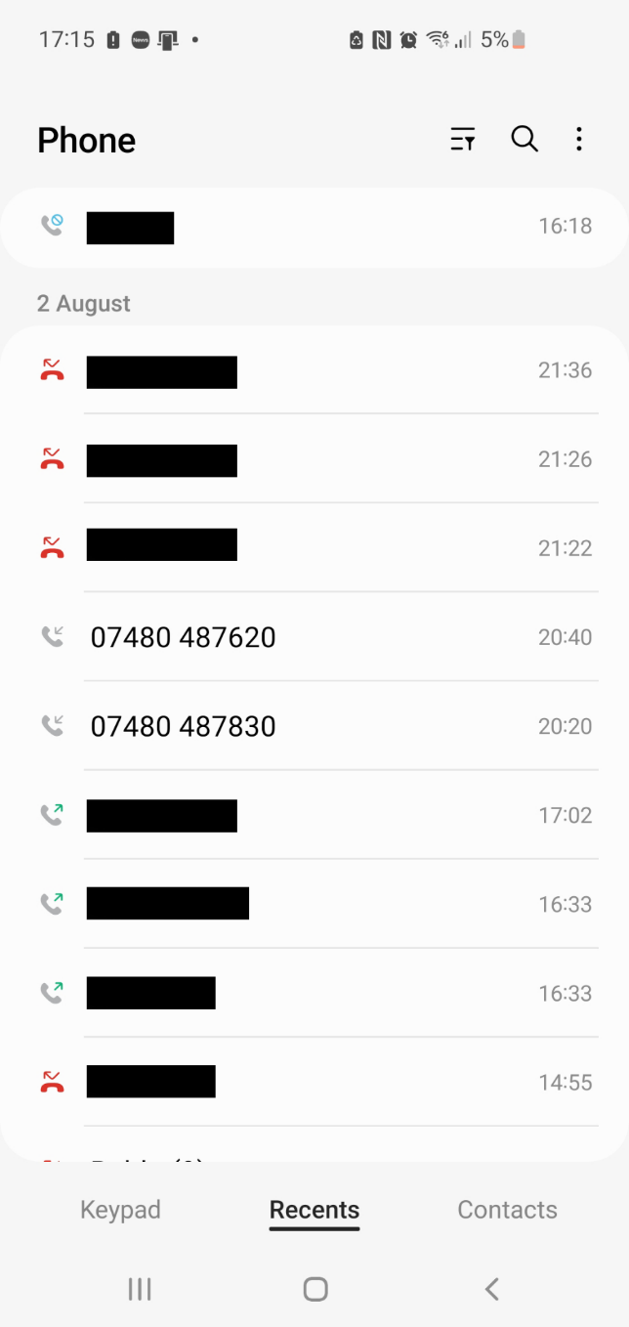  - Both telephone numbers have the same phone number starting digits = 07480 487 *** and this proves that they are from the same company that I ordered food from in Exhibit A1 /.  - The time of first call is as follows: 20:20Pm this is when the food was first delivered to Mr. Simon Paul Cordell.  - Time of second call is time logged as: 20:40Pm and is the time of when the delivery driver re returned back with the missing food.

🔹 Exhibit Bundle: Just Eat Delivery, Timeline Contradictions & Procedural Breakdown

📍 Exhibit A: Just Eat Order Confirmation – Timestamped Alibi
- Order Number: 654529129
- Delivery Date & Time: Saturday, 02 August 2025 at 20:15
- Delivery Address: 109 Burncroft Avenue, Enfield, EN2 7AE
- Clarification: This address is equivalent to 109 Burncroft Avenue, your legal residence.
- Payment Method: Credit/Debit Card ending in **

⏱️ Delivery Wait Time: Exhibit A1 /
- The listing states a 30–45-minute average delivery window, which helps estimate the time it took for the driver to return with missing items.
- This time marker is crucial for establishing your location and activity window, especially when cross-referenced with your telephone records (attached in the next exhibit).

📍 Exhibit A2 /: Timeline Contradiction – Rebbeca O’Hare’s Allegation vs. Proven Activity
Event | Time | Source
Just Eat order delivered | 20:15 | Screenshot evidence
Alleged threat outside Burncroft for Rebbeca O’Hare statement | 20:00 20:30 | (PC Obsiye MG11C) states that
Arrest at 109 Burncroft | 21:16 | PC Obsiye, PC Williams, PC Wilson-Wallis
Defendants Tell log entry, First Arrival of delivery driver! | 02 August 2025 | Personal documentation
Defendants Tell log entry, Second Time of delivery drivers Arrival. | 02 August 2025

Officer | Statement Date | Claimed Time | Role | Contradiction
PC Wilson-Wallis | 02/08/2025 | 21:16 | Witness to arrest | ❌ Misidentifies suspect; not present upstairs, BWV not reviewed!
PC Obsiye | 01/08/2025 | 0700–1600 | Arresting officer | ❌ Date/time impossible; backdated statement, BWV not reviewed!
PC Chan | 02/08/2025 | 1300 | Passive witness | ❌ Time mismatch; did not receive allegation, BWV not reviewed!
PC Williams | 30/08/2022: | 2100 | Late arrival | ❌ Wrong year; BWV not reviewed!

Rebbeca O’Hare: Has no timeline of incidents other than she waited to bring the children in so she did not see me and that

She left straight away to get the nappies after locking the door.

No Cad call timeline disclosed

🔍 Contradiction Summary:
- Rebbeca claims you were outside Burncroft Avenue threatening her around the same time the food was delivered to your flat.
- Your receipt, payment trail, and door code confirm you were inside your residence, receiving food and preparing to eat.
- Your diary and tell logs document your activities and reinforce your non-presence at the alleged scene.

Statement of Events – 14th August 2025 & a Brief description of case build up!
Continuation from entries dated 03/08/2025 and 08/08/2025
I remain subject to bail conditions that I believe unlawfully restrict my legal rights, as previously outlined in my case documentation. These restrictions appear to stem from misapplications of the Bail Act 1974 and the Sentencing and Bail Act 2022, and were influenced by the following breaches:
- Police and Criminal Evidence Act 1984 (PACE) – which requires proper arrest and interview procedures.
- Code C of PACE – guarantees access to legal representation while in custody.
- Article 6 of the Human Rights Act 1998 – ensures the right to a fair trial and legal advice.
- Crown Prosecution Service Code for Crown Prosecutors – mandates that charges must be based on sufficient evidence and public interest.
What I have request so far but cannot be acknowledged until legal aid is granted is the following: --
- A letter to the judges from my father
- My MG11 witness statement
- An impact statement regarding the wrongly imposed bail conditions
- A formal request for permission to travel to Turkey “Not that it should ever be needed”
- An email to Tuckers Solicitors titled “Urgent Request for Legal Support and Disclosure of Evidence”
Arrest and Detention – 03/08/2025
I was wrongly arrested on 03/08/2025 on suspicion of harassment, linked to events dating back to 1997 and still taking a place till date of the 15/08/2025, these claims involve Rebecca O’Hare since late 2017 and onwards till the date of the 03/08/2025 and are thoroughly documented in my personal diary, which is publicly hosted on my website. I have compiled extensive evidence supporting my account, including video recordings, written statements, and legal correspondence for her illegal actions she takes against me and my property.
It is my firm belief that Rebecca has been unlawfully enabled by certain government officials to harass and intimidate me within my own home, often in coordination with other neighbours. I am not alone in this assertion—multiple individuals are prepared to testify in court regarding her actions and the broader pattern of misconduct that has affected my living conditions.
- Undisclosed Name Witness 1
- Undisclosed Name Witness 2
Rebecca is aware that I have been documenting her behaviour, with others and this includes videos audio recordings, text, mostly from inside my own home and all at the Enfield councils request due to the diary they asked me to fill in but now won’t accept
- Enfield Councils Diary, they made me fill in.
I can prove this has prompted retaliatory actions, including even more false allegations and fabricated reports. These have been communicated to police, council authorities, and neighbourhood teams and prior courts all of whom have been repeatedly informed of the situation. I currently hold over 200 records detailing her and others illegal conduct and my attempts to seek lawful protection from her and others, but all requests made by me and others have consistently wrongly been denied.
The arrest on 03/08/2025 was triggered by yet another false telephone report made by Rebecca, consistent with a pattern of fabricated complaints previously disproven by myself and others and her hatred allowed the police to act yet again in gross misconduct against me, this has become a life endangering situation for me that is unjust and unmoral off officials persons who aid in these crimes against me while abusing their powers of trust and this also includes other civil persons apart from Rebbeca O’Hare, who have also take apart alike.
The abuse of police power started from the second of their arrival, the hammering with their fists on my front door in a way to intimidate a person to run in self-defence so they can chase you like pray, never caused me to run out of my backdoor. I stood my ground and asked who was present and what they wanted. Me in my Pajamers and with a medial note in my had led to the door being broken in. in was badly assaulted with the use of a stun gun that was used to hit me across the head rather than be discharged at me after it laser was directed directly into my eyesight ready to kill me. Lead to the woman officer who had been at the door and refused to hold any fair police values entered and joined in with her male assistant who she had ordered to do as he had done by breaking the door down unnecessarily and continuing with his own illegal action, he used more than bruit force after breaking the door down he was like a man on steroids ready to commit a crime. The police body cams will prove all of this. I was refused an ambulance and shouted at for asking for one as they took my medical note for post-surgery two-day prior onto the floor. More police offices rushed to their assistance but realised the force and told the officers to leave. I see the female officer outside and she was refusing to take statement of my neighbours who see what happened and new I was innocent, ki questioned her doing so and she refused to change her stance, and this was while the cameras were still rolling. It took my neighbours too call the ambulance as the police were lining and saying I’m not that important to the ambulance people and for that reason they won’t attend, this was a lie to cover up the truth.
I was taken to hospital and keep till there 04/08/2025 later transferred to Wood Green Police Station, where I was booked in at approximately 8:00 AM. I was interviewed in the presence of both an appropriate adult and my solicitor, who departed following the interview around 7:00 PM.
At approximately midnight, while still in custody, a police sergeant informed me that the case would be dropped, and I would be released shortly. However, it became clear that the permitted detention period was being misused. I was going to held from 8:00 AM on the 4th until 8:00 AM on the 5th then released only upon staff changeover and without charge. This extended detention exceeded lawful custody hours, particularly from midnight to 8:00 AM.
Throughout my time in the cell, I voiced my concerns repeatedly to the custody officer and other staff, both verbally and via the intercom. I maintained a fair and reasonable tone, but my requests were ignored for hours. When communication was eventually permitted, I was told my appropriate adult was asleep and the police would not disturb them and these hours. The same response was given when I requested access to legal counsel. I was also denied the right to speak with a duty solicitor.
Ultimately, the harassment case was dropped. However, at the custody desk, I was informed of this in a manner that bypassed my own decision-making. A phone call was made to a government-based scheme that allowed them to obtain their own appropriate adult without my consent or my mandated appropriate adults consents, despite prior arrangements for my release being agreed with them for them to pick me up. I had made clear that my appropriate adult must be contacted for pick-up regardless of the time. I was also refused bail due to an error: the alleged victim claimed I had been prosecuted or arrested twice before due to her. I challenged this and directed the custody officer to my criminal record, which confirms I have not been arrested or found guilty in the past 25 years, and have never been arrested due to her but he again refused right and set the laws illegally against me. Latter another police sergeant who had changed shifts proposed deal with me and in turn I agreed, and he explained the errors I =found in my criminal record were fabricated I have prior documented this down in more detail my mg11 statement and due to all I left the police station in a secure van to go to Highbury and Islington on Magistrates Court.

Court Proceedings – 04/08/2025
I was taken to Highbury and Islington Court under circumstances I believe involved coercion, as detailed in my MG11 statement. I was denied the right to speak or explain the circumstances of my arrest. Despite managing to raise my concerns more than once, the court refused to initiate an inquiry into my truthful account. Instead, I was granted bail to my sister’s address with a GPS tag and prohibited from entering Burncroft Avenue.
Although the judges appeared to grasp the essence of my concerns, they declined to address them and imposed further restrictions. I believe this outcome was influenced by manipulation related to my background and communications made to the court regarding entries in my criminal record, entries that are not held in the Courts registry’s and are currently being challenged through the appropriate channels. The court refused to address these discrepancies and instead placed me under unlawful restrictions.
These prior communications may have led court staff to misrepresent the case against me, without any lawful evidence. It appears the case is being used recklessly as leverage to fabricate a criminal record, following multiple failed attempts in the past—attempts that relied on inaccurate PNC/ACRO intelligence, as well as frauded official government documents, developed to set me up completely.

Bail Address and Compliance
Following the court hearing, my mother contacted the court via email to explain that my sister’s home was not suitable for me to stay in. She requested authorisation for me to reside at my grandmother’s address. We received two email confirmations from Highbury and Islington Court approving this change, along with a new court date of 08/08/2025 for finalisation of my bail conditions.
Since arriving at the bail address, I have remained fully compliant and have not returned to Burncroft Avenue.

Events of 14/08/2025
Ongoing Impact of Unjust Bail Conditions and Fabricated Judicial Records
To maintain focus and productivity, I have been organising my legal documentation and assisting with home improvements. These efforts have helped me remain grounded despite the ongoing impact of unjust bail conditions and curfews; restrictions imposed through decisions made by police, judiciary, and prosecuting teams. Many of these decisions relate to cases I have successfully contested over the course of my life.
One such injustice involves an Anti-Social Behaviour Order (ASBO) issued by Highbury & Islington Court, which I can now prove was heavily forged and unlawfully granted. This ASBO resulted in a wrongful eight-year curfew, which overlapped with the COVID-19 pandemic. I am now 43 years old and have been subjected to curfew restrictions since the age of 15, as reflected in my criminal record and its numerous NFA (No Further Action) entries. The situation worsened significantly from the age of 32, with the continued involvement of Highbury & Islington Court. I have been effectively locked down ever since, most recently out of fear of retaliation stemming from gross misconduct by officials.
These restrictions were imposed for crimes I did not commit, based on flawed case reviews and decisions made by the same court. Notably, the court has acknowledged that several of the cases used to justify these restrictions do not exist in their own registries. But now, with more time to examine the documentation provided to us, I can confidently assert that the entire record has been fabricated, either by individuals within the court’s reviewing team or by police personnel involved in case preparation.
Fabricated Records, Judicial Acknowledgment, and the Destruction of Family Life
This pattern of falsified documentation, unlawful curfews, and systemic obstruction has denied me basic freedoms and severely disrupted my family life. During one hearing, the judges themselves acknowledged, on record and in direct address to the prosecutor—that I had not been convicted of a crime or offence for over 25 years. This admission, while accurate, further highlighted the contradiction between my actual record and the fabricated narrative being used to justify ongoing restrictions. It undermined my legal standing and exposed a clear violation of procedural fairness that must be addressed.
These prolonged and unjust restrictions have denied me the opportunity to build a stable family life, including relationships with a partner, wife, and siblings. The flat I currently reside in was renovated in preparation for a partner. Yet despite this, I can clearly demonstrate that two injunction orders and two housing possession orders were fabricated against me and facilitated in part by individuals such as Rebecca O’Hare, who actively victimised me throughout my legal process.
The emotional and physical toll of this victimisation has been devastating. Rebecca and others, through coordinated harassment and interference in my private life, inflicted severe psychological stress on both me and my partners. As a direct result of this sustained abuse, I lost three unborn children across three separate relationships. These events occurred since she moved into the flats and copycatted other victimising me. She moved in between late 2017 and 2018, shortly after Rebecca moved into the area. The pattern of behaviour was not incidental, it was deliberate, malicious, and carried out as if it were a form of entertainment or sport, and government officials refused to arrest her no matter who or what we exhibited of her illegal actions and others, that took place against me and other persons.
These actions amount to torture, both psychological and procedural, mental torture and physical torture are two of a kind and protected under our Human Rights and due to official persons actions, this represents a gross abuse of legal systems, housing frameworks, and human rights. The cumulative impact has been the erosion of my ability to live freely, safely, and with dignity.
In addition, the police have continued to construct a false mental health record, despite there being no formal diagnosis of any mental health condition and another officially frauded document was handed to the judges in these proceeding of such a kind. After being deliberately fabricated by themselves.
This has been deliberately done with intent for years now and still hold no legal bases against me in fact it proves fraud the other way and is well documented by myself due to the illegal crimes committed in the past when the Government bodies involved acted in a joint circular coordination with the neighbourhood watch team, Enfield Council, and certain neighbours resulting in a further five years of unlawful processes. Then the COVID-19 pandemic compounded these restrictions, isolating me even more.
This situation is unjust, and I believe it must be formally addressed and rectified due to these proceedings.

Wrongful Arrest – 14/08/2025: A Breakdown of Safeguards
At approximately 6:00 AM on 14th August 2025, I began decorating the property I am housed in and what is an act of personal discipline and respect for myself and elders, which is what allows me to focus under illegal imposed, restrictive bail conditions. While working alone, I heard a knock at the front door. Upon answering, I was confronted by two female police officers and one male officer. Their urgency and physical positioning suggested a clear intent to enter without consent, raising immediate concerns about the legality and motive behind their visit.
When asked why they were there, they stated I was wanted for breach of electronic tag conditions. I calmly explained that this must be an error. I had attended Highbury & Islington Court on 8th August 2025, where I was granted permission to reside at my grandmother’s address from 4th August onward. This was confirmed via email correspondence between my mother and the court.
Despite offering to show them this evidence—including solicitor letters received that morning and documentation available on my website—they refused to engage. One female officer attempted to push her way into the property. I ensured her safety while closing the door to prevent unlawful entry. Their refusal to listen prompted me to secure the front windows, fearing forced access.
Before I could retrieve my phone to contact my mother, I heard a loud bang at the door. Concerned about damage, I shouted that I would open it voluntarily. I did so immediately, just before they attempted to kick it again.
Once inside, the officers attempted to restrain me without offering a clear explanation or acknowledging any of the evidence I presented. I demanded clarity. The female officer repeated that I was wanted for breach of tag due to not being present at my sister’s address on the 5th and 6th of August. I explained again that I had been granted permission to stay at my grandmother’s address since the 4th, and that this was confirmed by the court. I showed them the tag installed on my leg and offered to present all supporting documentation. They refused to engage.
It became clear I was being deliberately misrepresented and unlawfully detained. I stated this directly to the officers as they placed me in the police van. I asked how they had located my current address unless they had accessed CAD records or been informed of the second bail address. I pointed out they were executing an outdated warrant, despite my residence at this address only being disclosed in court on 08/08/2025.
After being placed in the police van, I asked why the officers had not contacted the tagging company to verify my location. The lead officer did not respond. Upon arrival at the station, it was evident that the female arresting officer, who had acted as the primary instigator, had heard everything I said both at my bail address and during transport. She rushed into the station immediately upon arrival, while the second female officer and the male officer, who had remained more passive throughout, escorted me from the van and placed me on a bench in the police car park.
While seated, I engaged in conversation with the male officer. He reiterated what he had said earlier at my front door: that the situation did not seem right. He acknowledged that the warrant was issued for the 5th and 6th of August 2025 and repeatedly stated that my electronic tag had been installed on the 11th. I asked him how he knew that, and he claimed I had told him. I clarified that I did not know the exact date of installation—only that it occurred after the 08/08/2025 court hearing.
A custody officer approached us at the bench. I explained the situation in full, believing he was there to assess whether further action was appropriate. He informed me that I would likely be placed on a secure van by lunchtime and taken to court. I objected, stating that this was unnecessary and could be resolved immediately by contacting my solicitor or the court directly. He responded with a remark similar to the sergeant’s earlier comment—that if police alone managed such matters, they might be better handled.
I disagreed and outlined the failure of all four safeguards meant to protect individuals in my position:
- Courts failed to update the tagging company after the 08/08/2025 hearing.
- Tagging company installed the tag at the new bail address but failed to cancel the outdated warrant.
- Police accessed CAD records and found the new address but still executed the outdated warrant.
- CPS failed to review and update the case across both police and court systems.
The custody officer listened but did not act. The sergeant who had previously dismissed my concerns walked past and, without further comment, instructed the arresting officer to “put him in there.” I was placed in a temporary holding cell to await further processing.
Later, a new custody officer brought me to the booking desk. He treated me fairly and appeared to recognise the inconsistencies. He stated that the computer showed I was barred from both my new bail address and Burncroft Avenue. I challenged this, stating that it was fabricated and contradicted the court’s own communications. He replied that he was simply reading what was on the system and could not verify external sources. I asked him to contact my solicitor firm—he knew who they were—but refused, stating he could not trust information from them.
While this conversation was ongoing, I noticed the same sergeant who had previously set me up without interview or lawful arrest. He was now behind the desk, appearing to begin his shift. I addressed him directly, stating: “You are the sergeant who set me up the other morning.” He did not respond. I waited until he was no longer busy and repeated myself. Still no reply.
Frustrated, I raised my voice and stated clearly: “You must answer me, considering your job title.” He finally replied, confirming: “Yes, I am the officer from the other day.” I then explained the consequences of his actions—that his misconduct had led to my unlawful arrest, the illegal placement of a monitoring tag around my leg, and the denial of legal representation. I asked whether he had deliberately orchestrated my presence at the station. He did not respond.
Video Link Hearing and Custody Exit – 14/08/2025
I was held in a cell and later informed that I would not be taken to court in person. Instead, a video link hearing would be conducted—further distancing me from the opportunity to present my case directly and transparently.
As I was escorted through the station toward the video link room, I passed the custody desk where the officer responsible for my unlawful detention was seated. I spoke aloud, stating clearly that he had caused me immense suffering and that I would be filing a formal complaint against him. I was then brought into the video link room, where I saw three judges, a court clerk, and the prosecutor. I had no legal representation.
A voice addressed me, and when I asked who it was, I was told it was the court clerk. I showed the tag on my leg to all present and explained that I had not been arrested for the original charge, and that I had complied fully with all judicial orders. I addressed the prosecutor directly, stating that the case was unmerited and unjust. I was told politely to listen.
The court informed me that I was being released and must attend trial on the 13th of September. I objected, stating that the process was unfair and that the hearing had failed to address the misconduct and procedural breaches. The court was then dismissed.
Upon exiting the video link room, I was brought back to the custody desk where the same officer—who had orchestrated my unlawful arrest and detention on 04/08/2025—was present. I spoke loudly so that all could hear: “You are not booking me out or handling this case. Get someone else to do it.” I reminded him of his actions and stated again that I was logging a formal complaint. He laughed.
The custody officer who had earlier approached me at the bench stood behind him. The officer responsible for my detention held my property bags and said, “If you don’t leave now, we will force you.” I replied, “That is illegal.” They then physically grabbed me by the arms and forcibly escorted me out of the station.
Once outside, the officer placed my property bags on the pavement and walked back into the station. No paperwork was provided. I was left alone, without documentation, legal support, or acknowledgment of the events that had just occurred.
I called my family, who came to collect me and brought me back home.

