Title: Decline of Community and Tenancy Integrity in a Council Estate
Who’s the girl illegally attacking me in 115 and should she legally be in the flat also her Motive “MO” behind what she does?

Girl Known as: Rebbeca O`Hare

The Illegal Subletting of Council Stock Homes!
The illegal subletting of flats by council secure tenants constitutes a breach of their tenancy agreements. In my block, there are six flats arranged over three levels, with two flats on each level. Each front door faces the next, and the bottom-floor flats have back gardens. I have lived in one of these bottom-floor flats since 2006.
This estate is designated for individuals over 40 years old; however, I've noticed an increasing trend of younger individuals moving in alongside the adult tenants. While their presence has contributed to some changes, my negative experiences in the community primarily stem from the actions of the original adults I once considered friends. Unfortunately, I have faced racial hatred, unfounded rumors, and a toxic atmosphere fueled by individuals seeking to emulate violent behavior. These actions have severely damaged our community spirit without justification.
Between 2006 and 2014, this place thrived with a strong sense of community, and I cherished my time here. Sadly, that sense of belonging has faded, and my overall experience has significantly declined. Despite this, I continue to keep an eye on the activities around me, taking notes of who lives whereas I have also been forced to maintain a diary of the wrongs I have endured, by some of those neighbors as requested by the council and police, when they asked me to document incidents involving members of the estate in my block and sent me a diary form to fulfill.
The two ground-floor flats are council-owned, while the second-floor flats are numbered 113 and 115, with 113 being directly above my flat. When I first moved in, 115 was occupied by a young couple, both white British, with whom I had no issues. However, in 2014, I began experiencing harassment from the residents of flats 111, 113, and 117 (the latter address of 117 being directly above 113). The situation escalated, as the council and police sided with them, due to initiating the problems of cause and this wrongful behaviour further exacerbating the problem.
With that being explained I can get closer to the point and that being about the legal occupation and inhabitance of 115 Burncroft Avenue based from my understanding

It is worth noting that the tenants of 115, who disapproved of their neighbors' behavior, eventually moved out.

2006, 2007, 2008, 2009, 2010, 2011

 | - Responsible Doctors & Enfield Council for Debra Andrews  - The reason that we have adduced this exhibit into these proceedings is because | 00/00/2006  Till  2011 | Evidence: Exhibit BB5 – 1 / 00/00/2006:  - We contain the Evidence in the Now Claimants Diary!  Evidence: Exhibit BB5 – 2 / 00/00/2006:  - This is a picture of the front layout of Burncroft Avenue  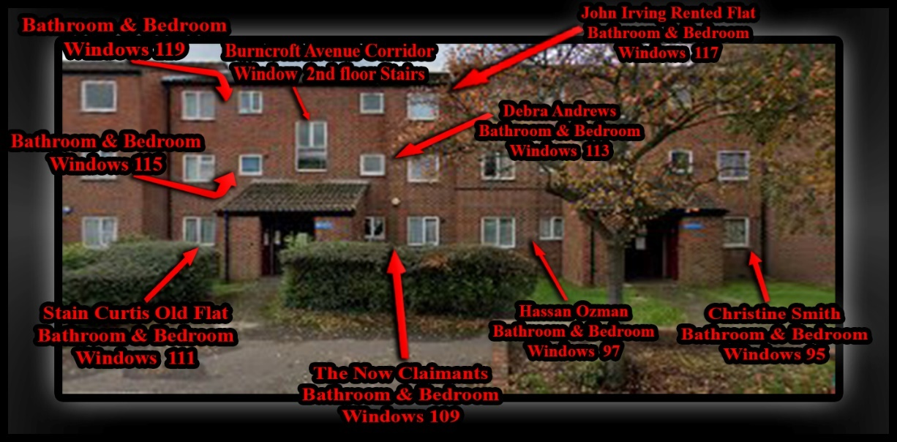  Evidence: Exhibit BB5 – 3 / 00/00/2006:  - This is a picture of the front layout of Burncroft Avenue  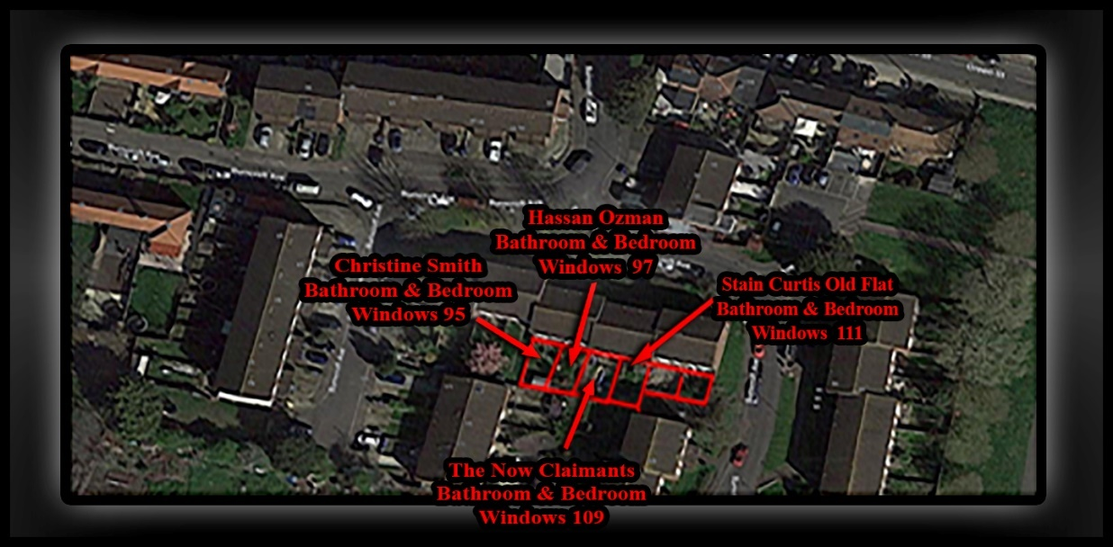  Evidence: Exhibit BB5 – 2 / 00/00/2006:  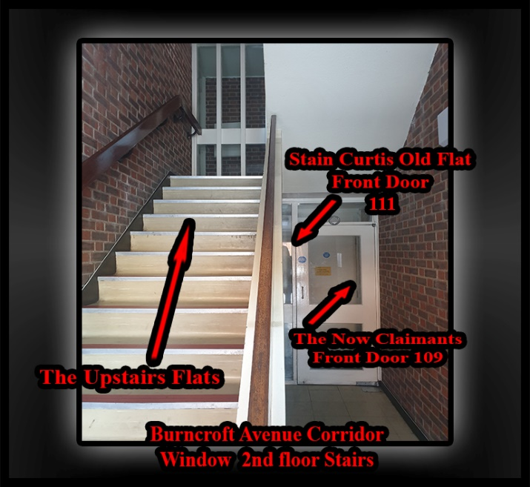  Evidence: Exhibit BB5 – 2 / 00/00/2006:  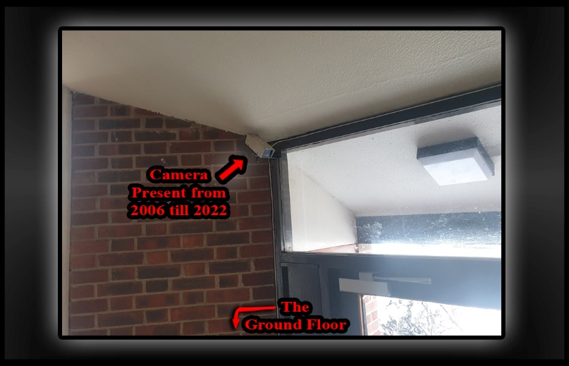  Evidence: Exhibit BB5 – 2 / 00/00/2006:  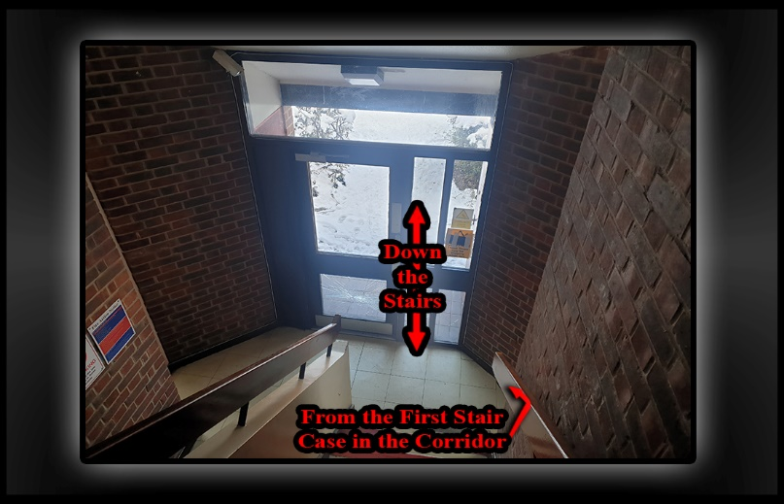  Evidence: Exhibit BB5 – 2 / 00/00/2006:  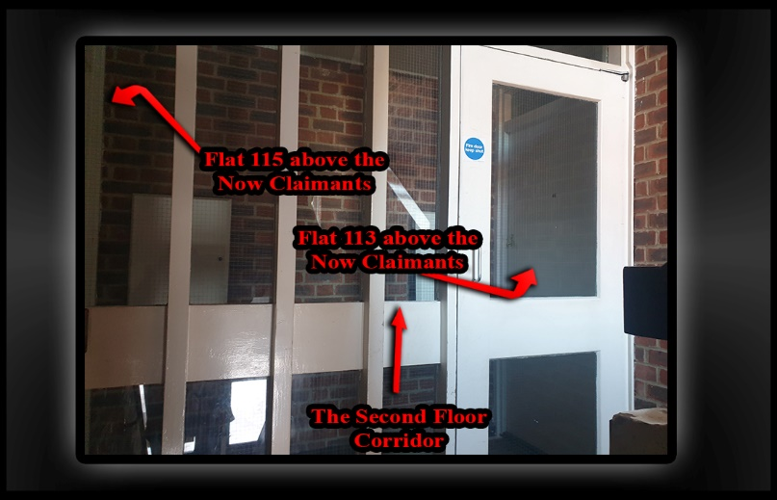  Evidence: Exhibit BB5 – 2 / 00/00/2006:  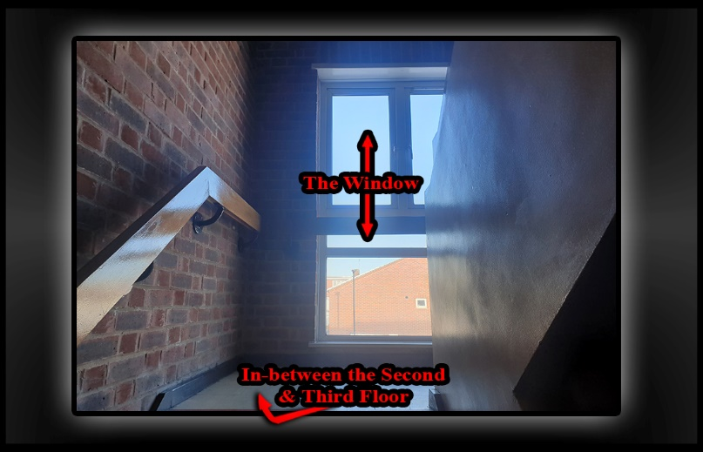  Evidence: Exhibit BB5 – 2 / 00/00/2006:  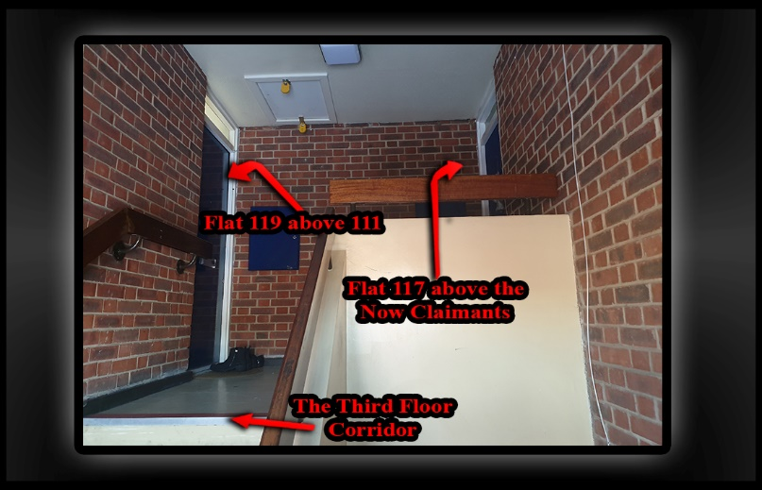

INFO | Statement Exhibit BB0 – 1 / 00/00/2014:  - O
 | - Responsible Doctors  - The reason that we have adduced this exhibit into these proceedings is because | 00/00/2014 | Evidence: Exhibit BB5 – 1 / 00/00/2014:  Evidence: Exhibit BB5 – 2 / 00/00/2014:  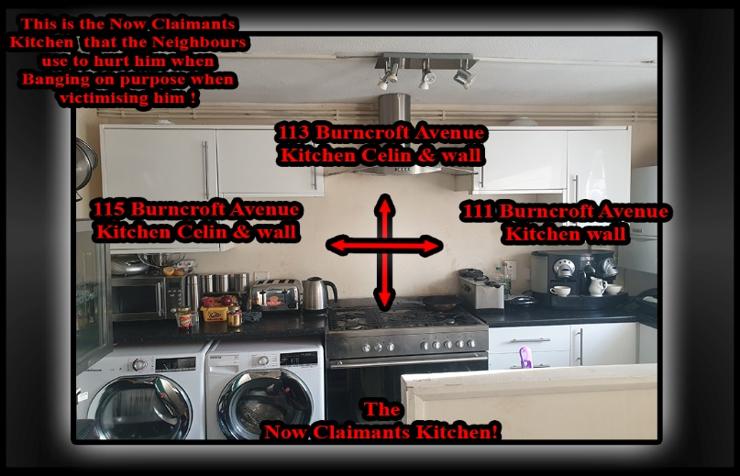

Outside Exhibit of road coming in and car park Rebecca O’Hare drove into on the 02/08/2025
These Videos were made on the 02/10/2025 but explains the second car park to be where Rebbeca Parked when it was really the first Car park. This will be updated tomorrow as it’s dark now! | 02/10/2025 – 1 VID-20251002-WA0000.mp4  02/10/2025 – 2 VID-20251002-WA0001.mp4  02/10/2025 – 3 VID-20251002-WA0002.mp4

🧠 Forensic Breakdown: Why Rebecca’s Timeline Is Impossible

🕰️ Your Sequence of Events (Step-by-Step)
- Initial Exit for Delivery
  - You exited your home to meet the delivery driver.
  - You handed him a number (e.g., 9e or 20) and began walking back toward your front door.
- Realization and Immediate Return
  - Before reaching your front door, you realized your bag was short.
  - You hurried back to the driver before he drove away.
- Driver’s Delay
  - The driver got out of his vehicle again.
  - He attempted to phone his boss but couldn’t get through.
  - This added several minutes to the interaction.
- Witnesses Present
  - During this time, your next-door neighbours were outside and witnessed the exchange.
  - You were visible and engaged in conversation—your location and activity were public and traceable.
- Rebecca’s Claimed Entry
  - She claims she drove into the rear car park and brought her children upstairs.
  - But you had already seen her drive past you into the car park while you were still outside.
  - Therefore, she had not yet entered the block or brought the children up at that point.
- Your Continued Presence Outside
  - You remained outside for approximately 10 minutes resolving the delivery issue.
  - Rebecca must have remained hidden in the car park during this time—there’s no evidence she entered the building.
- Second Delivery Agreement
  - You and the driver agreed he would return with the rest of the food.
  - You then returned inside to eat the partial delivery (chicken korma).

🔍 Logical Contradiction in Rebecca’s Statement
- She claims she brought the children upstairs and later came down to retrieve nappies.
- She also claims she saw your back in the corridor as she descended.
- But based on your timeline:
  - You were outside during her arrival.
  - You only returned inside after the delivery issue was resolved.
  - You had no reason to re-enter the corridor once inside—you were waiting for the second delivery and eating.
- For her to see you in the corridor, she would’ve had to descend at a time when you were no longer there.
- Unless she waited upstairs for 30–45 minutes before realizing the nappies were missing (which she does not claim), her version is chronologically impossible.

⚖️ Conclusion: Her Account Is Logically and Physically Implausible
Rebecca’s statement relies on a compressed and contradictory timeline. Your actions were visible, witnessed, and consistent. Her version requires:
- You to be in two places at once.
- Her to have entered the block while you were still outside (which she didn’t).
- A spontaneous corridor encounter that couldn’t have occurred based on your actual movements.
This undermines the credibility of her account and supports your assertion that her version of events is not just flawed—it’s structurally impossible.

- Statement of: PC George WILSON-WALLIS
- Date: 02/08/2025
- This is the witnessing officer statement regarding the arrest performed by officer 1543NA
- Mobile patrol NA22L called for a van to facilitate the transport of an individual I would later find out to be called Samual to custody for the offence of harassment.
- whilst this was going on at 21 :16 PC 1543NA began arresting Samual for the offence of harassment through the door

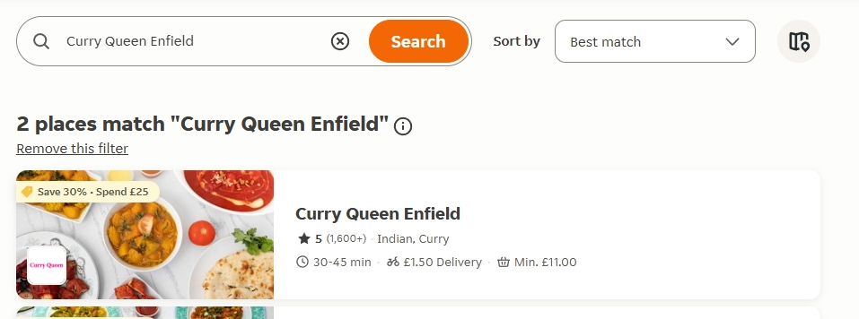

30 to 45 mins wait time for delivery.
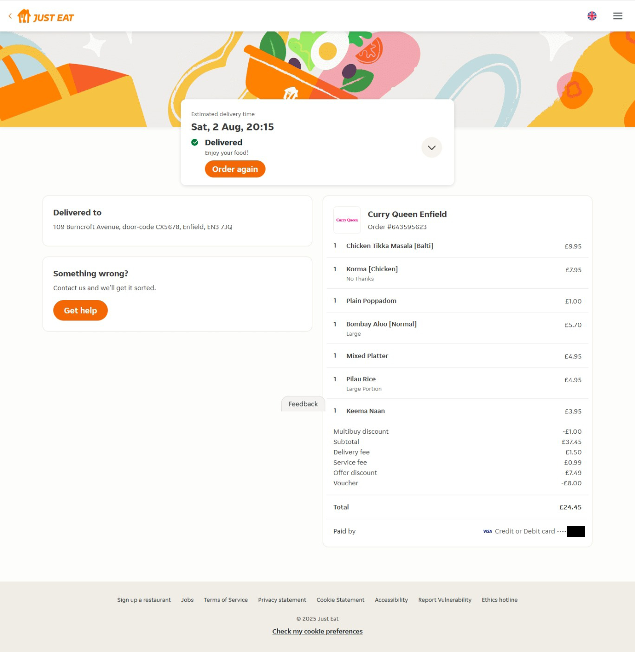

Delivered Say 02 Aug 2025 20:15Pm
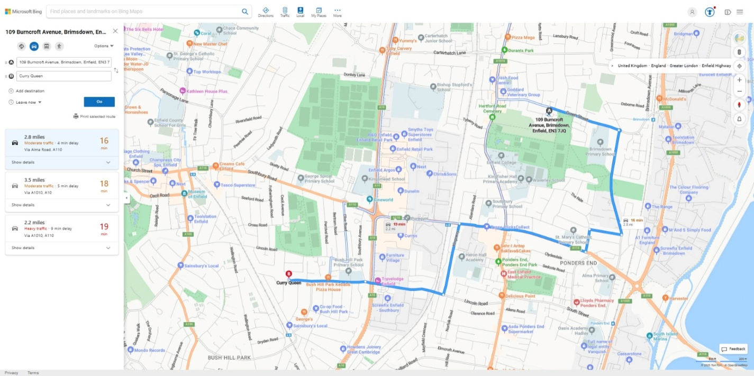
2.8 miles there and 2.8 miles back approximately 16 mins

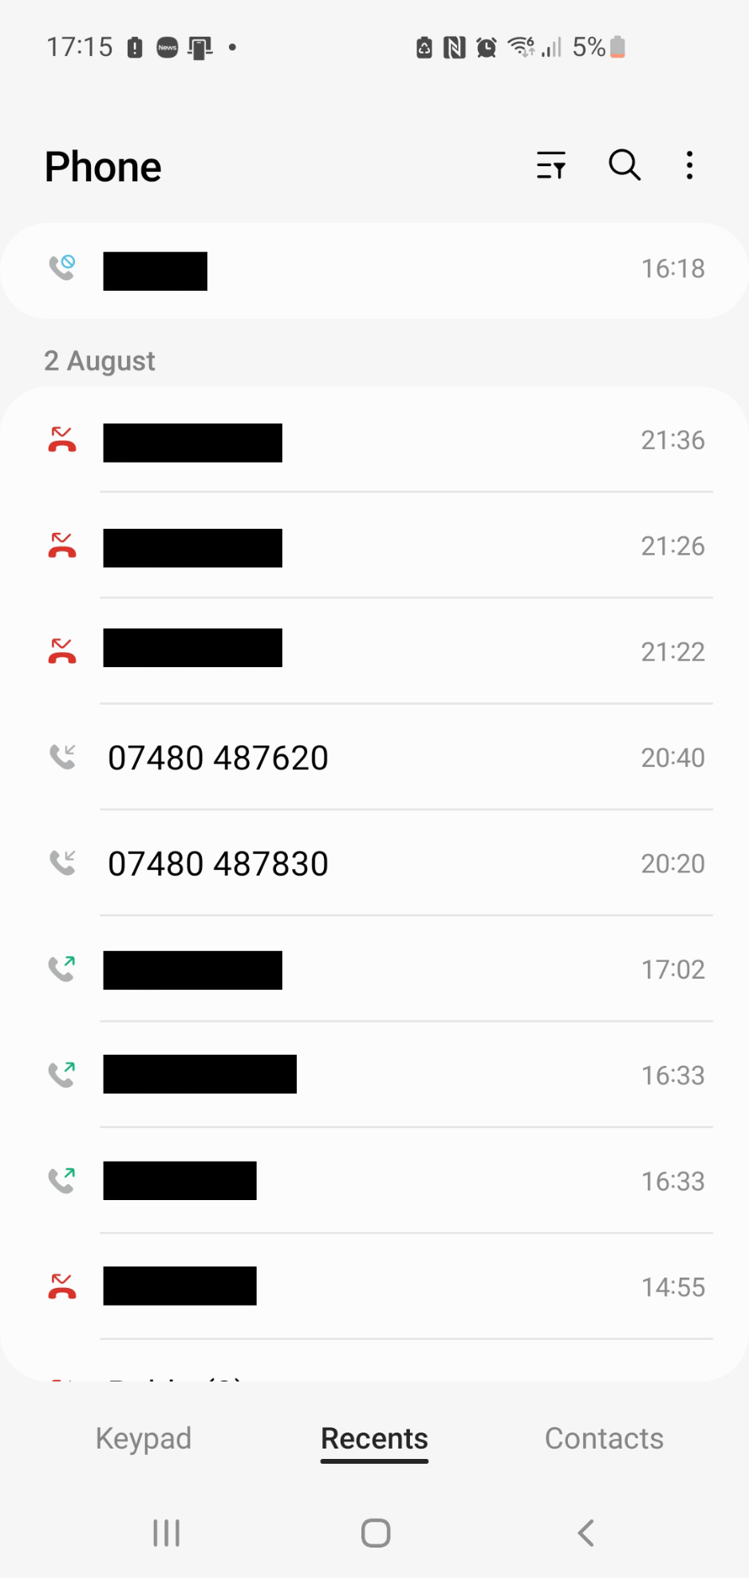

Both have the same phone number starting digits = 07480 487 ***
Time of first call: 20:20Pm
Time of second call: 20:40Pm

🔍 General Observations
- Unsigned Statement: The MG11C form explicitly states “Witness Signature: ……………………..” with no signature present. This renders the statement inadmissible unless verified in court. You are entitled to ask: “Who signed this statement, and when?” If unsigned, it fails the basic threshold under the Criminal Justice Act 1967 and Magistrates’ Courts Act 1980.

📂 Section A–J: January Incident

a–b: Alleged Threats and Video Evidence
- No video disclosed: Despite claiming to have sent video evidence to police, no footage has been disclosed under CPIA. → Challenge: “Where is the video? Has it been reviewed, timestamped, and verified by an officer?”
- Language used: Highly emotive and inflammatory, but lacks corroboration. No BWV, no third-party witness.

c–e: Door Fitting and Accusation
- Timeline ambiguity: She claims the door was off its hinges and she was inside, yet Simon allegedly spoke to the contractor and then to her. → Contradiction: If the door was off, how did she hear Simon from the living room and then go to the door?
- No contractor statement: The contractor is a key witness yet not cited or referenced.

f–g: Location Contradiction
- She states: “I don’t live above him.”

h–j: Website and Police Call
- Website reference: She claims you said she’s on a corruption website. That’s verifiable. → Challenge: “Which website? What content? Is it defamatory or factual?”
- Police call: No CAD number or officer response cited. Again, no disclosure.

📂 Section k–y: August 2nd Incident

k–n: Driving into the estate
- Pre-emptive fear: She admits she always checks if you’re outside. This shows bias and expectation—not actual threat.
- Staring at car: Not illegal. No verbal exchange yet she claims intimidation.

o–r: Parking and Entry
- No interaction: She confirms you weren’t present when she parked and walked upstairs. No threat occurred.

s–u: Alleged Threat to Blow Up Car
- No witnesses: She claims you made a serious threat while facing away from her. → Challenge: “How did she hear and interpret the words if she wasn’t paying attention?”
- No forensic follow-up: No CAD, no forensic sweep, no corroboration.

v–x: Shouting from communal door
- She admits: “I wasn’t paying attention to what he was shouting.” → Contradiction: If she didn’t hear the words, how can she claim threat or intent?

y: Fear and Mental Health Allegation
- Subjective fear: Her fear is real to her, but legally it must be based on objective threat.
- Mental health claim: She alleges your complaints are dismissed due to mental health. That’s discriminatory and irrelevant unless medically substantiated.

⚖️ Legal Leverage Points
- Unsigned statement: Procedurally invalid unless signed and verified.
- No disclosed evidence: No video, BWV, contractor statement, CAD logs, or third-party corroboration.
- Contradictions: Timeline, location, and attention inconsistencies.
- Bias and expectation: Her own words show she anticipates conflict, not that it occurs.
- Discriminatory framing: Mental health references are prejudicial and unsupported.

Folder PATH listing for volume OS

- Case_Summary_pdf.pdf:
- +

📂 Extracted Title Structure from Case Summary
- Summary of the Key Evidence
- Witness(es) and their role (e.g., eye witness, person providing identity)
- Defendant Interview

- Non-Key Evidence
- Visually Recorded Evidence
- Injuries
- Forensic Evidence
- DIP Testing
- Application for Order(s) on Conviction

I am the above named individual and reside at location known to police.

- Application for Compensation
- Other
- Officer’s Certification
- Supervisor’s Certification
- Conditional Cautioning Section

- CORDELL_Simon_01YE1267925_Section_9_pdf.pdf:
- +

📂 Extracted Title Structure from Section 9 Statement
- URN and Case Reference
- Section 9 Notice
- Notice to Defendant: Proof by Written Statement:

Here:
- List the witness(es) you want to give evidence in person.
- Send me the list not more than 7 days after this notice is served on you (as required by section 9(2)(d)of the Criminal Justice Act 1967).

- How to Reply to This Notice
- List of Witnesses Whose Statements Are With This Notice

- S9 Witness Statements

- Statement/Evidence List
- Witness Statement – PC George Wilson-Wallis
- Continuation of Statement
- S9 Exhibits
- List of Exhibits

- Defendant_Notice_of_Grant_of_Bail_pdf.pdf:
- Date of notice 27 August 2025. Details of your next hearing Date and time: 13 October 2025 at 10:00

- Let_to_Client_Magistrates_Court_Trial_Advice.pdf:
- I write with regard to your forthcoming trial, having now had the opportunity to review the evidence in connection with the following offence:- Threats of Criminal Damage to another's Property, s.2, Criminal Damage Act 1971.
- Bad Character

- PC_Chan_pdf.pdf:
- Statement of: Calvin Chan
- Date: 02/08/2025
- On Saturday 2nd August 2025 I was on duty in uniform
- She was explaining the allegation to PC Obsiye
- she described him as wearing a blue checkered pajama.
- We went downstairs to knock on the door
- I exhibit my BWV as CKC/01

- PC_obsiye_pdf.pdf:
- Statement of: PC Obsiye 1543NA
- Date: 01/08/2025
- On Friday 01st August 2025 between the hours of 0700 and 1600 I was on duty in full
- uniform carrying full PPE kit and BWV.
- We asked to enter, and we spoke with her in the living room.
- She stated that she has been having issues with her neighbour and its been ongoing for a while. She quickly grabbed her children and ran into the address. She remembered she left her nappy bag so went to go get it. That’s when the suspect caught her near the door and began saying something she did not know what he was saying at first so made a comment to herself that’s when the suspect said,
- She also stated there was another incident earlier in the year, when she did not have a front door and was getting it replaced.
- I explained to PC Chan 1405NA that the suspect who lived downstairs 109 would be arrested for harassment.
- I explained that he was arrested for harassment as today he went up to the victim and threatened to blow up her car and that no one would know it was him, also previously you had turned up to her house and threatened to slap her. You have been causing her distress.
- My BWV was on at the time and is exhibited as HAO/01

- PC_Williams_pdf.pdf:
- Statement of: Constable Reece Williams
- Date: 30 Aug 2022
- On 02nd of AUGUST 2025 I was in full uniform in a marked police van attached to call sign NA30L.
- The enforcer was handed to PC CHAN and PC OBSYIE explained to the resident of 109 BURNCROFT AVNEUE they were under arrest and cautioned them through the door as he refused to open
- I have not watched my BWV prior to writing this statement and it is true to the best of my knowledge. I exhibit my BWV as RAW/01

- PC_Wilson_Wallis_pdf.docx:
- +

- PC_Wilson_Wallis_pdf.pdf:
- Statement of: PC George WILSON-WALLIS
- Date: 02/08/2025
- This is the witnessing officer statement regarding the arrest performed by officer 1543NA
- Mobile patrol NA22L called for a van to facilitate the transport of an individual I would later find out to be called Samual to custody for the offence of harassment.
- whilst this was going on at 21 :16 PC 1543NA began arresting Samual for the offence of harassment through the door

- Rebecca_O_HARE_2nd_pdf.pdf: This statement is not signed
- The 2nd Witness Signature: Rebecca O’Hare
- Date:03/08/2025
- I Want to know who her statement was signed by?
- I am the above name person and this is my second statement regarding an incident that took place on the 2nd of August 2025 concerning my neighbour who has harassed me. I have submitted a video to the police upon request, that shows my neighbour hurling abuse at me whilst being at my front door. I exhibit the following video as ROH/01.

- Rebecca_O_hare_pdf.pdf: This statement is not signed
- I Want to know who her statement was signed by?
- In January my neighbour Simon (109) “was banging on my door” “shouting that I was making noise,” I’ll punch you up, I’ll slap you up and your daughter. He also said he would do the same thing to my children’s dad. I took a video of this and sent this to the police.
- In “January I was getting a new door fitted,” I’ve taken my daughter to school. I’ve come home; “the door was taken off the hinges by the contractor.”
- Simon has come upstairs and i was in the living room and I could hear him, Simon was asking the contractor if the guy that lives opposite from me (113) was home.
- I’ve gone to the door, “and he has started to accuse me of banging on the floor and keeping him awake at night.
- “I’ve explained that I don’t live above him”
- “then he has then shouting saying that he would hit me, hit my eldest daughter and drag my unborn baby out my stomach.
- “I kept telling him to move from the door,”
- he then went to say he’s got videos of me on a website about being corrupt.
- As I’ve called the police on that occasion, he has said call the fucking police I don’t care.

- On Saturday 2nd August 2025 I was driving into the estate where my block of flats is,
- As I’m driving in, I have seen my neighbour who I only know as Simon, he resides at 109 Burncroft avenue.
- Whenever I come into the estate the first place, I look is the bottom of my block, to see if he is outside.
- If he is I know that he would try and intimidate me, shout at me or something is going to happen.
- As I have driven in and drove around the bend, I could see him from the side staring at my car.
- I’ve driven into the small car park on the left and parked my car.
- I’ve got out my car to see if he was still there or not,
- once I’ve seen he is not there I’ve walked my two kids upstairs.
- I’ve had to go back downstairs to grab my children’s nappy bag I told my eldest daughter if the baby wakes up to call my phone. I’ve locked the door and taken the key with me
- As I’m walking down the stairs I hear another door, Simon has got to the bottom of the stairs before me, he was saying stuff but facing away from me.
- So I wasn’t paying any attention and he has turned around and been like ‘you hear me’, not in response to him I was like what? And then he has said ‘I will blow up your car, I will blow it to the other side of the street.’ Then he was like if you come and ask me, I will tell you I didn’t do it.
- I’ve closed the communal door to put space between us,
- I’ve walked towards my car to get the nappy bag he has opened the door and was shouting stuff at me as I’m walking towards my car,
- I wasn’t paying attention to what he was shouting at me I was trying to get to my car as quick as possible. I’ve got to my car and got what I needed and looked if he was still by the door, he wasn’t by the door, so I’ve started walking back home, once I got into my flat.
- I called the police. Because of his behaviour I am worried to leave the house with my children. I have been getting other people to drop things off for me. I try my best to stay as far away from him as possible but every time I see him I know that something would happen, there has been incidents when I am at the shop, he would stare at me but would not say anything, trying to intimidate me. I feel unsafe in my own home and fear for me and my children because of his threats, every time I make a complaint a feel that it is put down to his mental health. I am concerned that only if he touches me or my children that something would be done.

- ROH_01_mp4.mp4:
- +

- Simon_CORDELL_Charges_pdf.pdf:
- +

- Simon_CORDELL_Charges_pdf_pages.docx:
- +

- Simon_CORDELL_Pre_Cons_pdf.pdf:
- +

- Simon_CORDELL_Pre_Cons_pdf_pages.docx:
- +

- Conviction.Pdf:
- +

- signature-transparent-bg_bd3b4ec2-9608-4754-bd6a-54dd565a5306.png:
- +

- output.doc:
- +

No subfolders exist

Statement of Events – 14th August 2025 & a Brief description of case build up!
Continuation from entries dated 03/08/2025 and 08/08/2025
I remain subject to bail conditions that I believe unlawfully restrict my legal rights, as previously outlined in my case documentation. These restrictions appear to stem from misapplications of the Bail Act 1974 and the Sentencing and Bail Act 2022, and were influenced by the following breaches:
- Police and Criminal Evidence Act 1984 (PACE) – which requires proper arrest and interview procedures.
- Code C of PACE – guarantees access to legal representation while in custody.
- Article 6 of the Human Rights Act 1998 – ensures the right to a fair trial and legal advice.
- Crown Prosecution Service Code for Crown Prosecutors – mandates that charges must be based on sufficient evidence and public interest.
What I have request so far but cannot be acknowledged until legal aid is granted is the following: --
- A letter to the judges from my father
- My MG11 witness statement
- An impact statement regarding the wrongly imposed bail conditions
- A formal request for permission to travel to Turkey “Not that it should ever be needed”
- An email to Tuckers Solicitors titled “Urgent Request for Legal Support and Disclosure of Evidence”
Arrest and Detention – 03/08/2025
I was wrongly arrested on 03/08/2025 on suspicion of harassment, linked to events dating back to 1997 and still taking a place till date of the 15/08/2025, these claims involve Rebecca O’Hare since late 2017 and onwards till the date of the 03/08/2025 and are thoroughly documented in my personal diary, which is publicly hosted on my website. I have compiled extensive evidence supporting my account, including video recordings, written statements, and legal correspondence for her illegal actions she takes against me and my property.
It is my firm belief that Rebecca has been unlawfully enabled by certain government officials to harass and intimidate me within my own home, often in coordination with other neighbours. I am not alone in this assertion—multiple individuals are prepared to testify in court regarding her actions and the broader pattern of misconduct that has affected my living conditions.
- Undisclosed Name Witness 1
- Undisclosed Name Witness 2
Rebecca is aware that I have been documenting her behaviour, with others and this includes videos audio recordings, text, mostly from inside my own home and all at the Enfield councils request due to the diary they asked me to fill in but now won’t accept
- Enfield Councils Diary, they made me fill in..
I can prove this has prompted retaliatory actions, including even more false allegations and fabricated reports. These have been communicated to police, council authorities, and neighbourhood teams and prior courts all of whom have been repeatedly informed of the situation. I currently hold over 200 records detailing her and others illegal conduct and my attempts to seek lawful protection from her and other’s but all requests made by me and others have consistently wrongly been denied.
The arrest on 03/08/2025 was triggered by yet another false telephone report made by Rebecca, consistent with a pattern of fabricated complaints previously disproven by myself and others and her hatred allowed the police to act yet again in gross misconduct against me, this has become a life endangering situation for me that is unjust and unmoral off officials persons who aid in these crimes against me while abusing their powers of trust and this also includes other civil persons apart from Rebbeca O’Hare, who have also take apart alike.
The abuse of police power started from the second of there arrival, the hammering with their fists on my front door in a way to intimidate a person to run in self-defence so they can chase you like pray, never caused me to run out of my backdoor. I stood my ground and asked who was present and what they wanted. Me in my Pajamers and with a medial note in my had led to the door being broken in. in was badly assaulted with the use of a stun gun that was used to hit me across the head rather than be discharged at me after it laser was directed directly into my eyesight ready to kill me. Lead to the woman officer who had been at the door and refused to hold any fair police values entered and joined in with her male assistant who she had ordered to do as he had done by breaking the door down unnecessarily and continuing with his own illegal action, he used more than bruit force after breaking the door down he was like a man on steroids ready to commit a crime. The police body cams will prove all of this. I was refused an ambulance and shouted at for asking for one as they took my medical note for post-surgery two-day prior onto the floor. More police offices rushed to their assistance but realised the force and told the officers to leave. I see the female officer outside and she was refusing to take statement of my neighbours who see what happened and new I was innocent, ki questioned her doing so and she refused to change her stance and this was while the cameras were still rolling. It took my neighbours too call the ambulance as the police were lining and saying I’m not that important to the ambulance people and for that reason they wont attend, this was a lie to cover up the truth.
I was taken to hospital and keep till there 04/08/2025 later transferred to Wood Green Police Station, where I was booked in at approximately 8:00 AM. I was interviewed in the presence of both an appropriate adult and my solicitor, who departed following the interview around 7:00 PM.
At approximately midnight, while still in custody, a police sergeant informed me that the case would be dropped and I would be released shortly. However, it became clear that the permitted detention period was being misused. I was going to held from 8:00 AM on the 4rd until 8:00 AM on the 5th then released only upon staff changeover and without charge. This extended detention exceeded lawful custody hours, particularly from midnight to 8:00 AM.
Throughout my time in the cell, I voiced my concerns repeatedly to the custody officer and other staff, both verbally and via the intercom. I maintained a fair and reasonable tone, but my requests were ignored for hours. When communication was eventually permitted, I was told my appropriate adult was asleep and the police would not disturb them and these hours. The same response was given when I requested access to legal counsel. I was also denied the right to speak with a duty solicitor.
Ultimately, the harassment case was dropped. However, at the custody desk, I was informed of this in a manner that bypassed my own decision-making. A phone call was made to a government-based scheme that allowed them to obtain their own appropriate adult without my consent or my mandated appropriate adults consents, despite prior arrangements for my release being agreed with them for them to pick me up. I had made clear that my appropriate adult must be contacted for pick-up regardless of the time. I was also refused bail due to an error: the alleged victim claimed I had been prosecuted or arrested twice before due to her. I challenged this and directed the custody officer to my criminal record, which confirms I have not been arrested or found guilty in the past 25 years, and have never been arrested due to her but he again refused right and set the laws illegally against me. Latter another police sergeant who had changed shifts proposed deal with me and in turn I agreed and he explained the errors I =found in my criminal record were fabricated I have prior documented this down in more detail my mg11 statement and due to all I left the police station in a secure secure van to go to Highbury and Islington on Magistrates Court.

Court Proceedings – 04/08/2025
I was taken to Highbury and Islington Court under circumstances I believe involved coercion, as detailed in my MG11 statement. I was denied the right to speak or explain the circumstances of my arrest. Despite managing to raise my concerns more than once, the court refused to initiate an inquiry into my truthful account. Instead, I was granted bail to my sister’s address with a GPS tag and prohibited from entering Burncroft Avenue.
Although the judges appeared to grasp the essence of my concerns, they declined to address them and imposed further restrictions. I believe this outcome was influenced by manipulation related to my background and communications made to the court regarding entries in my criminal record, entries that are not held in the Courts registry’s and are currently being challenged through the appropriate channels. The court refused to address these discrepancies and instead placed me under unlawful restrictions.
These prior communications may have led court staff to misrepresent the case against me, without any lawful evidence. It appears the case is being used recklessly as leverage to fabricate a criminal record, following multiple failed attempts in the past—attempts that relied on inaccurate PNC/ACRO intelligence, as well as frauded official government documents, developed to set me up completely.

Bail Address and Compliance
Following the court hearing, my mother contacted the court via email to explain that my sister’s home was not suitable for me to stay in. She requested authorisation for me to reside at my grandmother’s address. We received two email confirmations from Highbury and Islington Court approving this change, along with a new court date of 08/08/2025 for finalisation of my bail conditions.
Since arriving at the bail address, I have remained fully compliant and have not returned to Burncroft Avenue.

Events of 14/08/2025
Ongoing Impact of Unjust Bail Conditions and Fabricated Judicial Records
To maintain focus and productivity, I have been organising my legal documentation and assisting with home improvements. These efforts have helped me remain grounded despite the ongoing impact of unjust bail conditions and curfews, restrictions imposed through decisions made by police, judiciary, and prosecuting teams. Many of these decisions relate to cases I have successfully contested over the course of my life.
One such injustice involves an Anti-Social Behaviour Order (ASBO) issued by Highbury & Islington Court, which I can now prove was heavily forged and unlawfully granted. This ASBO resulted in a wrongful eight-year curfew, which overlapped with the COVID-19 pandemic. I am now 43 years old and have been subjected to curfew restrictions since the age of 15, as reflected in my criminal record and its numerous NFA (No Further Action) entries. The situation worsened significantly from the age of 32, with the continued involvement of Highbury & Islington Court. I have been effectively locked down ever since, most recently out of fear of retaliation stemming from gross misconduct by officials.
These restrictions were imposed for crimes I did not commit, based on flawed case reviews and decisions made by the same court. Notably, the court has acknowledged that several of the cases used to justify these restrictions do not exist in their own registries. But now, with more time to examine the documentation provided to us, I can confidently assert that the entire record has been fabricated, either by individuals within the court’s reviewing team or by police personnel involved in case preparation.
Fabricated Records, Judicial Acknowledgment, and the Destruction of Family Life
This pattern of falsified documentation, unlawful curfews, and systemic obstruction has denied me basic freedoms and severely disrupted my family life. During one hearing, the judges themselves acknowledged, on record and in direct address to the prosecutor—that I had not been convicted of a crime or offence for over 25 years. This admission, while accurate, further highlighted the contradiction between my actual record and the fabricated narrative being used to justify ongoing restrictions. It undermined my legal standing and exposed a clear violation of procedural fairness that must be addressed.
These prolonged and unjust restrictions have denied me the opportunity to build a stable family life, including relationships with a partner, wife, and siblings. The flat I currently reside in was renovated in preparation for a partner. Yet despite this, I can clearly demonstrate that two injunction orders and two housing possession orders were fabricated against me and facilitated in part by individuals such as Rebecca O’Hare, who actively victimised me throughout my legal process.
The emotional and physical toll of this victimisation has been devastating. Rebecca and others, through coordinated harassment and interference in my private life, inflicted severe psychological stress on both me and my partners. As a direct result of this sustained abuse, I lost three unborn children across three separate relationships. These events occurred since she moved into the flats and copycatted other victimising me. She moved in between late 2017 and 2018, shortly after Rebecca moved into the area. The pattern of behaviour was not incidental, it was deliberate, malicious, and carried out as if it were a form of entertainment or sport, and government officials refused to arrest her no matter who or what we exhibited of her illegal actions and others, that took place against me and other persons.
These actions amount to torture, both psychological and procedural, mental torture and physical torture are two of a kind and protected under our Human Rights and due to official persons actions, this represents a gross abuse of legal systems, housing frameworks, and human rights. The cumulative impact has been the erosion of my ability to live freely, safely, and with dignity.
In addition, the police have continued to construct a false mental health record, despite there being no formal diagnosis of any mental health condition and another officially frauded document was handed to the judges in these proceeding of such a kind. After being deliberately fabricated by themselves.
This has been deliberately done with intent for years now and still hold no legal bases against me in fact it proves fraud the other way and is well documented by myself due to the illegal crimes committed in the past when the Government bodies involved acted in a joint circular coordination with the neighbourhood watch team, Enfield Council, and certain neighbours resulting in a further five years of unlawful processes. Then the COVID-19 pandemic compounded these restrictions, isolating me even more.
This situation is unjust, and I believe it must be formally addressed and rectified due to these proceedings.

Wrongful Arrest – 14/08/2025: A Breakdown of Safeguards
At approximately 6:00 AM on 14th August 2025, I began decorating the property I am housed in and what is an act of personal discipline and respect for myself and elders, which is what allows me to focus under illegal imposed, restrictive bail conditions. While working alone, I heard a knock at the front door. Upon answering, I was confronted by two female police officers and one male officer. Their urgency and physical positioning suggested a clear intent to enter without consent, raising immediate concerns about the legality and motive behind their visit.
When asked why they were there, they stated I was wanted for breach of electronic tag conditions. I calmly explained that this must be an error. I had attended Highbury & Islington Court on 8th August 2025, where I was granted permission to reside at my grandmother’s address from 4th August onward. This was confirmed via email correspondence between my mother and the court.
Despite offering to show them this evidence—including solicitor letters received that morning and documentation available on my website—they refused to engage. One female officer attempted to push her way into the property. I ensured her safety while closing the door to prevent unlawful entry. Their refusal to listen prompted me to secure the front windows, fearing forced access.
Before I could retrieve my phone to contact my mother, I heard a loud bang at the door. Concerned about damage, I shouted that I would open it voluntarily. I did so immediately, just before they attempted to kick it again.
Once inside, the officers attempted to restrain me without offering a clear explanation or acknowledging any of the evidence I presented. I demanded clarity. The female officer repeated that I was wanted for breach of tag due to not being present at my sister’s address on the 5th and 6th of August. I explained again that I had been granted permission to stay at my grandmother’s address since the 4th, and that this was confirmed by the court. I showed them the tag installed on my leg and offered to present all supporting documentation. They refused to engage.
It became clear I was being deliberately misrepresented and unlawfully detained. I stated this directly to the officers as they placed me in the police van. I asked how they had located my current address unless they had accessed CAD records or been informed of the second bail address. I pointed out they were executing an outdated warrant, despite my residence at this address only being disclosed in court on 08/08/2025.
After being placed in the police van, I asked why the officers had not contacted the tagging company to verify my location. The lead officer did not respond. Upon arrival at the station, it was evident that the female arresting officer, who had acted as the primary instigator, had heard everything I said both at my bail address and during transport. She rushed into the station immediately upon arrival, while the second female officer and the male officer, who had remained more passive throughout, escorted me from the van and placed me on a bench in the police car park.
While seated, I engaged in conversation with the male officer. He reiterated what he had said earlier at my front door: that the situation did not seem right. He acknowledged that the warrant was issued for the 5th and 6th of August 2025, and repeatedly stated that my electronic tag had been installed on the 11th. I asked him how he knew that, and he claimed I had told him. I clarified that I did not know the exact date of installation—only that it occurred after the 08/08/2025 court hearing.
A custody officer approached us at the bench. I explained the situation in full, believing he was there to assess whether further action was appropriate. He informed me that I would likely be placed on a secure van by lunchtime and taken to court. I objected, stating that this was unnecessary and could be resolved immediately by contacting my solicitor or the court directly. He responded with a remark similar to the sergeant’s earlier comment—that if police alone managed such matters, they might be better handled.
I disagreed and outlined the failure of all four safeguards meant to protect individuals in my position:
- Courts failed to update the tagging company after the 08/08/2025 hearing.
- Tagging company installed the tag at the new bail address but failed to cancel the outdated warrant.
- Police accessed CAD records and found the new address but still executed the outdated warrant.
- CPS failed to review and update the case across both police and court systems.
The custody officer listened but did not act. The sergeant who had previously dismissed my concerns walked past and, without further comment, instructed the arresting officer to “put him in there.” I was placed in a temporary holding cell to await further processing.
Later, a new custody officer brought me to the booking desk. He treated me fairly and appeared to recognise the inconsistencies. He stated that the computer showed I was barred from both my new bail address and Burncroft Avenue. I challenged this, stating that it was fabricated and contradicted the court’s own communications. He replied that he was simply reading what was on the system and could not verify external sources. I asked him to contact my solicitor firm—he knew who they were—but refused, stating he could not trust information from them.
While this conversation was ongoing, I noticed the same sergeant who had previously set me up without interview or lawful arrest. He was now behind the desk, appearing to begin his shift. I addressed him directly, stating: “You are the sergeant who set me up the other morning.” He did not respond. I waited until he was no longer busy and repeated myself. Still no reply.
Frustrated, I raised my voice and stated clearly: “You must answer me, considering your job title.” He finally replied, confirming: “Yes, I am the officer from the other day.” I then explained the consequences of his actions—that his misconduct had led to my unlawful arrest, the illegal placement of a monitoring tag around my leg, and the denial of legal representation. I asked whether he had deliberately orchestrated my presence at the station. He did not respond.
Video Link Hearing and Custody Exit – 14/08/2025
I was held in a cell and later informed that I would not be taken to court in person. Instead, a video link hearing would be conducted—further distancing me from the opportunity to present my case directly and transparently.
As I was escorted through the station toward the video link room, I passed the custody desk where the officer responsible for my unlawful detention was seated. I spoke aloud, stating clearly that he had caused me immense suffering and that I would be filing a formal complaint against him. I was then brought into the video link room, where I saw three judges, a court clerk, and the prosecutor. I had no legal representation.
A voice addressed me, and when I asked who it was, I was told it was the court clerk. I showed the tag on my leg to all present and explained that I had not been arrested for the original charge, and that I had complied fully with all judicial orders. I addressed the prosecutor directly, stating that the case was unmerited and unjust. I was told politely to listen.
The court informed me that I was being released and must attend trial on the 13th of September. I objected, stating that the process was unfair and that the hearing had failed to address the misconduct and procedural breaches. The court was then dismissed.
Upon exiting the video link room, I was brought back to the custody desk where the same officer—who had orchestrated my unlawful arrest and detention on 04/08/2025—was present. I spoke loudly so that all could hear: “You are not booking me out or handling this case. Get someone else to do it.” I reminded him of his actions and stated again that I was logging a formal complaint. He laughed.
The custody officer who had earlier approached me at the bench stood behind him. The officer responsible for my detention held my property bags and said, “If you don’t leave now, we will force you.” I replied, “That is illegal.” They then physically grabbed me by the arms and forcibly escorted me out of the station.
Once outside, the officer placed my property bags on the pavement and walked back into the station. No paperwork was provided. I was left alone, without documentation, legal support, or acknowledgment of the events that had just occurred.
I called my family, who came to collect me and brought me back home.

- First time I met White Couple
A

- First time I met 2nd Turkish looking woman
- 18/03/2017
- CRIS 5210999/17 - Subject's female neighbour at number 115, reports that Subject has knocking at her door, following her to her car and asks her why she has been making noises. Neighbour thinks Subject has mental health problem s. 1st instance harassment warning has been issued to Subject.

Lemmy
- 20/03/2017
I visited 109 Burncroft Avenue on 17/03/2017 to hand deliver to post a letter through Mr. Cordell’s door and as I got into my car to drive off after posting the letter, Mr Cordell ran after me shouting and screaming abuse. I did not stop to speak to him and he ran after me until I turned left into Green Street, as he was running after my car, he was shouting at people passing by to stop the car.
By the time I returned to the office, Mr Cordell had telephoned me several times. I telephoned him back and he wanted to know whether I was the person that posted a letter through his letterbox and I said yes. He asked why
did not stop when he ran after me and I told him that I had another visit and did not have the time to stop and talk to him. He stated that he will not attend the meeting at the Civic Centre or any of the council and that I should come to his flat. I offered to have the meeting at a neutral venue like the local library or even at his mother's house, but he refused and shouted to shout abuse and accuse me of taking sides with his neighbours. He denied doing the things that he is accused of doing and stated that he is the victim and that the council have refused to deal with his complaints against his neighbours. He stated that he has been suffering noise disturbances from his neighbours since he moved into his flat and that the council have refused to deal with it, He alleged that the council is conniving with the police to victimise him and threatened to put in a complaint. against me. He continued shouting abuse and will not Set me say a word. I then advised him that I will have to terminate the conversation as we were getting nowhere,

- First time I met 3rd Light skin Girl and Light skin Bloke

21/05/2021
The girl in 117 moved out.
R. lynch is her name I am not too sure of her first name.
This led me to doing some searches on the internet and I decided to look for the other people’s names that live on my estate that have been hurting me for the first time as well I spent the next couple of days doing this right up a till todays date of the 06/06/2021 when I started writing down what had taken place on the 08/09/10 of the 05/2021

